**News from the Parishes**

**Church of the Ascension, Annahilt Magherahamlet Parish Church**

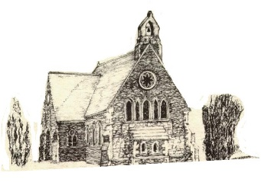 

**September 2024**

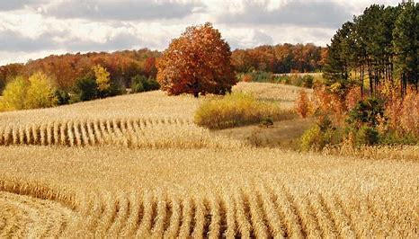

**Rector: The Revd Canon Robert Howard**

**15 Ballykeel Road, Hillsborough**

**BT26 6NW**

**Tel: 028 9263 8218**

**E-mail:** [**jrobert.howard@btinternet.com**](mailto:jrobert.howard@btinternet.com)

**Website:** [**www.annahiltandmagherahamlet.org**](http://www.annahiltandmagherahamlet.org)

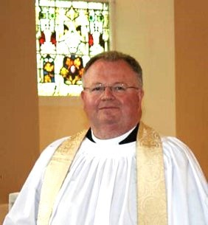**The Rector writes…..**

My dear Parishioners

For many this month of September marks the beginning of a new year. A new academic year begins at schools, colleges and universities. Our school staff return to their busy jobs and families settle back into their busy routine. For some, it may be the start of school. New things are happening.

September is a beautiful month in nature. New things are happening there too. The leaves start turning a beautiful dark colour and then start dropping as we head into the Autumn months. I love kicking up the leaves on a walk. I find great joy in the wonder of nature, as many of us do. I give thanks to God for the beautiful creation that God has given us to enjoy.

Unfortunately, we have not done our best to take care of this precious, unique world. In the Church calendar we have a chance to focus on creation during September and into October as it is the Season of Harvesttide. It is one of my favourite church seasons. There are Harvest Festivals to enjoy as we celebrate the fruits of the season and all that is gathered in. We can take time also to lament at the damage we have done in our greed as human beings: for the creatures that are now extinct or on the brink of extinction. We can ask God to show us ways to live more carefully and to see creation as a gift, not something to be taken for granted.

This is a chance for something new to happen. We can commit afresh to doing all we can to work for a more sustainable way of living, to see where we can add our voice to campaigns, including those seeking to clean up our rivers and oceans. We are passionate about caring for God’s world. I wonder what new things are happening in our midst? Perhaps jam is on the boil with the bountiful fruit of the season. Why not share some with a neighbour? Share the joy… God’s creation is meant to be enjoyed, and cared for, in equal measure, I believe.

I look forward to seeing you at the Harvest Festival Services on Sunday 29 September in Annahilt and on Sunday 27 October in Magherahamlet.

With love, prayers and blessings

Your sincere friend and Rector

Robert Howard

**Congratulations….**

…. to all who were successful in recent school examinations. We hope that all students will continue to give of their best whatever the circumstances. We would be pleased to hear news of the achievements of all of our parishioners.

…to Dr Celina Robinette BVSc MRCVS Veterinary Surgeon. Celina has graduated with distinction from Liverpool University and is now working in Longridge, Preston.

…to Charles and Ann Carson, Annahilt on the recent celebration of their Diamond Wedding Anniversary. The Rector was delighted to call at their home and present them with a floral arrangement on behalf of the Parish. Among the various other greetings and congratulations they received was a card from Their Majesties The King and Queen.

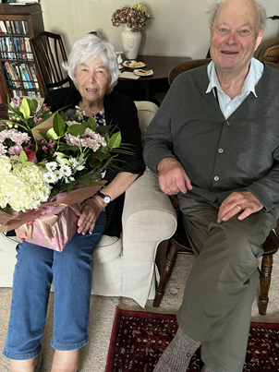

***PRAYER WARRIOR***

Do you have a concern or problem and would like someone to pray for you?

If so, contact the Rector (Tel 028 9263 8218) who will be willing to help.

This is completely confidential and no details will be passed on to anyone else unless you want them to.

***Prayers for the world***

Loving God, Lord of heaven and earth, this earth, our home, belongs to you. Give us grace to love it as you do. Give us courage to give ourselves, as you do, for the good of all people and all of your creation. Strengthen us to stand, as you do, with the vulnerable poor. Give us wisdom to know when we have enough, and the voice to say “enough” to all that harms creation and hurts the poorest.

This earth, our home, belongs to you.

**Amen.**

Dear Lord, you hold our world in your hands. You hear your creation groaning but you have promised to liberate it from its pain. We pray: renew our world. Forgive those of us who haven’t used their power wisely. Give us and our leaders the courage to think beyond our own economies; to seek genuine partnerships so that all people can experience the fullness of life, and that our planet is known to be the common home for all creation and future generations.

**Amen.**

Lord, we pray for our leaders whose decisions and policies have the potential to impact the lives of millions of people around the world - people who they may never meet, know, or be aware of, but who are your sons and daughters. God, we pray that your spirit will fill our leaders’ hearts and heads that they might hear the voices of the impoverished, the oppressed and the vulnerable. God help them see the impact of their actions, and the potential to release healing and hope through just policies.

**Amen.**

**Prayers**

*For His Majesty The King following the Anniversary of his Accession, 8 September*

Lord God, the Ancient of Days,  
you are sovereign over all your people;  
Give to His Majesty, King Charles  
enduring wisdom and faith  
in the service of the people of this land  
and of you, his Lord and master.  
Grant that his reign may be one of faithful witness  
And prove to others a source of hope,  
that they may come to know more fully  
your Son Jesus Christ,  
who is alive and reigns with you and the Holy Spirit,  
one God, now and forever.

**Amen.**

**Decoration of Annahilt Church for Harvest**

Saturday 28 September

From **9.30am**

Your assistance with the decoration will be greatly valued

Gifts of flowers, greenery, corn, fruit, vegetables and other foodstuffs will be very gratefully received at the Church on the day before (Friday) from 4.00 – 6.00pm

**Church Services in the Parishes of Annahilt and Magherahamlet**

*‘I was glad when they said to me: “Let us go to the house of the Lord”’*

Sunday 1 September **Trinity XIV**

10.00 Parish Communion Annahilt

12.00 Parish Communion Magherahamlet

Sunday 8 September **The Birth of the Blessed Virgin Mary**

10.00 Family Service Annahilt *Service Sheets*

12.00 Family Service Magherahamlet *Service Sheets*

Sunday 15 September **Trinity XVI**

10.00 Parish Communion Annahilt

12.00 Morning PrayerMagherahamlet

Sunday 22 September **Trinity XVII**

10.00 Morning Prayer Annahilt

12.00 Morning Prayer Magherahamlet

Sunday 29 September  **St Michael and All Angels**

12.00 Morning Prayer & Litany Magherahamlet

|  |
| --- |
| **Annahilt Harvest Festival**  Sunday 29 September 2024  10.00 Harvest Parish Communion *Service Sheets*  Preacher: The Revd Stephen McWhirter  Rector of Rossory (Clogher)  7.00 Service of the Word *Service Sheets*  *With the Baillies Mills Accordion Band*  Preacher: The Rt Revd Harold Miller  Former Bishop of Down & Dromore    *Supper afterwards in the Parochial Hall* |

Sunday 6 October **Trinity XIX**

10.00 Parish Communion Annahilt

12.00 Parish Communion Magherahamlet

Sunday 13 October **Trinity XX**

10.00 Family Service Annahilt *Service Sheets*

12.00 Family Service Magherahamlet *Service Sheets*

**Annahilt Harvest Appeal**

Included with this magazine is a Harvest Thank Offering Envelope. You are asked to think prayerfully about missionary work throughout the world and our obligation to support it. Also there is our ongoing responsibility to the poor and destitute. Then please share what you have with the needy by making as worthwhile and generous a thank offering as you can. The Thank Offering envelope may be returned at either of the Harvest Services. By putting your name and/or number on it, tax relief may be claimed through Gift Aid if you pay tax. Mark your Envelope “Gift Aid”.

Those Parishioners who view the magazine online may send donations directly to Patricia (35, Cabra Road, Hillsborough, Co Down, BT26 6NB) either by post or put an envelope on the plate in church marked accordingly.

This year we make our Harvest offerings to: The Church Missionary Society, Crosslinks, Christian Aid, Mission to Seafarers, South American Missionary Society.

**Annahilt Harvest Supper**

Following the success of such events on previous occasions, with great pleasure it is announced that the Harvest Supper will take place this year in the Parochial Hall following the Evening Service on Sunday 29 September at 7.00 pm.

It is hoped that parishioners, visitors and friends will avail of this occasion for engaging in face-to-face fellowship and conversation.

Our former Bishop, the Rt Revd Harold Miller will be making his first visit to Annahilt Parish since his retirement in 2017. It would be lovely to have a fully representative gathering of parishioners and friends both in Church and in the Parochial Hall to welcome him back.

The Baillie’s Mills Accordion Band are always most welcome guests and participants in our Churches. We look forward very much to hearing them again in our Evening Harvest Service.

**Children’s Harvest Offerings**

The younger members of the congregation are asked to bring a non-perishable item of food (eg a packet of biscuits or a tin of fruit) to the 10am service on Harvest Sunday. They will have the opportunity of making their own Harvest Offerings during the service.

**Magherahamlet Harvest Thanksgiving**

Sunday 27 October 2024

**Rite of Confirmation**

The Bishop has provisionally offered Sunday 24 November 2024 as a date for administering the Rite of Confirmation in our Group of Parishes. If there are sufficient numbers interested, the Service will take place on Sunday 24 November 2024, at 3.30 pm in the Church of the Ascension, Annahilt.

Young people from both Annahilt and Magherahamlet in Year 9 and above at school are invited to consider taking this step to full membership of the Church. There may also be adults in each parish who would also wish to be confirmed.

Anyone interested should inform the Rector as soon as possible.

**New Office Bearers in Magherahamlet**

With great regret we record that Hillary and Audrey Edgar have moved away from our locality. We will miss them greatly along with their very active participation in both Magherahamlet Parish and in the local community.

On their last Sunday in the Parish the Rector paid warm tribute to the substantial contribution of both Hillary and Audrey in the life of our Parish over the years and in particular Hillary’s role as Parochial Treasurer.

Suitable presentations were made afterwards.

We congratulate Abbie Stanford who has assumed the position of Honorary Treasurer and Frances Magorrian who has been appointed Honorary Secretary. We wish them both very well in their new offices.

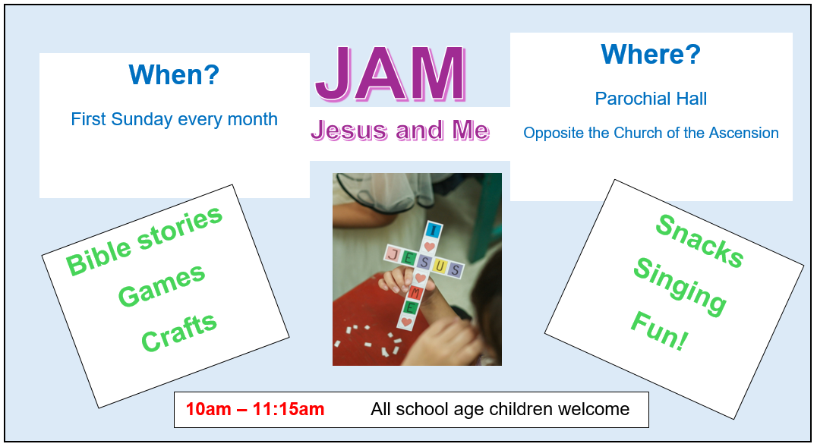

**Beginning on Sunday 6 October Children’s Activity on a Sunday in Annahilt will follow a new format on an experimental basis.**

During this trial period **JAM** (Jesus and Me) will normally meet on the **FIRST** Sunday of each month beginning at 10.00 am and finishing at 11.15 am. On this Sunday parents and guardians are invited to bring children of school age **directly** to the Parochial Hall rather than to Church beforehand. The illustrated notice above lists some of the activities that will take place. We very much look forward to seeing our young people of school age at JAM on the first Sunday morning of each month. The First Sunday of the month has been specifically chosen in the hope that it is easy to remember!

On the second Sunday of each month young people are encouraged to come to the Family Service in Church at 10.00 am. On other Sundays in the month children are welcome at the usual Church Service at 10.00 am.

**Magherahamlet**

Sunday School will resume on Sunday 15 September at 11.00 am in the Parochial Hall.

We look forward very much to welcoming new attendees



**A Celebration of Sunday School**

Almost 240 years ago, the first Sunday School in Ulster opened its doors in Bright Parish in the Diocese of Down.

On Sunday 8 September we’re returning to Bright to celebrate the legacy of Sunday School in the Church of Ireland and all those who have taught and teach our children about the Christian faith.

We would love at least one Sunday School representative from every parish to join us for a BBQ followed by a commissioning service in Bright Parish Church.

Please contact Millie Bellew for more details and to confirm you are coming on Sunday 8 September (from 5.00-7.00pm).

**Tel: 07543478757 or email:**[**millie@downanddromore.org**](mailto:millie@downanddromore.org)

Top of Form

Bottom of Form

**From the Parish Registers**

**Holy Baptism**

*‘Go therefore and make disciples of all nations baptising them in the name of the Father and of the Son and of the Holy Spirit’*

**28 July 2024**

Magherahamlet Parish Church

Lily Elizabeth, daughter of Hawthorne and Lisa Burrows

**Flowers for the Churches**

**Annahilt Magherahamlet**

**September**

1 Miss V Begley

8

15 Mrs F Magorrian

22

29 Harvest



**Church Cleaning, Annahilt**

**Month**

**September**

6-7

13-14 Mrs J Bolas Mr A Bolas

20-21 Mrs H Hill Mr T Hill

27-28 Mrs A Maxwell Mr R Maxwell

**October**

4-5 Mrs J Guiney Mrs H Cardosi

13-14 Mrs L McCambley Mrs E Harrison

18-19 Mrs E Crawford

25-26 Mrs S Chapman Mr S Chapman



Dear Mothers’ Union Members and Friends,

We sincerely hope that you and your families have benefitted from a relaxing summer break.

Annahilt members look forward to meeting up again on Monday 16th September at 8.00pm in the Parochial Hall. Our aim for the evening will be to discuss and agree on a Programme of monthly activities for our Mothers’ Union Branch for the remainder of 2024 and also to explore ways in which we can raise funds to support Mothers’ Union work, at home and abroad.

We would also be delighted to welcome anyone who would like to come along just for some company and a chat. Looking forward to seeing everyone,

Magherahamlet members have already met with suggestions made for our Autumn programme.

Kind Regards

Beth Esme

Avril McK & Sally Frances & Avril B

**Mothers’ Union Midday Wave of Prayers September 2024**

1-2 September: Harare in Zimbabwe; Machakos in Kenya; Ogori-Magongo & Ekiti in Nigeria; Southwark in England and Phulbani in India

3-5 September: Khartoum in Sudan; Dar es Salaam in Tanzania; Bari & Ilesa in Nigeria; Gloucester in England and Dugapur in India

7-9 September: Pacong in South Sudan; Southern Nyanza in Kenya; Kutigi & Ijesha North in Nigeria; Bristol in England and Karnataka Central in India

10-12 September: Pretoria in South Africa; North Mbale in Uganda; Oke-Osun in Nigeria; Exeter in England and Barbados

14-16 September: Mthatha in South Africa; Namirembe in Uganda; Pankshin &Sabongidda-Ora in Nigeria; Dublin & Glendalough in All Ireland and Central Solomons in Solomon Islands

17-19 September: Buye in Burundi; Sebei in Uganda; Abakaliki & Ekiti-Oke in Nigeria; Southwell & Nottingham in England and Belize

21-23 September: Rumbek in South Sudan; Soroti in Uganda; Aba Ngwa North &Oyo in Nigeria; Peterborough in England and North Eastern Caribbean & Aruba

24-26 September: Makamba in Burundi; North Karamoja in Uganda; Lokoja &Sapele in Nigeria; Truro in England and Tirunelveli in India

28-30 September: Katanga in DR Congo; Rwenzori in Uganda; Mbaise & Egba in Nigeria; Meath & Kildare in All-Ireland and Tiruchirappalli Thanjavur in India

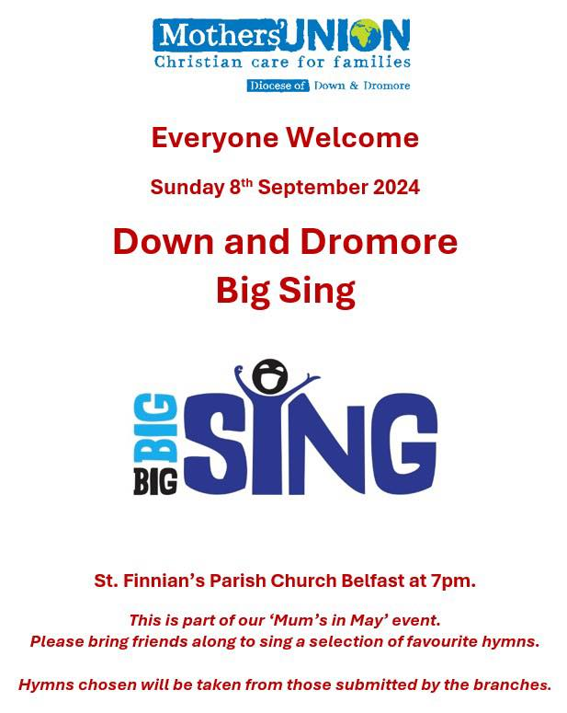

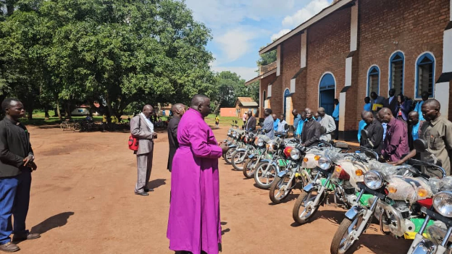

**Following our diocesan appeal and the arrival of 100 bicycles, 10 motorbikes and two rickshaw motorbikes in our link diocese of Maridi, South Sudan, Bishop Moses has sent a letter of thanks.**

*Dear Bishop David McClay, Dean Geoff, and the people of the Diocese of Down and Dromore,*

*I write to express my deepest gratitude and heartfelt appreciation on behalf of the Diocese of Maridi for your generous financial support and partnership. Your commitment to standing with us and empowering the work of the church in Maridi is truly remarkable. Your contribution has enabled us to purchase 100 bicycles for our priests, 10 motorbikes for the archdeacons, and two rickshaw motorbikes for the Mothers' Union and Young Family Groups and one Brick Machine for the Youth.*

*The 100 bicycles you provided for our priests have been an incredible blessing, allowing them to more effectively reach the remote villages and communities across our diocese. This practical support has strengthened their ability to provide pastoral care, lead worship, and share the good news of the gospel Our priests are overjoyed and send their sincere thanks.*

*Similarly, the 10 motorbikes you donated for our archdeacons have been transformative. These reliable modes of transport enable our archdeacons to oversee their large jurisdictions, support local church leaders, and respond quickly to emergencies.*

*The two special rickshaw motorbikes for our Mothers' Union and young family groups will also be invaluable, allowing them to travel to gatherings and initiatives across the diocese.*

*This substantial support will greatly enhance the mobility and ministry of our clergy and lay leaders across the diocese. In a region where transportation challenges are significant, these vehicles will ensure that the message of the Gospel reaches even the most remote communities more effectively. The priests, archdeacons, and leaders of the Mothers' Union and Young Family Groups will now be better equipped to serve their congregations, offering pastoral care, support, and guidance to those in need.*

*Your partnership empowers us to fulfil our mission and live out Christ's call to serve the least, the last, and the lost. The resources you have sacrificially provided are making a tangible difference in the lives of our people. We are deeply grateful.*

*We recognise the continued commitment of the Diocese of Down and Dromore to partnering with us in advancing the mission of Christ in Maridi. Your unwavering support is a testament to the bonds of Christian fellowship that unite us, and it serves as a beacon of hope for our people.*

*Please extend our profound thanks to the congregations and all the individuals who contributed to this initiative. May our Lord richly bless you all for your generosity and partnership in the Gospel.*

*May the Lord richly bless you and the Diocese of Down and Dromore for your faithful witness and generosity. You are valued brothers and sisters in Christ, and we look forward to continuing to work side-by-side in God's kingdom work.*

*Yours in Christ,  
Bishop Moses Zungo  
Diocese of Maridi*

**Thank you…..**

…..to those who contributed to the following special collections in Magherahamlet:

Children’s Day, Air Ambulance £128.00

Rector’40th Anniversary Ordination Service, Bicycles for clergy in our link diocese of Maridi £471.50

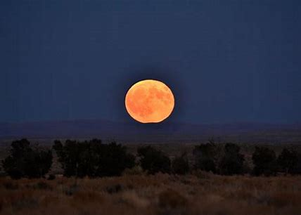

**The most familiar named moon**

September's Harvest moon refers to the time of year after the autumn equinox when crops are gathered. It also refers to the moon's particularly bright appearance and early rise, which lets farmers continue harvesting into the night. Other names include the corn moon or corn maker moon and the barley moon.

The full moon in September will be on Tuesday 17 September. The Super Harvest Moon will be the fourth full moon of Summer and the second of four full super moons in 2024.

There will also be a Penumbral Lunar Eclipse at the same time as the full moon.

A penumbral lunar eclipse occurs when the Moon travels only through the outer, fainter part of the Earth's shadow, or 'penumbra'. This happens when the Earth moves between the Sun and Moon but the three do not form a perfectly straight line.



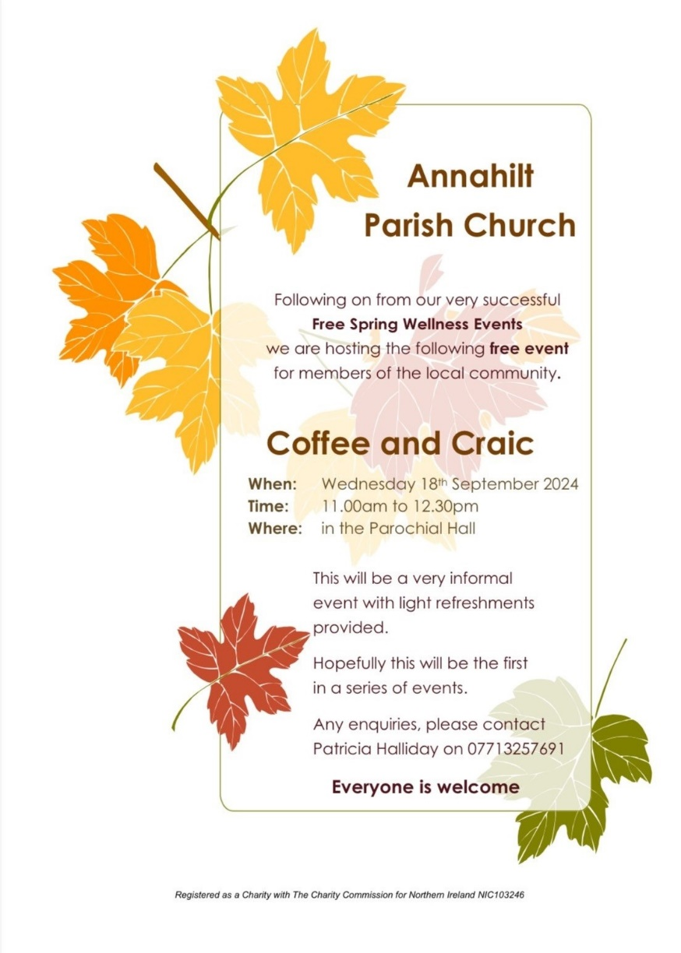

**Coffee and Craic**

Following the very successful Spring Wellness events held earlier in the year and a desire from those present to attend something similar in the future the organising committee is planning a "Coffee and Craic" morning in the parochial hall on Wednesday 18th September 2024 from 11am-12.30pm. The morning will be very informal and an open invitation is extended to all in the parishes and the community. At this stage the thoughts are that we would follow up with future events in possibly November 2024 and February 2025. Light refreshments will be served and there is no need to book. If anyone has any queries, please contact Patricia on 028 92665310 or 07713 257691.



**Bowling Club**

Annahilt Parish Bowling Club will re-open on Wednesday 18th September 2024 at 8pm in the Parochial Hall.

The club meets most Wednesday evenings and plays matches home and away. They also meet on one or two Saturday evenings per month.

New bowlers especially welcome. Come along and bring a friend, even if it's only for the tea and biscuits!

Enquiries to Patricia on 07713 257691.

**Lunch Club**

The next time we meet will be Friday 27 September in the Pheasant at the usual time of 12.30pm.

Subsequent Lunch Club meetings will take place on the following dates:

25 October

29 November

The Lunch Club is a very relaxed and enjoyable occasion, giving retired and semi-retired members an opportunity to connect with each other. If you would like the opportunity of enjoying a lunchtime meal in the company of established friends or perhaps some new ones, do come along. Please contact Violet Swarbrigg (Telephone 028 9263 8952) for further information.

**LISBURN FOODBANK**

The Lisburn Foodbank is providing an essential service to those within our community who are experiencing difficult times, often due to circumstances beyond their control.

The Foodbank provides emergency food and support to local people in crisis in the Lisburn area.

Parishioners may leave items for the Foodbank in the basket in Annahilt Church Porch, on the FIRST and SECOND Sunday of each month.

A particular request from the Foodbank is for cleaning items such as:

* small packs of toilet roll
* nappies
* baby wipes
* shower gel
* soaps
* washing powder

**YOUR HELP WOULD BE GREATLY APPRECIATED**.

**Recording of Annahilt Church Service recordings**

Free recordings (CD format) are available weekly of the Church services or requested special services.

These CDs are delivered free of charge. If you would like to receive a CD copy, please contact Shirley Robinette on 07974093382

**Parish Website:  AnnahiltAndMagherahamlet.org**

Parishioners are reminded that the website [annahiltandmagherahamlet.org](http://annahiltandmagherahamlet.org/) has been created to provide information on church related activities and organisations for parishioners and the wider community. The website also continues to host online services most weeks. In addition, the website contains a list of upcoming church services and news from our group of parishes, as well as downloadable versions of the parish magazine.  The site will be continually developed, so if you have any submissions, suggestions or requests relating to the website, these can be sent to [admin@annahiltandmagherahamlet.org](mailto:admin@annahiltandmagherahamlet.org).



[www.annahiltandmagherahamlet.org](http://www.annahiltandmagherahamlet.org)

**Parish Magazine**

Any contributions for the next edition of the Parish Magazine should be left with the Rector or Roger Maxwell ([roger.maxwell1@btinternet.com](mailto:roger.maxwell1@btinternet.com)) by Sunday 22 September 2024.

Registered as a charity with The Charity Commission for Northern Ireland

NIC103246 (Annahilt) and NIC102122 (Magherahamlet)