News from the Parishes
Church of the Ascension, Annahilt Magherahamlet Parish Church
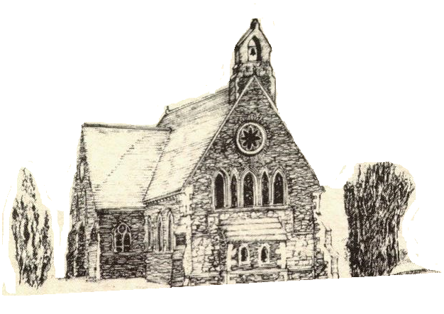

September 2021

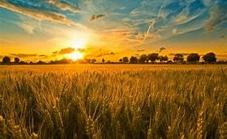

Rector: The Revd Canon Robert Howard
15 Ballykeel Road, Hillsborough
BT26 6NW
Tel: 028 9263 8218
E-mail: jrobert.howard@btinternet.com
Website: www.annahiltandmagherahamlet.org

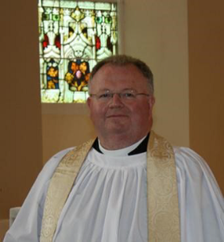
The Rector writes….

My dear Parishioners

September normally marks the return to all sorts of activities and organisations in parish life. People look forward to seeing friends they haven’t seen for a while and immersing themselves in those activities that are important to them.
For the second consecutive year, we are unable to say with clarity what will unfold for each of our organisations and activities. We have begun a process of consulting with different organisations and groups to try to get a sense of where people are with regards to resuming activities. Some are very keen to ‘get going’ again. Others are not so sure. As always, in these challenging times, there are risk assessments and precautions to be set in place before anything can happen as people’s safety is our paramount concern.
The Archbishop of Armagh & Primate of All Ireland, The Most Reverend John McDowell recently issued a statement on behalf of the Church of Ireland following the loosening of some restrictions around public worship. In this he stressed that the wearing of face coverings will still be legally required when entering and exiting a Church building. It is also strongly advised that they be worn whilst singing or moving around inside church premises.
He also emphasised that ‘the clear guidance from the Chief Medical Officer and Chief Scientific Advisor remains that face coverings should continue to be worn. This has also been endorsed by our Bishop, the Rt Revd David McClay. I wholeheartedly agree and earnestly request parishioners to continue wearing face coverings for the time being when attending church services. The benefits, particularly in regard to the welfare of others, outweigh the risks. Congregational singing also potentially increases the risk of the spread of the virus so wearing a face covering is an absolutely necessary mitigation against that risk.
The Archbishop also pointed out that by wearing a face covering we are showing our support and consideration for other members of the congregation, particularly the more vulnerable and those with underlying health concerns.
It seems very clear that we would be rather reckless to disregard the best scientific advice available to us. It seems a very appropriate point also to pay tribute to our Churchwardens, Trevor Hill and David Keith (Annahilt),Virginia Begley and Larry Fryers (Magherahamlet), the Glebewardens (William Mathers and David Guiney (Annahilt), George McCurry and Norman Hughes (Magherahamlet), the Health and Safety Officers Roger Maxwell (Annahilt) Hillary Edgar and Will Chambré (Magherahamlet) and the Select Vestries who have been doing all in their power to keep us all safe as we come to public worship. We are especially indebted to all those involved in sanitising and cleaning in between services to make this possible as well as maintaining the rigorous track and trace records. We appreciate everyone’s help and cooperation as we endeavour to continue to meet together in person. One positive change is that the social distancing regulation in Church Services has now been reduced to 1 metre. This will enable us to increase the number of potential worshippers at Services in Church. If you have not yet returned to ‘In Church’ Services or only occasionally have done so, perhaps you will take this opportunity of coming back to Church in this new season of activity in our Group of Parishes?
The recent rise in infection numbers and the prevalence of the Delta variant mean that we must continue to be as careful and vigilant as possible.
Please do keep an eye on the parish website and as we continue these discussions with our organisations. People will be in touch with members as soon as any activities are given the green light to resume.
While we may not have the clarity we would wish for in terms of the resumption of activities and organisations, there are things we do have definite plans for.
We hope to resume face to face activities in both Sunday Schools on Sunday 5 September 2021. We are also hoping to resume the traditional Harvest Supper in Annahilt following the Evening Service on Sunday 26 September.
I want to take this opportunity to wish all our younger parishioners well as they return to school and university. Education has been severely disrupted over this past year and a half and we all hope that things will stabilise to enable people to enter fully into all that their educational opportunities have to offer.
Very best wishes to everyone.

Your sincere friend and Rector

Robert Howard

Congratulations…
…. to all who were successful in recent school examinations. We hope that all students will continue to give of their best whatever the circumstances.
We would be pleased to hear news of the achievements of all of our parishioners.

In-Church Worship in Church of the Ascension, Annahilt and Magherahamlet Parish Church

Numbers are reduced at Services in both Churches because of the legal requirement to facilitate safe distancing. Because of this, it would be very helpful if those intending to come to church would give notice of their intentions.
Annahilt
Trevor Hill trevorhill111@btinternet.com
Magherahamlet
Hillary Edgar hillary.edgar01@btinternet.com

Alternatively, you may contact by telephone:
Annahilt
Trevor Hill 07890552930
Magherahamlet
George & Sally McCurry 028 9756 3955
Hillary Edgar 028 4481 1361

For Annahilt, notification of attendance can also be given via the Parish website up to the Friday before.

PRAYER WARRIOR
Do you have a concern or problem and would like someone to pray for you? If so, please contact the Rector (Tel 028 9263 8218) who will be willing to help. This is completely confidential and no details will be passed on to anyone else unless you want them to.

Prayers for the world

Loving God, Lord of heaven and earth, this earth, our home, belongs to you. Give us grace to love it as you do. Give us courage to give ourselves, as you do, for the good of all people and all of your creation. Strengthen us to stand, as you do, with the vulnerable poor. Give us wisdom to know when we have enough, and the voice to say “enough” to all that harms creation and hurts the poorest.
This earth, our home, belongs to you.
Amen.

Dear Lord, you hold our world in your hands. You hear your creation groaning but you have promised to liberate it from its pain. We pray: renew our world. Forgive those of us who haven’t used their power wisely. Give us and our leaders the courage to think beyond our own economies; to seek genuine partnerships so that all people can experience the fullness of life, and that our planet is known to be the common home for all creation and future generations.
Amen.

Lord, we pray for our leaders whose decisions and policies have the potential to impact the lives of millions of people around the world - people who they may never meet, know, or be aware of, but who are your sons and daughters. God, we pray that your spirit will fill our leaders’ hearts and heads that they might hear the voices of the impoverished, the oppressed and the vulnerable. God help them see the impact of their actions, and the potential to release healing and hope through just policies.
Amen.

Walk with Water – Christian Aid Week 2021

On a very pleasant evening on the Wednesday of Christian Aid Week, our little group met at Hillsborough Forest Park to begin our 5 k “Walk with Water” in support of Christian Aid Week 2021.
We each arrived, armed with buckets of varying colours, shapes and sizes and were delighted to welcome Robert, our Rector and friend, who joined us for the occasion.
As we walked along, enjoying the exercise and the company, we began to notice some very puzzled expressions on the faces of other park users, some of whom stopped to ask us what we were doing. We were then able to pass on the story of Rose Jonathan. Rose is a 68 year old grandmother from Kenya who, because of severe drought and a changing climate, is forced to walk up to seven hours a day to fetch water for her family and her livestock. Rose has been the sole carer for her 6 grandchildren since her husband died and her daughters moved to the city for work.
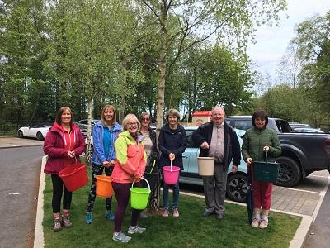
In the rural areas of many African countries, it falls to women and girls to collect water for their families and farm animals, which can involve long and often dangerous journeys on foot. Christian Aid is responding to the crisis by funding the building of low tech, sustainable earth dams which capture and store water when the rains do come, thus easing the situation for the local communities.
I am delighted to be able to tell you that the total raised was approximately £2500, through both the parish and from online donations and included an allowance for gift aid. This was a wonderful amount and I would like to thank all those who supported us in our walk and in doing so, have helped Christian Aid in raising vital funds towards enabling communities to access clean water – something which, in Annahilt, we take very much for granted.
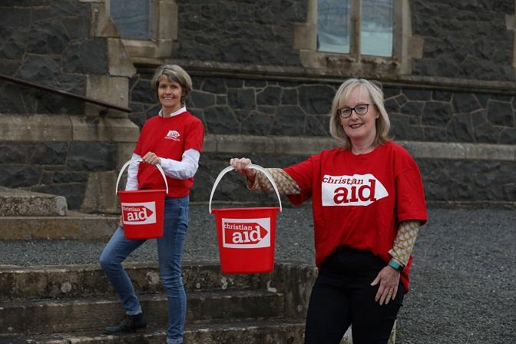
Every pound raised is an expression of our Christian love and compassion, of our belief that all life is equal and precious in the sight of God.
You may be interested in the following facts:
£4.40 could teach 10 families how to plant drought-tolerant crops that can survive drought
£10 could buy a pair of taps at a water point that will be installed at an earth dam, making it easier for people to access the water supply
£42 could buy 350 kg of cement which is needed to build an earth dam
£545 could pay for a skilled labourer to work on the construction of an earth or sand dam

Thanks again.
Louise McGregor

Decoration of Annahilt Church for Harvest
Wednesday 22 September
From 7.30pm
Gifts of flowers, greenery, corn, fruit, vegetables and other foodstuffs will be gratefully received.

Your assistance with the decoration will also be greatly valued

Please note the change in day and time of this year’s harvest decoration. This is to allow 72 hours between decoration and the Sunday services in line with public health guidelines.

Church Services in the Parishes of Annahilt and Magherahamlet
‘I was glad when they said to me: “Let us go to the house of the Lord”’ Psalm 122 v1

Sunday 5 September Trinity XIV
10.00 Parish Communion Annahilt
12.00 Parish Communion Magherahamlet

Sunday 12 September Trinity XV
10.00 Family Service Annahilt
12.00 Family Service Magherahamlet

Sunday 19 September Trinity XVI
Vocation Sunday
10.00 Morning Prayer Annahilt
12.00 Morning Prayer Magherahamlet

Sunday 26 September Trinity XVI
12.00 Morning Prayer Magherahamlet

Annahilt Harvest Festival

Sunday 26 September 2021
10.00 Harvest Parish Communion
Preacher: The Rt Revd Alan Harper
Former Archbishop of Armagh & Primate of All Ireland
7.00 Evening Prayer
Preacher: The Revd Canon Norman Porteous
Rector of Derryloran (Cookstown)

Supper aftterwards in the Parochial Hall

Sunday 3 October Trinity XVII
10.00 Parish Communion Annahilt
12.00 Parish Communion Magherahamlet

Sunday 10 October Trinity XVIII
10.00 Family Service Annahilt
12.00 Family Service Magherahamlet

Annahilt Harvest Appeal
Included with this magazine is a Harvest Thank Offering Envelope. You are asked to think prayerfully about missionary work throughout the world and our obligation to support it. Also there is our on-going responsibility to the poor and destitute. Then please share what you have with the needy by making as worthwhile and generous a thank offering as you can. The Thank Offering envelope may be returned at either of the Harvest Services. By putting your name and/or number on it, tax relief may be claimed through Gift Aid if you pay tax. Mark your Envelope “Gift Aid”.
This year we make our Harvest offerings to: The Church Missionary Society, Crosslinks, Christian Aid, Mission to Seafarers, South American Missionary Society.

Annahilt Harvest Supper
Unfortunately, due to public health restrictions we were unable to host the traditional Harvest Supper last year. On account of a very recent easing of these restrictions catering on parochial premises is now possible provided risk assessments are carried out which include clear reference to the type of catering proposed. Therefore, with great pleasure it is announced that the Harvest Supper will be resumed this year in the Parochial Hall following the Evening Service on Sunday 26 September at 7.00 pm.
It is hoped that parishioners, visitors and friends will avail of this occasion for engaging in face-to-face fellowship and conversation which was not possible over the various lockdown periods.

Children’s Harvest Offerings
The younger members of the congregation are asked to bring a non-perishable item of food (eg a packet of biscuits or a tin of fruit) to the 10am service on Harvest Sunday. They will have the opportunity of making their own Harvest Offerings during the service.

Magherahamlet Harvest Thanksgiving
Sunday 24 October 2021

Sunday School
Sunday School in Annahilt and Magherahamlet will resume on Sunday 5 September It is hoped that our young people in both parishes will be encouraged to take seriously their attendance at Church (in particular at Family Services) and Sunday School. This is of vital importance in developing respect for Sunday, God’s Day, at an early age. It also facilitates teachers in carrying out their work if young people are regular in their attendance.
Until further notice,
- Children in Annahilt attending Sunday School should go directly to the Parochial Hall rather than going initially to Church. Children in Magherahamlet attending Sunday School are asked to go directly to the Parochial Hall at 11.00 am as before.
- All teachers and children are asked to be 1 metre apart from other non-household members. Household members can still sit beside each other in the normal manner.
- Seats to be placed to ensure a 1 metre distance between non-household attendees.
- Seats to be filled as per the direction of the Sunday School Teachers.
- Please note posters and signs displayed at the entrance to the Hall to explain social distancing.
- Teachers and children are asked to maintain 1 metre distance when using sanitiser placed at the entrance to the Hall and keep moving into the designated room where Sunday School will take place so as not to create a ‘bottle neck’.
- Following Sunday School, the children will remain in the hall until directed to leave by the teachers.
- Parents / Guardians are asked to please wait for their children outside the Hall and ensure that crowding does not occur at entrances or exits.
Teachers and children are asked NOT to attend Sunday School if they are experiencing symptoms or have been recently recovering or are in an ‘at risk’ group.
We look forward very much to the resumption of face to face activities in both our Sunday Schools. New attendees will be especially welcome.

Flowers for the Churches
Annahilt Magherahamlet
September
Day
5
12 Miss V Begley
19 Mrs F Magorrian
26 Harvest

Church Cleaning, Annahilt
Month

September

3-4 Mrs E Crawford Mrs M Finlay
10-11 Mrs A Patterson
17-18 Mrs J Bolas Mr A Bolas
24-25 Mrs A Maxwell Mr R Maxwell

October
1-2 Mrs J Guiney Mrs H Cardosi
8-9 Mrs E Ogle
15-16 Mrs L McCambley Mrs E Harrison
22-23 Mrs H Hill Mr T Hill
29-30 Mrs B Harrison Mrs E Harrison
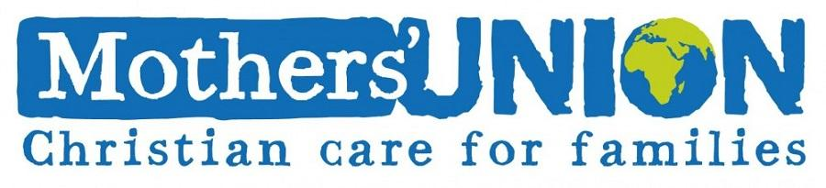

Dear Mothers’ Union Members and Friends,

We sincerely hope that you have all had a very pleasant and relaxing time over the last couple of months and have benefitted from the lovely sunny weather and a break from your usual routines.

In her latest correspondence, Mothers’ Union Down and Dromore President, Roberta, has indicated that meeting up again will be a very different from what we have been used to and will have to be approached in a very tentative and careful manner with each Branch being issued with a set of guidelines which need to be adopted to ensure the safety and wellbeing of everyone. Roberta suggested that a church service may be one of the safest ways to begin and I will keep you informed of any arrangements if that is to happen. In the meantime please keep in touch and look out for one another.

May God bless you all.

Beth Esme
Avril Anne

Mothers’ Union—Midday Prayers—September 2021
Rebuilding hope and confidence. Season of Creation

Monday: Creator God
In your time, Creator God, this world was put in place, and in your time became beautiful, through the craftsmanship of your love. Remind us always, as we look at sunrise, landscape and tiny child, that at the centre of all things, is the creative love of God.
You are worthy, our Lord and God, to receive glory and honour and power,
for you created all things, and by your will they were created and have their being.
Revelation 4:11
The earth is yours O Lord
You created it and gave it form.
You called life out of chaos
Made humankind in your image, co-creators with you.
You looked at all you had made and pronounced it good. Blessed be God forever.
Amen.

Tuesday: Creation
The heavens declare the glory of God; the skies proclaim the work of his hands. Day after day they pour forth speech; night after night they display knowledge.
There is no speech or language where their voice is not heard. Their voice goes out into all the earth, their words to the ends of the world.
Psalm 19:1-4
Creation proclaims the glory of God
Let our lips not stay silent.
Nature sings its praise to God
Let our praise rise in harmony
The heavens declare the splendour of God
Let our lives reflect his beauty.
May we, who alone of all his creation, know the joy of God’s eternal salvation, let our mouths, hearts and lives be filled with praise and thanksgiving above all in heaven and earth.
Amen.

Wednesday: Caring for creation
You appointed them rulers over everything you made; you placed them over all creation.
Psalm 8:6
All that God has made is very good; let us steward creation with integrity and care.
Lord we give thanks that all you have made is very good: For the quality and quantity of your provision; enough for all throughout your world to eat their fill and thrive.
Lord forgive us that our stewardship has not been good: We have exploited our union with creation; taking without replenishing; hoarding without sharing.
Lord, help us to take responsibility for the future: To sustain and value your creation, that those to come will find a fruitful inheritance.
All that God has made is very good; let us steward creation with integrity and care.
Amen.

Thursday: Fruitfulness of creation
The land produced vegetation: plants bearing seed according to their kinds and trees bearing fruit with seed in it according to their kinds. And God saw that it was good.

Genesis 1:12
Lord of creation, bountiful giver, we bring you our first fruits of praise.
One crop, one fruit, one seed, one flower, one creature, one race. If all creation was one of each kind, we would overflow with gratitude and praise. Yet, Lord, we are blessed by your lavish abundance; we marvel at nature’s diversity. Lord of creation, we give you thanks for nature’s rich variety. Lord of the harvest, we praise you for creation’s wondrous array.
Lord of creation, bountiful giver, we bring you our first fruits of praise and celebrate your goodness with thankful hearts.
Amen.

Friday: Climate change
I brought you into a land of plenty, to enjoy its gifts and goodness, but you ruined my land; you disgraced my heritage.
Jeremiah 2:7
God of life, we pray for all those who are struggling with the effects of climate change and the exploitation of our earth’s resources.
Fill us with a spirit of concern for the future, that we may learn from our state of environmental irresponsibility and become responsible custodians of your creation.
May those in authority make decisions that will be life-giving for all.
Inspire us to refocus our lives and centre on all you have created, so we may redress the injustice of climate change and look forward to a future full of hope in a caring, sharing, respectful world.
In Jesus’ name.
Amen.

Saturday: Creator God
The God who made the world and everything in it is the Lord of heaven and earth.
In him we live and move and have our being.
Acts 17:24, 28
O Divine Voice,
You sing and the universe comes into being;
O Divine Breath,
You breathe and all things spring to life;
O Divine Word,
You call and creation is sustained;
O Divine Flesh,
You are born among us,
and the Creator is clothed in creation; In amazement and awe, in wonder and celebration we marvel at this mystery:
In you all things live and move and have being,
In all things, you live and move and express your Divine artistry;
And so we join with creation in the eternal song of worship and wonder.
Amen.

Mothers' Union Prayer
Loving Lord,
We thank you for your love so freely given to us all.
We pray for families around the world.
Bless the work of the Mothers' Union as we seek to share your love through the encouragement, strengtheningand support of marriage and family life.
Empowered by your Spirit, may we be united in prayer and worship, and in love and service reach out as your hands across the world.
In Jesus' name.Amen.

Retirement of the Revd Colin Taylor
The final Sunday in the full time ministry of the Rector of Dromara & Garvaghy, the Revd Colin Taylor is to be Sunday 5 September.
Colin has been a friend and colleague of the Rector over many years. He has preached on different occasions in both the Church of the Ascension, Annahilt and Magherahamlet Parish Church. We have greatly appreciated the friendship and co-operation of both him and his gracious wife Eleanor during their period of service in our neighbouring parishes.
We wish Colin and Eleanor every blessing as they move into retirement in Belfast.

LISBURN FOODBANK

The Lisburn Foodbank is providing an essential service to those within our community who are experiencing difficult times, often due to circumstances beyond their control.

The Foodbank provides emergency food and support to local people in crisis in the Lisburn area.
Parishioners may leave items for the Foodbank in the basket in Annahilt Church Porch, on the FIRST and SECOND Sunday of each month.
A particular request from the Foodbank is for items listed below:

Toiletries
Small boxes of washing powder
Cleaning Supplies
Toilet Rolls (2 or 4)
Baby wipes
Nappies

The Lisburn Foodbank is providing an essential service to those within our community who are experiencing difficult times, often due to circumstances beyond their control.

YOUR HELP WOULD BE GREATLY APPRECIATED.

Parish Website: AnnahiltAndMagherahamlet.org
Parishioners are reminded that the website annahiltandmagherahamlet.org has been created to provide information on church related activities and organisations for parishioners and the wider community. Since the first lockdown began in March, more a year ago, the website has hosted online services each Sunday. It also contains a list of upcoming church services and news from our group of parishes, as well as downloadable versions of the parish magazine. The site will be continually developed, so if you have any submissions, suggestions or requests relating to the website, these can be sent to admin@annahiltandmagherahamlet.org.

www.annahiltandmagherahamlet.org

Parish Magazine
Any contribution for the next edition of the Parish Magazine should be left with the Rector or Roger Maxwell (roger.maxwell1@btinternet.com or magazine@annahiltandmagherahamlet.org) by Sunday 19 September 2021.

Registered as a charity with The Charity Commission for Northern Ireland
NIC103246 (Annahilt) and NIC102122 (Magherahamlet)

