**News from the Parishes**

**Church of the Ascension, Annahilt Magherahamlet Parish Church**

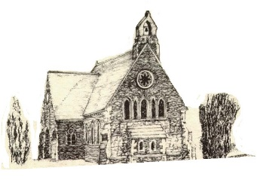 

**September 2025**

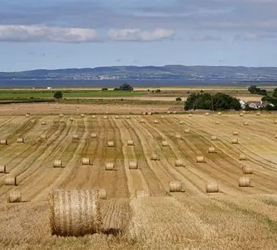

**Rector: The Revd Canon Robert Howard**

**15 Ballykeel Road, Hillsborough**

**BT26 6NW**

**Tel: 028 9263 8218**

**E-mail:** [**jrobert.howard@btinternet.com**](mailto:jrobert.howard@btinternet.com)

**Website:** [**www.annahiltandmagherahamlet.org**](http://www.annahiltandmagherahamlet.org)

**The Rector writes….**

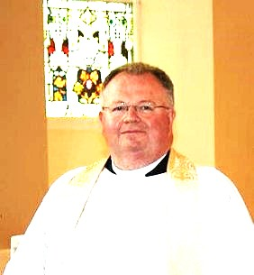My dear Parishioners

I wonder how many of us have thought about what it means for us to be part of a team? Teamwork in the church is more than just how parishes are set up and organised. It’s about working together collaboratively. It’s about recognising and valuing all that the members of the body of Christ have to offer.

Whether we work or are retired, every church member is called to serve God as circumstances and abilities allow. Every member is a witness of Jesus Christ working in this world. As we know, the church is not a building. The church is the people of God. That means both ordained and lay members.

The churches in our parish meet for worship a couple of hours each week but what is the church doing during the rest of the week? Our weekly worship gives us an opportunity to come together and strengthens us for service. It enables us to praise God in song and prayer. It helps us seek guidance from God regarding how we are to serve in the coming week and it nourishes us for what we’re called to do through Holy Communion.

The question is not *whether* we serve Christ throughout the week – it’s ***how***we serve him. Most of us are quite responsive to the will of God but, perhaps, are not used to thinking of ourselves as ministers of Jesus Christ. Every member is ministering, being led by Christ to work and serve in the world. Some people are better at sharing the gospel in words; some are better at sharing it through their work and when Christians work together, they can often be even more effective than they would be alone.

One of the first tasks Jesus did when he began his ministry was to gather a team to share the work. Those first disciples were a mixed bag – they quite often misunderstood and got it wrong, they fell out with each other and jostled for position. Being part of a team isn’t easy but it’s what God calls us to be, and how God calls us all to minister in this part of his world. Those first disciples got there in the end, with amazing results. “*And let us not grow weary of doing good, for in due season we will reap, if we do not give up.” (Galatians 6.9)*

In the coming months there’ll be a great need to work as a team in the Group of Parishes going during this new season of activity. I would like to think that a call to God’s service will be on your hearts and minds as you respond to requests for help. For whatever reason the numbers volunteering in every area have declined and there are still many essential roles to be taken up to keep the parishes running smoothly. Please do consider offering your time and talents to benefit the work of God in Annahilt and Magherahamlet.

With love, prayers and blessings

Your sincere friend and Rector

Robert Howard

**Congratulations….**

…. to all who were successful in recent school examinations. We hope that all students will continue to give of their best whatever the circumstances. We would be pleased to hear news of the achievements of all of our parishioners.



***PRAYER WARRIOR***

Do you have a concern or problem and would like someone to pray for you?

If so, contact the Rector (Tel 028 9263 8218) who will be willing to help.

This is completely confidential and no details will be passed on to anyone else unless you want them to.

***Prayers for the world***

Loving God, Lord of heaven and earth, this earth, our home, belongs to you. Give us grace to love it as you do. Give us courage to give ourselves, as you do, for the good of all people and all of your creation. Strengthen us to stand, as you do, with the vulnerable poor. Give us wisdom to know when we have enough, and the voice to say “enough” to all that harms creation and hurts the poorest.

This earth, our home, belongs to you.

**Amen.**

Dear Lord, you hold our world in your hands. You hear your creation groaning but you have promised to liberate it from its pain. We pray: renew our world. Forgive those of us who haven’t used their power wisely. Give us and our leaders the courage to think beyond our own economies; to seek genuine partnerships so that all people can experience the fullness of life, and that our planet is known to be the common home for all creation and future generations.

**Amen.**

Lord, we pray for our leaders whose decisions and policies have the potential to impact the lives of millions of people around the world - people who they may never meet, know, or be aware of, but who are your sons and daughters. God, we pray that your spirit will fill our leaders’ hearts and heads that they might hear the voices of the impoverished, the oppressed and the vulnerable. God help them see the impact of their actions, and the potential to release healing and hope through just policies.

**Amen.**

*For His Majesty, The King following the Anniversary of his Accession, 8 September*

Lord God, the Ancient of Days,

you are sovereign over all your people;  
Give to His Majesty, King Charles  
enduring wisdom and faith  
in the service of the people of this land  
and of you, his Lord and master.  
Grant that his reign may be one of faithful witness  
And prove to others a source of hope,  
that they may come to know more fully  
your Son Jesus Christ,  
who is alive and reigns with you and the Holy Spirit,  
one God, now and forever.

**Amen.**

**Decoration of Annahilt Church for Harvest**

Saturday 27 September

From **9.30am**

Your assistance with the decoration will be greatly valued

Gifts of flowers, greenery, corn, fruit, vegetables and other foodstuffs will be very gratefully received at the Church on the day before (Friday) from 4.00 – 6.00pm

**Church Services in the Parishes of Annahilt and Magherahamlet**

*‘I was glad when they said to me: “Let us go to the house of the Lord”’*

Sunday 7 September **Trinity XII**

10.00 Parish Communion Annahilt

12.00 Parish Communion Magherahamlet

Sunday 14 September **Trinity XIII**

10.00 Family Service Annahilt *Service Sheets*

12.00 Family Service Magherahamlet *Service Sheets*

Sunday 21 September **St Matthew’s Day**

10.00 Parish Communion Annahilt

12.00 Morning PrayerMagherahamlet

Sunday 28 September **Trinity XV**

12.00 Morning Prayer Magherahamlet

|  |
| --- |
| **Annahilt Harvest Festival**  Sunday 28 September 2025  10.00 Harvest Parish Communion *Service Sheets*  Preacher: The Right Revd Adrian Wilkinson  Bishop of Cashel, Ferns & Ossary  7.00 Service of the Word *Service Sheets*  *With the Lurgan Salvation Army Band*  Preacher: The Rt Revd Adrian Wilkinson  Bishop of Cashel, Ferns & Ossary    *Supper afterwards in the Parochial Hall* |

Sunday 5 October **Trinity XVI**

10.00 Parish Communion Annahilt

12.00 Parish Communion Magherahamlet

Sunday 13 October **Trinity XVII**

10.00 Family Service Annahilt *Service Sheets*

12.00 Family Service Magherahamlet *Service Sheets*

**Annahilt Harvest Appeal**

Included with this magazine is a Harvest Thank Offering Envelope. You are asked to think prayerfully about missionary work throughout the world and our obligation to support it. Also there is our ongoing responsibility to the poor and destitute. Then please share what you have with the needy by making as worthwhile and generous a thank offering as you can. The Thank Offering envelope may be returned at either of the Harvest Services. By putting your name and/or number on it, tax relief may be claimed through Gift Aid if you pay tax. Mark your Envelope “Gift Aid”.

Those Parishioners who view the magazine online may send donations directly to Patricia Halliday (35, Cabra Road, Hillsborough, Co Down, BT26 6NB) either by post or put an envelope on the plate in church marked accordingly.

This year we make our Harvest offerings to: The Church Missionary Society, Crosslinks, Christian Aid, Mission to Seafarers, South American Missionary Society.

**Annahilt Harvest Supper**

Following the success of such events on previous occasions, with great pleasure it is announced that the Harvest Supper will take place this year in the Parochial Hall following the Evening Service on Sunday 28 September at 7.00 pm.

It is hoped that parishioners, visitors and friends will avail of this occasion for engaging in face-to-face fellowship and conversation.

The Bishop of Cashel, Ferns & Ossary the Rt Revd Adrian Wilkinson will be making his first visit to Annahilt Parish. It would be lovely to have a fully representative gathering of parishioners and friends both in Church and in the Parochial Hall to welcome him.

Also for the first time at one of our Harvest Thanksgiving Services, instrumentalists from The Salvation Army in Lurgan will be taking part. We look forward very much to welcoming them at our Evening Harvest Service.

**Children’s Harvest Offerings**

The younger members of the congregation are asked to bring a non-perishable item of food (eg a packet of biscuits or a tin of fruit) to the 10am service on Harvest Sunday. They will have the opportunity of making their own Harvest Offerings during the service.

**Magherahamlet Harvest Thanksgiving**

Sunday 26 October 2025

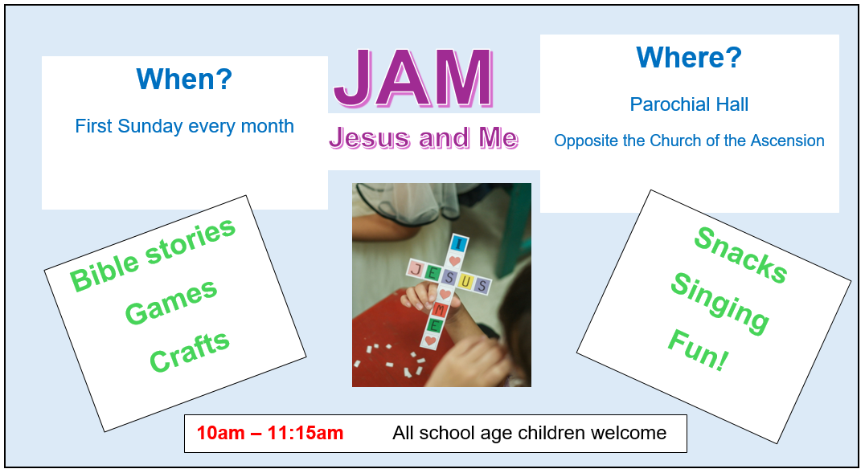

**Beginning on Sunday 7 September Children’s Activity on a Sunday in Annahilt JAM (Jesus And Me) will resume following the Summer Break.**

**JAM** (Jesus and Me) normally meets on the **FIRST** Sunday of each month beginning at 10.00 am and finishing at 11.15 am. On this Sunday parents and guardians are invited to bring children of school age **directly** to the Parochial Hall rather than to Church beforehand. The illustrated notice above lists some of the activities that will take place. We very much look forward to seeing our young people of school age at JAM on the first Sunday morning of each month. The First Sunday of the month has been specifically chosen in the hope that it is easy to remember!

On the second Sunday of each month young people are encouraged to come to the Family Service in Church at 10.00 am. On other Sundays in the month children are welcome at the usual Church Service at 10.00 am.

**Magherahamlet**

Sunday School will resume on Sunday 7 September at 11.00 am in the Parochial Hall.

We look forward very much to welcoming new attendees.

**From the Parish Registers**

**Christian Burials**

*‘In Christ shall all be made alive’*

**2 September 2025**

**Robert Thomas (Bert) Carlisle, formerly of ‘Rockorry’, 14 Glebe Road, Aughnaleck**

*Following Service in the Church of the Ascension, Annahilt burial took place in adjoining Churchyard*

In the Funeral address, The Rector said we had come together to remember and thank God for a dear Christian man whose faith in his Lord was strong, whose love for Ruth, his devoted wife of 64 years was so obvious, and whose friendship was endearing.

At Bert’s request, some of the most comforting words of Holy Scripture were read during the Service, ‘Peace I leave with you, my peace I give you’. There was a peace today, a release even. No longer was Bert struggling against a debilitating illness, but instead is enjoying the freedom of a peaceful eternity. The Lord has a home prepared for those who love him. It's the home we were meant for as believers. It's Bert Carlisle’s' home now and it's a perfect home, freed from the pains of this life.

Bert was born on 4 February 1939 and brought up in Stewartstown, Co Tyrone. He was educated at Howard Memorial Primary School, Moygashel and Dungannon Technical School, and went into employment at 14 years of age. He was exempted from preliminary examinations of Institute of Cost and Works. He became an Accountant through references and subsequently studied for a period of 2 years but (and he would have been very open about this) did not undertake any examinations.

From 1953 to 1959 Bert was employed by Stevenson and Sons Ltd, Moygashel as Office Junior and then as Wages Clerk, moving on at this own request in September 1959 to Glass fabrics, Dungannon, where, for a year he also served as Wages Clerk.

From September 1960 to June 1963 Bert served in Elliott Equipment Ltd, Lisburn as Assistant Cost Accountant and Office Manager. He left due to the impending closure of the Company.

From June 1963, he was employed for 34 years by Calor Gas Northern Ireland Ltd initially as Office and Accounts Manager, from 1970 as Administration Manager, from 1975 as Operations Manager and Chief Executive of Dungannon Gas Compamy. In 1980 he was appointed to the Board as Operations Director and in 1984 as Sales and Marketing Director He took over as General Manager in 1989 and ultimately as Managing Director 1n 1990, a position he occupied for 7 years until he retired on medical grounds in 1997. However, he retained the positions of Non-Executive Director of Northern Ireland and Calor Teoranta Republic of Ireland Boards.

Throughout his entire working life Bert was a trusted Employee, a person of the highest integrity.

Following their marriage on 6 June 1961on 6 June 1964 in Annaghmore Parish Church. Bert and Ruth settled on Glebe Road, Aughnaleck. Their home was an ‘open one’ and they were a very welcoming and hospitable couple. They joined the Parish of Annahilt where they became devoted attendees of worship in the Parish Church. They were particularly faithful communicants (and continued to receive the sacrament while in care when they were no longer able to attend Church). They were very supportive of Annahilt’s link with Magherahamlet Parish particularly when the Choirs of the two Churches came together to lead the music on special occasions. Bert was a very enthusiastic Choir member. Traditionally on Good Friday evening there were 2 simultaneous services in both Annahilt and Magherahamlet, the only occasion in the year when this happened. At one stage a Magherahamlet parishioner suggested that as the two congregations were together at services throughout Holy Week perhaps, we should consider staying together on Good Friday. The Rector mentioned this at Annahilt. The suggestion was warmly welcomed and it was Bert who then said that the first year we do this, the service should be in Magherahamlet. There began a very happy precedent which continues to this day of one Good Friday Service alternating between both Churches every other year.

Bert was a founder member of the local Youth Club and over many years was faithful and dedicated member of the Select Vestry, Chairman of the Finance and Development Committee (which oversaw the purchase of the present Rectory). In earlier years he was keenly involved in the organization of the Parish Bar-B-Q. Later, he was synonymous with the organization of the Parish Burns Night, a fund-raising event which ran for ten successive years and was always a great financial and social success. With his extensive contacts he ensured that significant items were gathered beforehand for auction on Burns Night. He also invited various friend and acquaintances to the event who he knew could have been relied upon to make worthwhile bids!

Bert also served as a Parochial Nominator, being one of the four parochial representatives who was involved in the appointment of the present Rector.

As hobbies Bert embraced Photography, Game Shooting, Fishing and Wildlife Art. At any event or function prior to the development of digital technology, Bert was always on hand with his cameras. He must have produced literally thousands, even tens of thousands of photographs of the highest quality over the years. Bert was sometime Chairman of Game Conservancy Northern Ireland Branch and Deputy Chairman of North Atlantic Salmon Trust, Northern Ireland Branch. He served on Boards and Committees associated with both of these very worthwhile causes which have raised substantial sums of money over the years.

In 1994 Bert was responsible through his position of MD Calor for spearheading a major charity initiative in aid of Save the Children by sponsoring four employees to run in the New York Marathon. By so doing, in excess of £10,000 was raised.

Bert loved his cars. One Sunday in beautiful weather our two parishes came together for a joint Children’s Day Service which was held at Larchfield. Bert and Ruth turned up in his open topped sportscar. So many came over for a good look! Bert was delighted…Ruth was mortified!

Both Bert and Ruth loved dogs, breeding and rearing many. A particular favourite was ‘Lady Di’.

Away from home, Bert & Ruth travelled extensively but their favourite spot was The Cotswolds where they holidayed every year.

Bert loved to laugh. He loved to poke fun at others, but he could take it in return.

Over the years Bert lived as ‘a man of the country’ and considered May his favourite month of the calendar year.

Our loving and caring thoughts are with Ruth, his brother Eric, his sisters Muriel and Ireen, his sister-in-law Hilary, his nephews and nieces, great nephews and great nieces, and the entire family circle to whom we extend our deep and prayerful sympathy.

**3 September 2025**

**William (Billy) Ritchie**

*Following cremation burial took place in Magherahamlet Churchyard*

**Flowers for the Churches**

**Annahilt Magherahamlet**

**September**

1 Mrs K Kingston

8 In memory of Bert Carlisle Miss V Begley

15 Mrs F Magorrian

22

29 Harvest



**Church Cleaning, Annahilt**

**Month**

**September**

5-6 Mrs S Chapman Mr S Chapman

12-13 Mrs L McCambley Mrs E Harrison

19-20 Mrs S Chapman Mr S Chapman

26-27 Mrs A Maxwell Mr R Maxwell

**October**

3-4 Mrs S Chapman Mr S Chapman

10-11 Mrs J Guiney Mrs H Cardosi

17-18 Mrs S Chapman Mr S Chapman

24-25 Mrs E Crawford

**November**

1 Mrs S Chapman Mr S Chapman

7-8 Mrs H Hill Mr T Hill

14-15 Mrs S Chapman Mr S Chapman

The number on the rota of volunteers who clean the Church of the Ascension has significantly declined. It would now be unviable except that one couple has offered to clean the Church every 2nd week.

**It really would be very helpful if there were additional volunteers who would ease the burden on those who already faithfully fulfil this important role. If you would be willing to help, please contact the Rector (Tel 028 9263 8218) or the Secretary to the Vestry, Colin Hassard (Tel 028 9263 8263)**

**Shankill-2-Shankill Fundraising Walk**

Congratulations to Archdeacon Mark Harvey, has completed his Shankill-2-Shankill fundraising Walk along the perimeter of Dromore Diocese. He received a great send-off from Shankill Parish and was joined by other walkers on the journey.

Mark, who is the rector of Shankill Parish Lurgan, walked the entire 100 mile circular route from Monday 18 August until Sunday 24 August. His original target was £15000 and this was surpassed, raising a total of £20500. £14000 will go to the **Reimagining Shankill Project** to restore and reorder the church, whilst **Fields of Life,** and **the NI Air Ambulance** will each receive £3000.  This is Shankill Parish Lurgan’s major fundraiser for this year, as parishioners continue to work hard to enable the restoration of their historic church.

**The route**

Starting at Shankill Parish Church in Lurgan, the route wound its way to Maghaberry via Aghalee. The second day was to Ballynahinch via Annahilt, and then day 3 on to Newcastle. Day 4 Mark went along the south Down coast to Kilkeel, then Warrenpoint via Rostrevor on day 5. Day 6 to Loughbrickland via Newry, and finally on day 7 back to Shankill via Scarva, Gilford and Portadown.

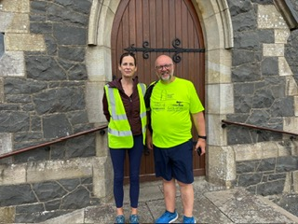

**Archdeacon Mark Harvey and one of his walking companions, Ruth, at Annahilt on Tuesday 19 August**

The inspiration for the route came from Mark’s role as Archdeacon of Dromore, and he stopped in different parishes along the way for rest and refreshment breaks.

Mark has been rector of Shankill for 8 years. Having turned 60 in late 2024, he sees this not simply as a fundraiser but also as a great way to improve his health and fitness!



Dear Members and Friends

We sincerely hope that you and your families have benefitted from the beautiful weather we have enjoyed over the past summer.

Members of both Brancheslook forward to meeting (on dates to be confirmed). Our aim for each evening will be to discuss and agree on a Programme of activities for the Mothers’ Union Branches for the remainder of 2025.

Our fondest thoughts are with Ruth Carlisle following the death of her dear husband Bert. We extend our deepest sympathy to her and to Bert’s brother Eric, sisters Muriel and Ireen, and the extended family circle.

With kind regards

Beth Avril & Sally

Esme Frances & Avril B

**MOTHERS’ UNION MIDDAY PRAYERS**

**SEPTEMBER THEME – THE POWER OF RECONCILIATION**

**Reflection for ‘The Power of Reconciliation’**

Sometimes it seems that our troubled world is immersed in the pain and suffering of conflict and broken relationships, yet Jesus reminds us that even though we are all less than perfect, every one of us is worthy of being redeemed, loved, and forgiven. As members of Mothers’ Union, there is hope and a desire to continue building a future of reconciliation, justice and peace in partnership with The Community of The Cross of Nails. “Being a part of the Community of the Cross of Nails affirms who we are at our core - a movement of men and women contributing to peace and reconciliation at all levels, from the fellowship of friendship over a cup of tea to conflict zones, Mothers’ Union members embody the spirit of what the Cross of Nails is all about.”

***(Lynne Tembey, former Worldwide President)***

**MONDAY - FORGIVENESS**

Heavenly Father, help us first to recognise our own failings and neglect to ‘forgive and forget', in order that unburdened, we may work towards a future free of resentment or animosity. We pray that in our healing we may be transformed and reconciled with you. Amen.

**Litany of Reconciliation**

All have sinned and fallen short of the glory of God. The hatred which divides nation from nation, race from race, class from class, Father, forgive.

The covetous desires of people and nations to possess what is not their own, Father, forgive.

The greed which exploits the work of human hands and lays waste the earth, Father, forgive.

Our envy of the welfare and happiness of others, Father, forgive.

Our indifference to the plight of the imprisoned, the homeless, the refugee, Father, forgive.

The lust which dishonours the bodies of men, women, and children, Father, forgive.

The pride which leads us to trust in ourselves and not in God, Father, forgive.

Be kind to one another, tender-hearted, forgiving one another, as God in Christ forgave you.

**TUESDAY – REDEMPTION**

Risen Lord Jesus, we come to you prayerfully, not because we have to, because we want to.

You came into our world to redeem us by your death and glorious resurrection. Each day may we remember what we are ashamed of and turn to you for forgiveness.

Change us, dear Lord, that we may remember what we are ashamed of and turn to you for forgiveness.

Change us dear Lord, may we be lights in the darkness and may we encourage and welcome people to enter our wondrous worldwide fellowship of Mothers’ Union, loving both God and neighbour. Amen.

**WEDNESDAY – EMPOWERMENT**

Hebrews 12:14. Make every effort to live in peace with everyone and be holy; without holiness no one will see the Lord. Loving Lord, help us to remember that we are all created in your image. Empower us to look for you in all others and especially in those that are different from us. Aiming to love our neighbour, help us to learn to live with the differences and to celebrate and cherish our diversity. Amen.

**THURSDAY – HOPEFULNESS**

Psalm 33:22. May your unfailing love be with us, Lord, even as we put our hope in you. Loving Lord, we thank you for your love for each one of us and the hope that we have in you. As we seek to share that love and that hope in our own communities, we pray that others will be drawn to you and the transforming power of your love. Amen.

**FRIDAY – RECONCILIATION**

O Lord, you have searched me out and known me; you discern my thoughts from afar. Such knowledge is too wonderful for me, so high that I cannot attain it. (Psalm 139) But I know that you have reconciled us through the cross of our Lord Jesus which has restored our broken relationship and brought justice and peace into our lives. Amen.

**SATURDAY – JUSTICE AND PEACE**

Amos 5:24. But let justice roll on like a river, righteousness like a never failing stream! Compassionate God, be with us all as we hold out hands of blessing to our Mothers’ Union family wherever they may be, and hands of reconciliation and peace to those in need whatever their circumstances. Amen.

**FINAL BLESSING PRAYER**

Be kind to one another, tender-hearted, forgiving one another as God forgave you and may God’s blessing be with you as you journey on in faith and trust. Amen

**Ongoing works around Annahilt Parish Hall.**

Over the summer months, considerable work has been undertaken in Annahilt Parish Hall. Re-pointing the exterior of the old kitchen; elimination of damp between the new kitchen and main hall (lower level in area of the hatch); replacement glazing in kitchen; damp proofing and lining the internal walls of the old kitchen; new kitchen units and worktop on hatch wall in kitchen; replacement of four “old style” windows in the old kitchen, hall beside boiler room, boiler room and ladies toilet; new external doors in old and new kitchen; and internal painting of hall, toilets, foyer, new kitchen and old kitchen. There are some other minor items also to be completed. As we enter the last week of August, it is hoped that the windows and kitchen units will be fitted and complete and the painter will be able to start in the first few days in September.

Activities commencing in September may have to work around the painter’s schedule!

Thanks to those parishioners who volunteered for work parties clearing the hall in preparation for the builder starting and those who assisted with the first “clean” on 25th & 26th August. A further major clean plus washing all the crockery, etc will be arranged once the painter is finished.

The estimated cost for the whole project is £30K, less a £1350 grant from Lisburn and Castlereagh City Council for a small part of the work. This work will help preserve the fabric of the hall for many years to come.

Thanks to Ivan Bradford and Patricia Halliday for organising the work beyond the main contract and the various work parties.

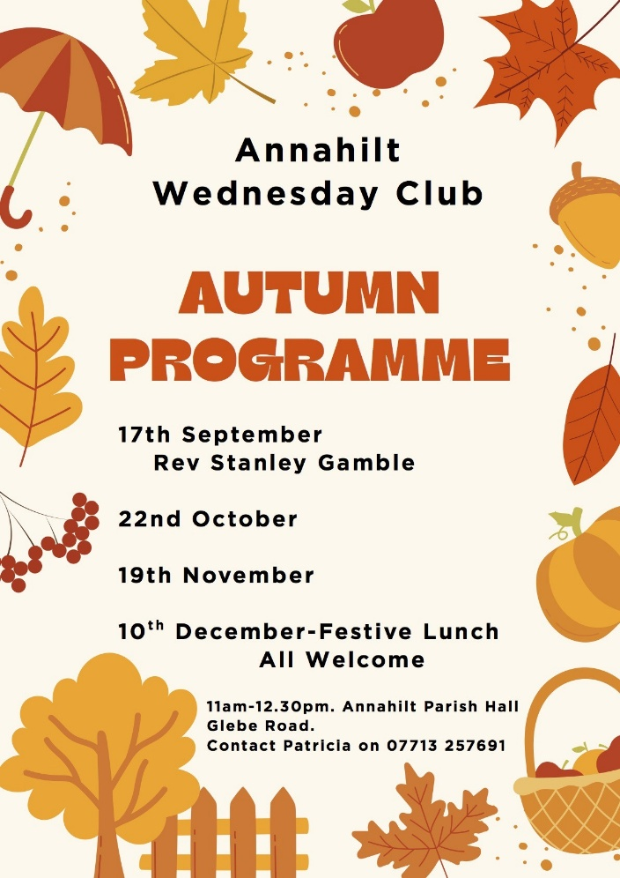

**Annahilt Wednesday Club**

Annahilt Wednesday Club will recommence on Wednesday 17th September (subject to negotiation with the painter!) at 11am. The Club is aimed at all Seniors and retirees in the community, for a morning of coffee/tea, scones and craic, making new friends, with either a speaker or some fun and games. Admission is free. Donations towards expenses welcome. Our guest speaker in September will be Padre Stanley Gamble who will talk about his time as a Padre to the United Nations in Cyprus. Padre Gamble is also known as Rev Dr Canon Stanley Gamble, Rector of Killinchy Union and a native of Lisburn.

Future dates: 22nd October, 19th November & Festive lunch on 10th December.

Booking is only required for the Festive lunch. On other days just turn up for 11am -12.30pm. Queries to Patricia on 07713 257691.



**Vintage Afternoon Tea Fundraising event**

On Saturday 18th October 2025, Annahilt Parish is holding a Vintage Afternoon Tea fundraising event for Parish Funds. Plans are progressing well and we will shortly be in contact with Parishioners looking for support in at least one of a number of ways:

· Supplying sandwiches

· Supplying “home baked” pastry or traybakes

· A donation towards the necessary expenses

· Purchasing tickets for the event for themselves and their friends

Admission to the event is ideally by ticket. Ticket sales in advance will assist with determining amounts of food required, however we will not turn anyone away on the day.

Contact Patricia for tickets on 07713 257691 or other members of the committee (see July/Aug mag)

In addition to the above we are seeking the loan of three-tier cake stands, and china, delph or good stainless steel tea pots and coffee pots/cafetieres. If anyone has any such items that they would be prepared to lend us for the day, please contact Patricia by 15th September.

**Annahilt Parish Bowling Club**

The Bowling Club is scheduled to resume on Wednesday 17th September 2025 at 8pm in the hall.

Again, subject to negotiation with the painter. Anyone interested in coming along to learn a new sport or pick up something they haven’t done for a while will be very welcome. We meet most Wednesday evenings and some Saturdays, though League matches are both home and away and away matches could be on any evening Monday – Friday. All welcome. Contact Patricia on 07713 257691.



**Lunch Club**

Annahilt Lunch Club continues to meet in The Pheasant Restaurant on the last Friday of every month (except December) at 12.30pm.  
The autumn dates are:  
26 September 2025  
31 October 2025  
28 November 2025  
  
The Lunch Club is very informal and gives retired and semi-retired members of the local community the opportunity to enjoy fun and friendship over a light meal.  
  
Please contact Violet Swarbrigg (07866914651) for further information or just come along as everyone will be made very welcome.

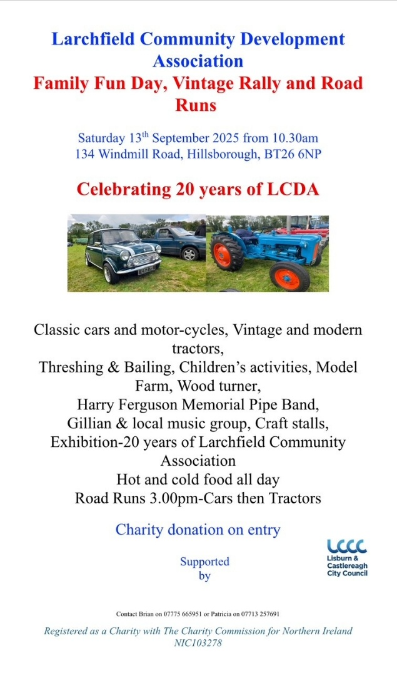

**Larchfield Community Development Association event Saturday 13th September 2025**

The annual Family Fun Day, Vintage Rally and Road Runs for tractors and cars will take place on 13th September at 134 Windmill Road, Hillsborough, BT26 6NP.

This is always a great day out for all the family. Donation on entry for charity. All welcome.

**Walks in grounds of HRP Hillsborough Castle**

Anyone can join with us in these walks kindly accommodated by an invitation from Larchfield Community Development Association. Next date is Wednesday 24th September, meeting at 11am at the reception area off the A1 car park. Contact Patricia on 07713 257691.

**LISBURN FOODBANK**

The Lisburn Foodbank is providing an essential service to those within our community who are experiencing difficult times, often due to circumstances beyond their control.

The Foodbank provides emergency food and support to local people in crisis in the Lisburn area.

Parishioners may leave items for the Foodbank in the basket in Annahilt Church Porch, on the FIRST and SECOND Sunday of each month.

A particular request from the Foodbank is for cleaning items such as:

* Fairy Liquid
* small packs of toilet roll
* large nappies (sizes 6 and 7)
* baby wipes
* shower gel
* soaps
* washing powder

**YOUR HELP WOULD BE GREATLY APPRECIATED**.

**Parish Website:  AnnahiltAndMagherahamlet.org**

Parishioners are reminded that the website [annahiltandmagherahamlet.org](http://annahiltandmagherahamlet.org/) has been created to provide information on church related activities and organisations for parishioners and the wider community. The website also continues to host online services each Sunday. In addition, the website contains a list of upcoming church services and news from our group of parishes, as well as downloadable versions of the parish magazine.  The site will be continually developed, so if you have any submissions, suggestions or requests relating to the website, these can be sent to [admin@annahiltandmagherahamlet.org](mailto:admin@annahiltandmagherahamlet.org).



[www.annahiltandmagherahamlet.org](http://www.annahiltandmagherahamlet.org)

**Parish Magazine**

Any contributions for the next edition of the Parish Magazine should be left with the Rector or Roger Maxwell ([roger.maxwell1@btinternet.com](mailto:roger.maxwell1@btinternet.com)) by Sunday 28 September 2025.

Registered as a charity with The Charity Commission for Northern Ireland

NIC103246 (Annahilt) and NIC102122 (Magherahamlet)