News from the Parishes
Church of the Ascension, Annahilt Magherahamlet Parish Church
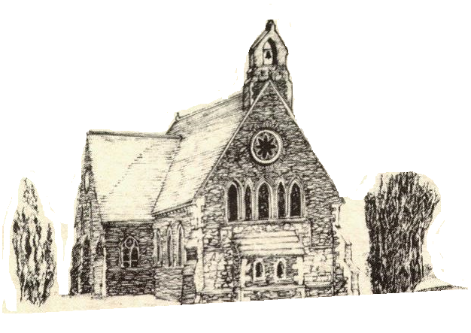

December 2022 and January 2023

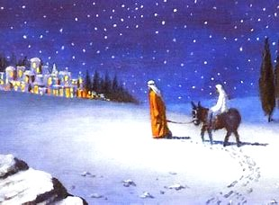

Rector: The Revd Canon Robert Howard
15 Ballykeel Road, Hillsborough
BT26 6NW
Tel: 028 9263 8218
E-mail: jrobert.howard@btinternet.com
Website: www.annahiltandmagherahamlet.org

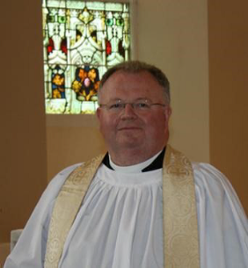The Rector writes….

My dear Parishioners

Are you ready for Christmas? This is such a busy time of year – cards to write, presents to buy and wrap, , let alone the tree and decorations as well as the food and the family and other people with whom we make contact, and perhaps only connect with once a year. And it all needs preparation. The supermarkets start preparing for Christmas almost as soon as the summer holidays are over: they replace the aisles of barbecues with tinsel and baubles. The Church also has a particular season set aside for preparing – we call it Advent. Advent in the Church starts four Sundays before Christmas, so this year it began on 27 November. This is not intended as a tinsel-filled celebration time. Rather, it is a time of penitence, of self-denial.
The preparation we need as Christians for Christmas is nothing to do with cards or wrapping paper. Instead, it is everything to do with being ready to receive Christ into our world, into our lives. For the Christ-mas that we celebrate on 25thDecember is the coming of God into the world as a human being. It is the birth of Jesus, the only Son of God, as a human baby. The scandal is that this Messiah was not born in a royal palace or somewhere of great splendour, but as we know in a dirty, smelly stable.
The account of the Nativity is a tremendous one, that points us to the real reason for the season – the wonder that God chose to become a human being out of love for us. Jesus is God’s love embodied in flesh. And that love was not only shown to us in the way that Jesus lived among people in Galilee 2000 years ago, the way he walked around, the things he said, the miracles he performed. God’s love was fully demonstrated in the way Jesus died – the way he was totally unfairly executed on a cross, as if he were some sort of criminal – and then when he was raised to life three days later. We only understand the enormity of God’s love embodied in Jesus, born at Christmas, if we look to the events around Easter.
We cannot begin to understand why Jesus was born, without understanding that God gave him to the world, to die on a cross for our sins, so that he would rise from the dead on the third day, to provide us with a way to forgiveness for sins. There has never been a time in all of human history, either before or since, when God had reached out in the same way to save his people. The first Christmas is a once and for all event. This is the moment when salvation for humankind came to be.
Therefore, in Advent we prepare as a Church for that time of great celebration, but also as church members, we prepare our hearts to be ready to experience God’s love and his forgiveness afresh, as he comes to us in the Christ-child. Ideally, Advent is a time to have some quiet reflection, to clear away all that clutters up our minds, and to make space within ourselves, for God’s love in Christ to come to us in a new and fresh way.
‘Quiet’, ‘space’, ‘uncluttered’, are all words that seem to be almost the opposite of what often happens in the run-up to Christmas. That is where our approach as a Church is in contrast to the rest of our society. In order to help us find this space, I encourage you to spend at least some time in silent prayer or in contemplation. It requires no words, no ‘techniques’ – quite the opposite – and can be a most rewarding and moving form of prayer. Even if you have never tried anything like this before, I urge you to try it: as one part of your preparation for the coming of Christ into the world and into our lives this Christmas.
How ever we prepare ourselves for the coming of Christmas, may we each one of us be prepared to know Christ born within our own lives, and to know his forgiveness, and his resurrection power at work within us.
I wish you all an enriching and fulfilling Advent, a peaceful and blessed Christmas and a hopeful New Year.

Your sincere friend and Rector

Robert Howard

Thank you……
….to all who contributed to Magherahamlet Harvest Appeal. £1665 was raised.
…..to all who contributed to recent special collections for the Poppy Appeal
Annahilt £312.78
Magherahamlet £145.00
….;to all who in any way supported the Christmas Fair in Annahilt. To date £2800 has been raised.
…..to all the various volunteers who have assisted in the Church cleaning, as well as all who provided flowers for the Churches during the past year.
The cleanliness of the Churches for public worship does not go unnoticed and is much appreciated by all, especially during present circumstances.
The floral arrangements which are given each week are also valued and admired by all who worship in both Churches.
….to Colin Robinette and William Mathers for their ongoing assistance in the online transmission of Services.

Congratulations…
….to James Finlay, Annahilt on his recent marriage to Michelle Herron. We wish both James and Michelle every happiness.
…..to Rachel Crawford, Annahilt on her engagement to Otto Jimenez

The season of Advent
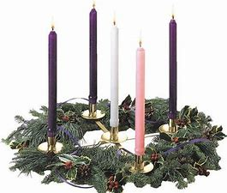‘Advent’ means ‘coming’ and marks the four weeks leading up to the celebration of the Nativity and the coming of Christ. It is traditionally a season of penance and preparation before Christmas. The official Church liturgical colour is purple, a symbol of penitence. Weddings used to be forbidden during this season, as they once were during Lent.
Tradition has given its own flavour to each of the Advent Sundays. The Sunday next before Advent was known as ‘Stir up Sunday’, so named because it was the day for ‘stirring up’ Christmas puddings. The second Sunday was known as Bible Sunday when our focus was on the reading, preaching and distribution of God’s Word as revealed in the books of the Bible. The third Sunday is the ‘Gaudete’ Sunday from the Latin word for ‘rejoice’. On that day everyone took a break from the penitential theme. A rose coloured candle is lit on this Sunday.
In our Churches an Advent wreath is often among the decorations made with evergreen branches such as holly, yew or pine. The four Advent candles are fixed into the wreath along with a white candle which represents the Light of Christ coming into the world at Christmas.
Advent calendars are still popular today, usually a card with twenty-four small doors, one to be opened each day from the first day of December until Christmas Eve. Each door conceals a picture, which originally had biblical themes. Every morning children open one door to see a pretty picture or find a chocolate inside. This popular tradition arose in Germany in the late 1800s and soon spread throughout Europe and North America.

CHRISTMAS TREES – WHAT’S THAT ALL ABOUT?

We may well wonder why are Christmas trees so special?
The tradition of having Christmas trees originates from a few different cultures but generally they were thought to bring good spirits to the household and keep bad ones away. Christmas trees were first believed to have been introduced to the UK in the 1800’s, though some think it could have been earlier than that. Many think Prince Albert, Queen Victoria’s consort, was responsible for bringing an evergreen tree over from Germany which he put it up at Windsor Castle, creating a custom that has lasted over 100 years.
Are there different types of Christmas tree? Yes, many! Nowadays the most popular Christmas tree is probably the Nordmann Fir. It has very soft needles that are easy to decorate, and so ideal for families with young children. Traditional Christmas trees tend to be Norway Spruces- usually seen in Churches, also outside 10 Downing Street and at other locations around Whitehall and Westminster as well as in hotels and at civic buildings and shopping thorough fares throughout the country as they are the largest variety of Christmas trees. Noble firs (which have cones) are also prized for their perfect conical shape, centred foliage, silvery-blue colour and pleasant scent. Some other common types are the Korean and Fraser fir, which both have cones, a nice shape and a pleasant scent, one being slightly lighter in colour than the other.

What is the best way to look after them?

Christmas Tree farmers suggest leaving your tree outside for as long as possible, taking the net off so the branches can ‘open’, and cutting around an inch off the trunk, which will draw more water into the tree. Basically, we ought to treat it like a cut flower! If we do, there is every possibility that the average Christmas tree should last until the New Year.

What is the best way to buy them?

There are no hard and fast rules. I chose to buy mine at a Christmas tree farm, where I was able to pick my own tree and have it cut down straightaway. At the time of writing, the Christmas Tree for the Church of the Ascension, Annahilt has been freshly cut at Larchfield and delivered. This is a tradition going back very many years and we are deeply grateful to Gavin and Sarah Mackie for continuing it. The tree at Magherahamlet will be erected and decorated in the coming days.

Is a real Christmas tree better than an artificial one?

An artificial tree is very convenient but I would miss the scent; especially when it’s damp or with the heating on because that will allow the sap to rise to the surface.

How should we dispose of our tree when Christmas is over?

If possible, let us find somewhere that will recycle it.

THE LITTLE PRINCE

The Little Prince is a timeless and classic story or even fable, which appeals to the child within us all, and encompasses themes such as friendship, love, isolation, and human empathy. In many ways the tale is paradoxical, appearing at first sight to comprise a simple children’s book, but at the same time possessing an underlying deeper meaning, and an almost mythological symbolism, directed towards adults.
The book begins with a summary of the differences in perception between children and adults, and how many adults often fail to perceive important things, while some can see through a child’s eyes and have imagination. This is a central theme throughout the remainder of the story. The plot describes how an aircraft pilot (the narrator), becomes stranded in the barren Sahara Desert, when his aircraft engine suddenly breaks down and he crashes, and is befriended there by a young boy, the Little Prince, who comes from another planet, and whilst the pilot attempts to make the necessary repairs, the Little Prince tells the pilot the story of his life.
The Little Prince has travelled from an Asteroid called “B612”, which is “scarcely larger than a house,” and which was discovered by a Turkish astronomer in 1909. The Little Prince describes his Asteroid, as well as his profound love for the beautiful and enchanting solitary rose in his garden. The Little Prince then goes on to tell the pilot, stories about the characters he has met on his travels, each teaching him a valuable lesson or secret. For example, the Little Prince meets a fox who wants the Little Prince to tame him, and by being tamed, the fox becomes special, and different from other foxes, just like the rose which the Little Prince loves back in his garden on the Asteroid becomes special as she is the object of the Little Prince’s admiration and adoration.
As the story progresses, the Little Prince becomes sad over his recollections, and seeks to return home to see the rose on his Asteroid again, who has somewhat taken the Little Prince’s love for granted; but the Little Prince has since learned he was too young to know how to love her.
The Little Prince then tells the pilot that he must reluctantly say farewell and when he leaves it may look as if he has died, as his body is too heavy to take with him, but this is not the case. The underlying theme of the novella is the overriding importance of love: The Little Prince initially finds the love of his rose too challenging through his lack of insight, and leaves to explore the galaxy in search of self-knowledge. The story is fantastical but also has a certain logic when seen through the imagination of a child, but also there is an element of an as yet untold story that the reader’s imagination and interpretation must provide. Given that the story was published in 1943, amidst the Second World War, it appears that the author is also seeking de-politicise human emotion, and to raise the importance of love and empathy as paramount and uniting factors. The Little Prince is a beautiful and engaging moral allegory to remind adults through a child’s eyes of what counts in life, the need for open mindedness and curiosity, and as the fox tells the Little Prince, “One sees clearly only with the heart. Anything essential is invisible to the eyes.”

The True Gift of Christmas

The gifts I’d leave beneath your tree
Aren’t those that you can touch or see,
No toys meant just for pointless play,
But gifts to bless you every day.
The gift of friendship warm and true,
Is one that I would leave for you.
Good health and happiness and cheer
To keep you smiling through the year.
The gift of peace that comes from God,
With prayer to guide each path you trod.
And when your heart has lost its song,
The gift of hope to cheer you on.
These are the gifts I’d leave for you.

Kay Hoffman

Once in a Manger

Once in a manger, a long time ago,
Before there was Santa and reindeer and snow, A star shone down on humble beginnings below Of a baby just born who the world would soon know.
Never before had there been such a sight.
Would the Son of a King have to suffer this plight?
Are there no armies to lead? Are there no battles to fight?
Shouldn't He conquer the world and demand His birth right?
No, this frail little infant asleep in the hay
Would change the whole world with the words He would say.
Not about power or demanding His way, But mercy and loving and forgiving God's way.
For only through humbleness would the battle be won, As shown by the actions of God's only true son.
Who gave up His life for the sins of everyone,
Who saved the whole world when His journey was done.
Many years have now passed since that night long ago
And now we have Santa and reindeer and snow
But down in our hearts the true meaning we know, It is the birth of that child that makes Christmas so.

Tom Krause

Gifts at Christmas
On Christmas Day, at the 10.00 am Family Service in Annahilt and at Parish Communion at 11.30 am in Magherahamlet, the young people attending are asked to bring with them a present which they have been given for Christmas. There will be an opportunity during the service to show their gift to the congregation and to say a prayer of thanksgiving.

Holy Communion in Church
There will be four celebrations of the Holy Communion in the Group of Parishes over the Christmas period.
There will be a SAID Communion Service on the Sunday BEFORE Christmas, 18 December, at the later time of 9.30 am. This may be of particular interest to those who usually attended the early celebration prior to its suspension at the beginning of the Pandemic. In present circumstances it may also suit those who prefer a shorter and ‘quieter’ act of worship.
On Christmas Eve, 24 December at 11.15 pm the First Communion of Christmas will be shared with the Minister and Congregation of Legacurry Presbyterian Church.
On Christmas Day, 25 December at the earlier time of 11.30 am the Parish Communion of Christmas Day will be celebrated in Magherahamlet Parish Church.
On New Year’s Day, 1 January 2023 there will be Parish Communion in Annahilt at 10.00 am and in Magherahamlet at 12.00 noon.

Private Communion at Christmas
Any parishioners who are ill or housebound or who in present circumstances are not in a position to attend church and would like Holy Communion in their own home before Christmas should contact the Rector who will only be too pleased to make the arrangements. Tel 028 9263 8218.

Vocation Retreat

As part of its commitment to develop ministry, and endorsed by the House of Bishops, the Commission on Ministry is organising a Vocation Retreat in Dromantine Retreat Centre from Friday 27 January – Sunday 29 January 2023. The retreat is one of a series of events to encourage vocations to the ordained ministry within the Church of Ireland.
The word “vocation” means calling. It is a dialogue in which God calls and we listen. Each of us is unique and God calls each one of us in a unique way. In the Church of Ireland ordained ministry is a particular calling to ministry, one which as a church we value highly.
For some the calling to ordination is a moment of decision, for others it is a lengthy process, extending over months and years. We may hear a gentle voice inside us asking questions or we may be prompted by others asking questions of us. What is important is that we take time to listen to God’s voice. One way in which we may allow God to speak to us about vocation is to attend a retreat where we can meet with others who have heard and responded to that call or to meet with those who are questioning their own sense of vocation.
This retreat is for those who may just be beginning to ask whether God is calling them to the ordained ministry. It is also for those who may be further along the road. Wherever you are on the journey, coming to a retreat to hear others talk about their experiences, learning what that might mean for you personally and practically and, above all, allowing God to speak to you, may just clarify that decision for you. The retreat will be a mixture of informal talks, practical guidance, discussion and times of quiet, all held in the beautiful surroundings of Dromantine Retreat and Conference Centre, which is situated just outside Newry on the A1.

Guest Speaker: Bishop Jill Duff

Jill has been Bishop of Lancaster, a Suffragan Bishop in the Diocese of Blackburn, from June 2018. She is a sought–after conference speaker with a particular interest in enabling people to identify their calling and enter into the fullness of everything that God has for them. Prior to becoming Bishop, Jill served as Vocations Development Advisor in the Diocese of Liverpool and then as the first Director of St Mellitus College, North West.
Throughout the retreat there will be times of worship and times for silence and personal reflection. There will also be opportunity for informal chats with members of the clergy and members of the Commission on Ministry.
Cost: Participants are asked for a contribution towards costs of €75/£65. The retreat is financed through the Commission on Ministry.
If you are interested in attending and would like to know more, please contact Judy Peters at judith.m.peters@gmail.com
To make a booking, please fill out this booking form (in Microsoft Word format) and email to nicole.gallagher@rcbdub.org by Friday, 23 December 2022.
Payment can be made electronically through the Representative Church Body, and banking details will be made available on receipt of the booking form.
‘Now these are the gifts Christ gave to the church: the apostles, the prophets, the evangelists, and the pastors and teachers. Their responsibility is to equip God’s people to do his work and build up the church, the body of Christ.” Ephesians 4 v 11–12

Church Services in the Parishes of Annahilt and Magherahamlet

‘I was glad when they said to me: “Let us go to the house of the Lord”’

Sunday 4 December Advent II
Bible Sunday
10.00 Parish Communion Annahilt
12.00 Parish Communion Magherahamlet

Sunday 11 December Advent III
10.00 Children’s Christingle & Gift Service Annahilt Service Sheets
12.00 Morning Prayer Magherahamlet

Sunday 18 December Advent IV
9.30 am Holy Communion Annahilt
10.00 No Service Annahilt
11.30 am Festival of Nine Lessons & Carols Magherahamlet Service Sheets
3.00 pm Festival of Nine Lessons & Carols Annahilt Service Sheets
Followed by seasonal refreshments in the Parochial Hall
Saturday 24 December Christmas Eve
11.15 pm The First Communion of Christmas Annahilt
with the Minister & Congregation of Legacurry Presbyterian Church
Preacher: The Revd Bobby Liddle
Sunday 25 December Christmas Day
10.00 Family Service Annahilt Service Sheets
11.30 am Parish Communion & Holy Baptism Magherahamlet Service Sheets
Saturday 31 December New Year’s Eve
7.00 pm United Watchnight Service Legacurry Presbyterian Church
Preacher: The Rector

Sunday 1 January 2023 Christmas II
10.00 Parish Communion Annahilt
12.00 Parish Communion Magherahamlet

Sunday 8 January Epiphany I
10.00 Family Service Annahilt Service Sheets
12.00 Family Service Magherahamlet Service Sheets

Sunday 15 January Epiphany II
10.00 Parish Communion Annahilt
12.00 Morning Prayer Magherahamlet

Sunday 22 January Epiphany III
10.00 Morning Prayer Annahilt
12.00 Morning Prayer Magherahamlet

Sunday 29 January Epiphany IV
World Leprosy Day
10.00 Morning Prayer & Litany Annahilt
12.00 Morning Prayer & Litany Magherahamlet

Sunday 5 February Presentation of Christ in the Temple
10.00 Parish Communion Annahilt
12.00 Parish Communion Magherahamlet

PRAYER WARRIOR
Do you have a concern or problem and would like someone to pray for you?
If so, contact the Rector who will be willing to help.
This is completely confidential and no details will be passed on to anyone else unless you want them to.
028 9263 8218

Flowers for the Churches
Annahilt Magherahamlet
December

4
11 Mrs B Harrison Mrs F Magorrian
18 Mrs B Harrison The Rector
25 The Rector The Rector

Church Cleaning, Annahilt
December
2-3 Mrs J Guiney Mrs H Cardosi
9-10 Mrs E Ogle
16-17 Mrs J Bolas Mr A Bolas
23-24 Mrs A Maxwell Mr R Maxwell
30-31 Mrs H Hill Mr T Hill

January

6-7 Mrs L McCambley Mrs E Harrison
13-14 Mrs E Crawford
20-21 Mrs J Guiney Mrs H Cardosi
27-28 Mrs E Ogle

February
3-4 Mrs J Bolas Mr A Bolas
10-11 Mrs A Maxwell Mr R Maxwell
17-18 Mrs H Hill Mr T Hill
24-25 Mrs L McCambley Mrs E Harrison

March
3-4 Mrs E Crawford
10-11 Mrs J Guiney Mrs H Cardosi

With the closure of direct services in the local area, five experienced Social Workers last year set up a not-for-profit Community Interest Company called STARNI to continue providing support to children and families impacted by sexual abuse. STARNI is based in Millennium Court Arts Centre in Portadown. Our mission is to create a safe and nurturing environment where children feel comfortable and safe enough to explore their thoughts and feelings.
STARNI has now been running just over one year. They are continually working with more children and would love to be able to give them Christmas gifts with our support.
This year, at the Christingle Service in Annahilt and at the Carol Service Magherahamlet we are asking whether you might consider donating a gift which should be new, wrapped and with some indication of the age of the child for whom it is intended. Alternatively, if you would like to donate the money you might have otherwise spent on a Christmas gift, this would go directly to the running costs of STAR NI and would greatly assist us as they keep the company up and running.
If you would like to know more about STARNI, you can find the organisation on Facebook and Instagram. Representatives are looking forward to meeting you when they attend the Christingle Service on Sunday 11 December at 10.00 am in Annahilt and the Carol Service on Sunday 18 December at 11.30 am in Magherahamlet. As always, STARNI thank you so much for you your ongoing support, it is greatly appreciated and makes a big difference.

Dear Mothers’ Union Members and Friends,

In the run-up to Christmas it is great that both our Branches have been able to gather in person as we anticipate and look forward to a more upbeat celebration of the Festival without the restrictions of recent years.
In November, you all displayed considerable creativity at the Christmas Workshops in both Branches. These were also great ‘fun’ evenings which were much enjoyed by all who participated.
The December Christmas Party in Annahilt and the Magherahamlet Parcel Night also went very well. We were delighted on both occasions to have Aubrey Campbell and members of the Baillies Mills Accordion Band who led us in carol singing and gave an illustrated presentation of the Band’s activities over the years. We thank them for their input and the time they spent with us at a very busy time of the year.
We wish you all a very peaceful Christmas and every blessing in 2023
With very kind regards

Beth Avril
Esme Ann

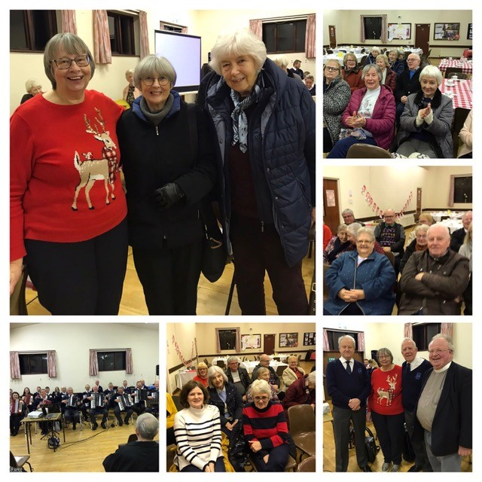

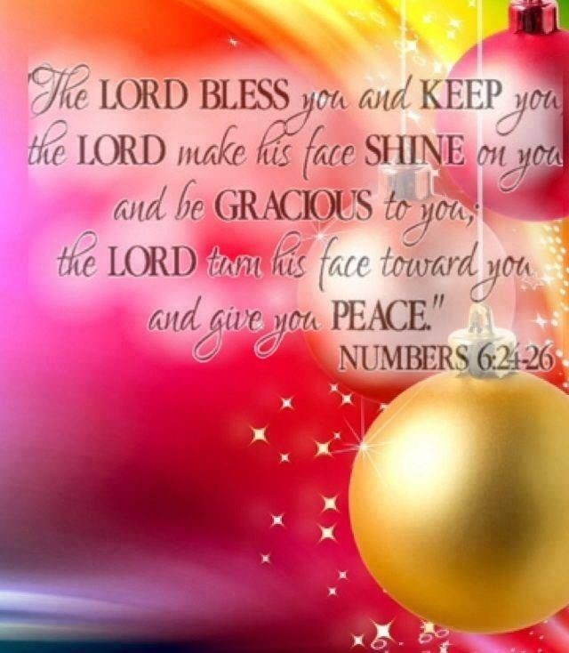

Mothers’ Union - Midday Prayers - December 2022 Season of transformation

Monday: Advent transformation
For God so loved the world that he gave his one and only Son, that whoever believes in him shall not perish but have everlasting life.
John 3:16
In this moment of Advent we turn from the gloom of uncertainty and look towards the dawning of light. With this gift of Advent we receive a way to give our lives to the Saviour of the world. Within this longing of Advent we find peace for our restless hearts as we travel to worship the new-born King. Before the door of Advent we stand assured of acceptance as we step through to meet our Messiah.
Through our relationship with Advent we experience God’s everlasting love as we marvel at the new-born Christ.
Amen.

Tuesday: Darkness to light
The people walking in darkness have seen a great light; on those living in the land of deep darkness a light has dawned.
Isaiah 9:2
Gracious God, we joyfully await the dawning of your Light, Jesus Christ.
May the radiance of his glory illumine the lives of those in darkness. May the flame of his holiness reveal the deeds of ignorance and evil. May the light of his word chase the shadows of guilt and despair. May the warmth of his love melt the winter of selfishness. Come to our world, Lord, and heal its wounds, shining in the darkness and restoring joy, faith, hope and love.
Transform us into a people of his light, that we may reflect your wondrous grace to our waiting world.
Amen.

Wednesday: Despair to hope
I wait for the Lord, my whole being waits, and in his word I put my hope.
Psalm 130:5
This Advent, as we wait for the Hope of the World we pray for God’s hope to transform the despair of loss and loneliness.
God of sure and certain hope, hear our prayer.
This Advent, as we wait for the Hope of the World we pray for God’s love to bring hope in the lives of our family and friends.
God of sure and certain hope, hear our prayer.
This Advent, as we wait for the Hope of the World we pray for God’s hope to transform our doubts and fears into faith.
God of sure and certain hope, hear our prayer.
Amen.

Thursday: Lamenting to rejoicing
Surely this is our God; we trusted in him, and he saved us. This is the Lord, we trusted in him; let us rejoice and be glad in his salvation.
Isaiah 25:9
Loving God, we rejoice in this season of good news and good will, we celebrate once more the birth of your Son, our Saviour Jesus Christ.
Prince of Peace, Lord of lords, we praise you!
For the wonder of this season, for its message of love and forgiveness, its promise of peace and justice, and the gift of life everlasting,
Loving God, we praise you!
We look forward to the day when the Jesus of Bethlehem will return as Lord of all.
King of kings, Lord of lords, with all creation, we will praise you!
Amen.

Friday: Injustice to righteousness
He will reign on David’s throne and over his kingdom, establishing and upholding it with justice and righteousness from that time on and for ever.
Isaiah 9:7
Lord Jesus, send your Holy Spirit upon our Christmas preparations.
We who are anxious over many things – look forward to your coming among us;
we who are blessed in so many ways – long for the complete joy of your kingdom;
we whose hearts are heavy – seek the joy of your presence.
Give us courage to be your people, to show your justice, grace, mercy, peace, and love, and to be a part of your transformation of our world until the day when the baby whose birth we celebrate comes again in peace and we sing your praise and glory forever.
Amen.

Saturday: Advent transformation
The Word became flesh and made his dwelling among us. We have seen his glory, the glory of the One and Only, who came from the Father, full of grace and truth.
John 1:14
Your Word, O God, has given us life; your Word incarnate gives us new life in the Easter promise.
May your Word transform this Advent season, dispelling the darkness of fear and mistrust; may your Word dwell among us always, awakening our hearts to your enduring love, justice and peace.
Jesus, Lord and Saviour, we thank you for this season of celebration; the renewal of your love for us that never fails. We pray for all your people that today even in the darkest corners your lamp may be lit and your light may shine giving joy and peace.
Amen.

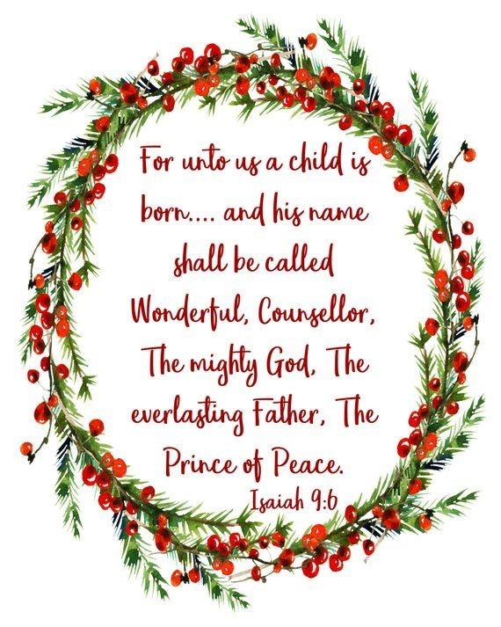

Finance Matters – Annahilt

Weekly Giving Envelopes
These are now available in Church. If you require yours to be delivered, please contact Patricia.
Monies to be included in the 2022 accounts must be with The Treasurer on or by 31st December 2022.
Gift Aid
If you are a tax payer you should be able to "Gift Aid" your giving to the Parish at no cost to yourself and the Parish benefits by an additional 25% on top of your giving.
If you are eligible to Gift Aid your giving, please contact Patricia. Likewise, if your circumstances have changed and you no longer pay tax, it is essential that we are advised so that we can cancel your declaration at the appropriate time.
Monthly Standing Orders/Direct Transfers
An increasing number of parishioners now find it more convenient to pay part or all of their giving by one of these methods and if you wish to discuss, please contact the Annahilt Treasurer, Patricia Halliday for this or any of the above items on Landline 028 9266 5310, Mobile 07713 257 691, E: patriciaapc@btinternet.com
Finance Matters – Magherahamlet
If you are a UK taxpayer, you can boost the amount of every donation you make by giving through “Gift Aid”. This is an Income Tax relief scheme created to help charities like our church get the most out of funds that they receive. Gift Aid enables the church to recover the base rate of tax on your donation. The scheme adds 25 pence on each £1.00 you give at no extra cost to you.
We would ask all taxpayers who give to parish funds to give through “Gift Aid”. All that is required is the completion of a “Gift Aid Declaration” form. If you have recently stopped paying tax then any existing Gift Aid declaration needs to be cancelled. Please contact the Treasurer, Hillary Edgar on 028 44811361 should you require a “Gift Aid Declaration” form or need to update an existing Gift Aid Declaration.

Annahilt Parish Bowling Club
The club resumed at the end of September and have played their matches in the first half of The Lisburn League season with mixed outcomes. We have welcomed some new faces to Bowling and some new members who are experienced bowlers. The Christmas competition is imminent, when we have a night of festive competitive bowling between our own members and round off the year with a festive supper. If anyone is interested, do please come along on a Saturday evening. (Contact Patricia).

LISBURN FOODBANK

The Lisburn Foodbank is providing an essential service to those within our community who are experiencing difficult times, often due to circumstances beyond their control.

The Foodbank provides emergency food and support to local people in crisis in the Lisburn area.
Parishioners may leave items for the Foodbank in the basket in Annahilt Church Porch, on the FIRST and SECOND Sunday of each month.
A particular request from the Foodbank is for items listed below:

Cleaning products
Nappies
Sugar
Tea
Coffee
Biscuits
Rice Pudding
Custard

YOUR HELP WOULD BE GREATLY APPRECIATED.
Parish Website: AnnahiltAndMagherahamlet.org
Parishioners are reminded that the website annahiltandmagherahamlet.org has been created to provide information on church related activities and organisations for parishioners and the wider community. Although circumstances have changed considerably since the various lockdown periods the website continues to host online services each Sunday. It also contains a list of upcoming church services and news from our group of parishes, as well as downloadable versions of the parish magazine. The site will be continually developed, so if you have any submissions, suggestions or requests relating to the website, these can be sent to admin@annahiltandmagherahamlet.org.

www.annahiltandmagherahamlet.org

Parish Magazine
Any contribution for the next edition of the Parish Magazine should be left with the Rector or Roger Maxwell (roger.maxwell1@btinternet.com) by Sunday 22 January 2023.

Registered as a charity with The Charity Commission for Northern Ireland
NIC103246 (Annahilt) and NIC102122 (Magherahamlet)
Top of Form

