**News from the Parishes**

**Church of the Ascension, Annahilt Magherahamlet Parish Church**

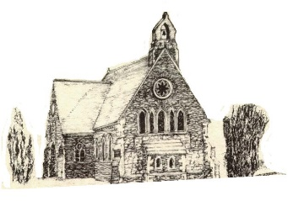 

**October/November 2024**

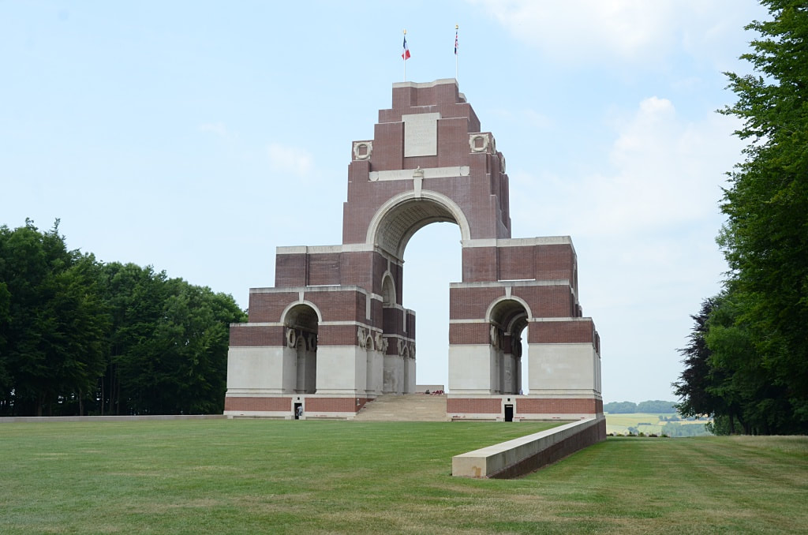

**Rector: The Revd Canon Robert Howard**

**15 Ballykeel Road, Hillsborough**

**BT26 6NW**

**Tel: 028 9263 8218**

**E-mail:** [**jrobert.howard@btinternet.com**](mailto:jrobert.howard@btinternet.com)

**Website:** [**www.annahiltandmagherahamlet.org**](http://www.annahiltandmagherahamlet.org)

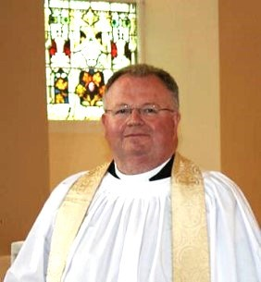

**The Rector writes…..**

My dear Parishioners,

November seems to be the month for remembering.

All Saints’ Day at the beginning of the month is a chance to remember with thankfulness those whom we have loved but see no more.

And, of course, there is also our national Act of Remembrance, on Remembrance Sunday, always observed on the second Sunday. I never fail to be moved as the poppies fall down from the roof of the Royal Albert Hall during the Festival of Remembrance on the night before.  That remembrance is all the more poignant in our own day as the reality of war and its human cost is once again apparent especially in Ukraine and in the Middle East.  There will be services at war memorials and in churches across the diocese and beyond as we remember those who died fighting to protect us and bring peace and justice to our world, and we pray for those serving in our Armed Forces today.

Memories, and remembering, are such central parts of our personalities and character, and in many ways make up part of who we are. Being remembered is very important to us, and the thought that we might be forgotten can be heart-breaking. I sometimes read these verses from Isaiah to people who are feeling lost and abandoned for any reason, or who are grieving the passing of years which means that all those whom they knew and loved, and who held the memories of them as younger people, have died:

*God says, “‘Can a mother forget the baby at her breast and have no compassion on the child she has borne?  Though she may forget, I will not forget you!**See, I have engraved you on the palms of my hands.” (Isaiah 49:15-16a)*

For Christians, of course, the most significant act of remembering is when we come together to remember in bread and wine the death and resurrection of Jesus.  Jesus’ willing sacrifice of himself on the cross for the sake of others is, for Christian believers, the ultimate expression of the self-giving love at the heart of God, when Christ’s hands were marked by the nails of the cross.

“Do this in remembrance of me.”

So in this season of Remembrance, as we remember with poppies, or bread and wine, may we all take time to pause, reflect, and be thankful.

With love, prayers and blessings

Your sincere friend and Rector

Robert Howard

**Congratulations….**

**……**to Victoria Robinette on her engagement to Daniel Jenkins

**The King’s Accession Day**

The second anniversary of the death of Queen Elizabeth II and the Accession of King Charles III was observed at Services in both Annahilt and Magherahamlet on Sunday 8 September.

We also remembered all who suffered life changing injuries and bereavement following the terrorist atrocities in the United States on 11 September 2001.

*A prayer for King Charles III following the Anniversary of his Accession:*

Lord God, the Ancient of Days,  
you are sovereign over all your people;  
Give to His Majesty, King Charles  
enduring wisdom and faith  
in the service of the people of this land  
and of you, his Lord and master.  
Grant that his reign may be one of faithful witness  
And prove to others a source of hope,  
that they may come to know more fully  
your Son Jesus Christ,  
who is alive and reigns with you and the Holy Spirit,  
one God, now and forever. Amen.

**Reflections on Harvest Time in Annahilt**

In Annahilt we gave thanks for the blessings of Harvest on Sunday 29 September. Although much of the summer weather was less than the best. this year harvest yields were generally bountiful. As a result, the twin themes of celebration and thanksgiving was very evident throughout each of the services.

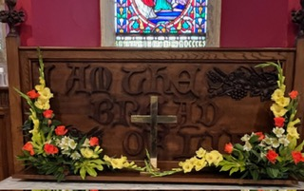

There were beautiful displays of flowers, along with fruit and vegetables. During the years of the Pandemic restrictions there were real difficulties distributing fresh harvest produce afterwards. However, last year and this year we were once again able to resume donating it to the Northern Ireland Hospice. Other parishioners continued the more recent practice of giving non-perishable food items which were later donated to the Food bank.

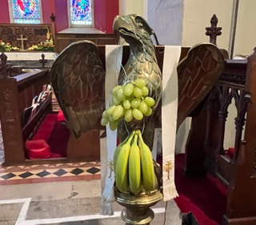

There was a lovely atmosphere of worship on Sunday. In the morning, a Celebration of the Holy Communion was presided over by the Rector, assisted by the visiting preacher, the Revd Stephen McWhirter, Rector of Rossory in the diocese of Clogher. The special music featured an anthem ‘For the Autumn Sky’, sung by a united Choir of both Annahilt and Magherahamlet, accompanied by our Choir Leader, Mr Tim Howe, who presided at both the Organ and Piano. There was also a sung version of the Lord’s Prayer, a musical setting of the ‘Gloria in excelsis’ and an alternative setting of the sung ‘Amen’.

In the evening, an uplifting Service of Evening Prayer was conducted by the Rector. On this occasion, the visiting preacher was our former Bishop, the Right Revd Harold Miller, who was making his first visit to Annahilt since his retirement in 2019. Again, Tim accompanied the united Choir from Annahilt and Magherahamle. The Baillie’s Mills Accordion Band played prior to and following the Service and also led the congregational singing in very familiar Harvest hymns as well as some not so well known ones. The Anthem ‘Sing to the Lord of Harvest’ was sung in addition to the morning anthem. A Vesper was also sung following the Blessing. It was wonderful that the Harvest Supper afterwards was so well supported with most of the congregation going across to the Parochial Hall afterwards. On behalf of everybody present, The Band Secretary, Stephen Dickson expressed appreciation of the hospitality provided.

At the conclusion of each Service the Rector thanked all those who had provided gifts and those who assisted with the decoration of the church. He expressed particular appreciation of the playing of the Organist Mr Tim Howe and of the role of Baillie’s Mills Accordion Band. In addition, he expressed gratitude to the Churchwardens who co-ordinated the seating arrangements in addition to their normal duties, also to Colin Hassard, who type-set the Orders of Service. Finally he expressed appreciation of the Ministry of the Word of the Revd Stephen McWhirter at the morning service and that of Bishop Harold Miller in the evening, also expressing great pleasure at his return to the Parish. Bishop Miller suitably replied and closed in prayer.

**Rite of Confirmation**

The Bishop has provisionally offered Sunday 24 November 2024 as a date for administering the Rite of Confirmation in our Group of Parishes. If there are sufficient numbers interested, the Service will take place on Sunday 24 November 2024, at 3.30 pm in the Church of the Ascension, Annahilt.

Young people from both Annahilt and Magherahamlet in Year 9 and above at school are invited to consider taking this step to full membership of the Church. There may also be adults in each parish who would also wish to be confirmed.

Anyone interested should inform the Rector as soon as possible.

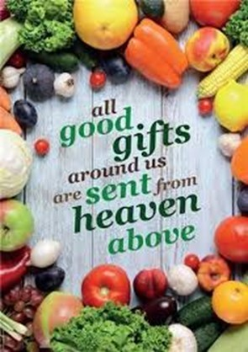

**Decoration of Magherahamlet Church for Harvest**

Saturday 26 October

From **2pm**

Your assistance with the decoration will be greatly valued

Gifts of flowers, greenery, corn, fruit, vegetables and other foodstuffs will be very gratefully received

**Magherahamlet Harvest Appeal**

Harvest Thank Offering envelopes are currently being distributed. Once again we have the opportunity of thanking God for all his love and goodness, especially in the realms of nature. We can also do this by making as worthwhile and generous a thank offering as possible. The Thank Offering envelope may be returned at either of the Harvest Services.

**Magherahamlet Harvest Supper**

With great pleasure, the Harvest Supper will take place in the Parochial Hall following the Evening Service on Sunday 27 October at 7.00 pm.

It is hoped that parishioners, visitors and friends will avail of this occasion for engaging in face-to-face fellowship and conversation which was not possible over the various past lockdown periods.

**Children’s Harvest Offerings**

The younger members of the congregation are asked to bring a non-perishable item of food (e.g. a packet of biscuits or a tin of fruit) to the 12 noon service on Harvest Sunday. They will have the opportunity of making their own Harvest Offerings during the service.

**Philippians 4:13 God gives me strength**

*Prayers for climate change*

Creator of our common home,

You fill the earth and sea and sky with life

Forgive us our neglect of your creation

The choking waste of our pollution

The damage done by careless habits

And our indifference to future generations.

Help us to amend our lives

To refuse more plastic if we can’t reuse it

To lift our voice for lasting change

And to live well and gently on the earth

To the glory of your Son, the Living Word

Through whom you made this fragile world.

**Amen.**

Creator God,

We acknowledge that as your handiwork, we stand alongside all that you have made.

Trees and rivers, mountains and valleys, soaring birds and scuttling creatures, all are held within your care.

May we grow in our love and appreciation for the fabulous variety around us and may our awe and wonder draw us closer to the natural world and through it to you, the God of all things.

We pray in Jesus name,

**Amen.**

God of life, we praise you for the beauty of creation, its richness and variety; yet, through greed and ignorance, we scar your world with plastic waste and throw so much away.

Make us more like Jesus, treading gently on our common home, and breathe your Spirit on us, that we may care more deeply for your Earth.

We ask this through Jesus Christ our Lord.

**Amen.**

**Church Services in the Parishes of Annahilt and Magherahamlet**

*‘I was glad when they said to me: “Let us go to the house of the Lord”’* Psalm 122 v1

Sunday 27 October **Last Sunday after Trinity**

10.00 Morning Prayer Annahilt

**Magherahamlet Harvest Festival**

**Sunday 27 October 2024**

12.00 noon Harvest Parish Communion *Service Sheets*

Preacher: The Revd Canon Nigel Baylor

Rector of Jordanstown (Connor)

7.00 pm Evening Service *Service Sheets*

Preacher: The Revd Katharine Poulton . Rector of Julianstown (Meath)

*Supper afterwards in the Parochial Hall*

Sunday 3 November **Festival of** **All Saints**

10.00 Parish Communion Annahilt

12.00 Morning Prayer Magherahamlet

Sunday 10 November **Remembrance Sunday**

10.00 Morning Prayer & Act of Remembrance Annahilt*Service Sheets followed by Light Refreshments in the Parochial Hall in support of Christian Aid*

12.00 Morning Prayer & Act of Remembrance Magherahamlet *Service Sheets*

Sunday 17 November **II Sunday before Advent**

10.00 Parish Communion Annahilt

12.00 Parish Communion Magherahamlet

Sunday 24 November **Sunday before Advent**

*Feast of Christ the King*

***10.00 No Service in Annahilt***

**11.30 am** Morning Prayer Magherahamlet

**3.30 pm** Rite of Confirmation Annahilt

Preacher: The Bishop The Right Revd David McClay

**In Memoriam**

On the Sunday after All Saints Day (3 November) at the 10.00 am and 12 noon services in Annahilt and Magherahamlet respectively, we will remember by name those from each parish who have died during the past year.

**Archbishops call for prayers for peace in the Middle East**

*The Archbishop of Armagh, the Most Revd John McDowell and the Archbishop of Dublin, the Most Revd Dr Michael Jackson are encouraging members of the Church of Ireland to pray for an immediate end to hostilities in the Middle East:*

Following the recent escalation of conflict in the Middle East we are asked to continue holding all of the communities affected in our prayers. The Archbishops have called on the leaders in those communities to make fresh efforts to establish an immediate ceasefire for the preservation of life, and to work for the preservation of peace.

The Anglican Diocese of Jerusalem, as part of the world-wide Anglican Communion, is present and serves its neighbours in Israel, Palestine, Lebanon, Syria and Jordan.

***A Prayer for the Peace of the World (Book of Common Prayer)***

*Almighty God, from whom all thoughts of truth and peace proceed; Kindle, we pray thee, in every heart the true love of peace; and guide with thy pure and peaceable wisdom those who take counsel for the nations of the earth; that in tranquillity thy kingdom may go forward, till the earth is filled with the knowledge of thy love; through Jesus Christ our Lord. Amen.*



***PRAYER WARRIOR***

Do you have a concern or problem and would like someone to pray for you?

If so, contact the Rector (Tel 028 9263 8218) who will be willing to help.

This is completely confidential and no details will be passed on to anyone else unless you want them to.



**SUNDAY SCHOOL IS BACK!**

**WHEN?**

**Annahilt from10.00 am until 11.15 am on 1St Sunday of each month in Parochial Hall, JAM (Jesus and Me) our revamped Sunday School.**

**Family Service in Church on 2nd Sunday of month in Church.**

**Magherahamlet at 11.00 am Every Sunday in Parochial Hall (except 2nd Sunday of month when Family Service is held in Church.**

**WHERE? Parochial Hall \\**

If you are thinking about sending your child and have any queries, please contact the Rector or the Sunday School teachers.

**JAM**

JAM kicked off the year in Annahilt with thirteen children and young people in the Parochial Hall on Sunday 6th October. It was lovely to see everyone with ages ranging from Primary One up to Year 14 in post-primary.

We had games, activities and crafts. Our theme was Autumn, thanking God for nature, and there was an abundance of creativity on display with everyone working in teams to create Autumn collages using materials from the church grounds. We also reflected on the Parable of the Sower.

The young people made delicious hot chocolate and marshmallows for everyone to finish our morning on a sweet note!

If you would like to come along, we meet in the Parochial Hall on the first Sunday of every month at 10 am (next JAM is Sunday 3rd November). All school-aged children and young people are very welcome.

(NB JAM – Jesus and Me – is our revamped Sunday School)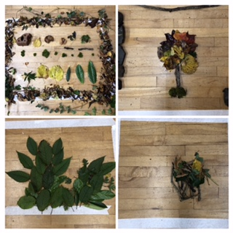

**Festival of Remembrance 2024**

**

In 2024, The Royal British Legion continue their commemoration of the theme of ‘Service’ and ‘Service Not Self’ in the Festival of Remembrance at the Royal Albert Hall in London, broadcast each year on national television.

Through personal testimony and storytelling, through music and ceremony, the Festival will express the core values of Service which maintain the admiration and esteem the public holds for the Armed Forces and civil society. Values such as placing others before themselves, devotion to duty and unfailing reliability.

The Festival will commemorate the above values through both the lived experience of our Armed Forces community by honouring veterans who lost their lives or were injured in service and actively serving personnel. It will further honour their families, descendants and representatives.

Perhaps in this year’s season of Remembrance, as well as remembering and giving thanks for the sacrifice of those who fought and died in service of our nation and of peace, we can also remember to pray for those still serving now, for those who love them and support them, and for healing of the seen and unseen scars of war.

God of healing and of peace, in whose service is perfect freedom, we hold before you those who serve our nation in His Majesty’s Armed Forces, and those who love them.

We pray that during times of separation you would protect their relationships.

We pray that during times of reunion you would ease the transitions and be present in homecomings.

We pray for healing of bodies, minds, and spirits broken by experiences of combat, and for healing of grief for those who will never return.

Hold and guard all who serve on behalf of others, and their loved ones, we pray.

**Amen.**

**A Prayer to be said by families visiting a war grave or memorial:**

Lord Jesus, we believe that you stood beside *N and his fellow soldiers* as they fought to bring peace to your world.

We believe that you have stood among us as we have tried to imagine the fear and pain and loneliness of the wounded and the dying on the battlefield.

We believe that you stand beside us now, as we remember and honour *N*.

In your great mercy, bless our good memories, comfort us when we grieve for the life that might have been, and strengthen us in all we do to seek the peace and freedom which are your desire for the world. **Amen**.

**Flowers for the Churches**

**Annahilt Magherahamlet**

**October**

6 Mrs AM Edgar

13

20 Mrs S McCurry

27 Harvest

**November**

3 Mrs M Keown

10 Remembrance Sunday Remembrance Sunday

17

24 Confirmation



**Church Cleaning, Annahilt**

**Month**

**October**

18-19 Mrs E Crawford

25-26 Mrs S Chapman Mr S Chapman

**November**

1-2

8-9 Mrs H Hill Mr T Hill

15-16 Mrs L McCambley Mrs E Harrison

22- 23 Mrs A Maxwell Mr R Maxwell

29 –30 Mrs J Guiney Mrs H Cardosi



Dear Mothers’ Union Members and Friends,

At our September meeting ideas were put forward for the remainder of this year’s programme. Further announcements will be made in due course.

We extend our sincere congratulations to Ann & Charles Carson on the recent celebration of their Diamond Wedding Anniversary.

At their meeting on 23 October Magherahamlet members will gather together to make up floral decorations for the Harvest Festival.

Our next meeting will be on Wednesday 13 November at 8.00 pm in the Parochial Hall.

With very kind regards and every blessing

Beth Esme

Avril McK & Sally Frances & Avril B

**Mothers’ Union Midday Wave of Prayers October 2024**

**1-3** October: Nzara, South Sudan; North Kigezi, Uganda; Kivu, Rwanda; Damataru, Nigeria; Auckland, New Zealand and Vanuatu and New Caledonia, Vanuatu

**5-7 October:** Mbhashe, South Africa; Kitgum, Uganda; Ukwa & Ilesa South West, Nigeria; Tasmania, Australia and Central Melanesia, Solomon Islands

**8-10 October**: Ethiopia; Zanzibar, Tanzania; Awgu/Aninri, Nigeria; Freetown, Sierre Leone; Monmouth, Wales and Malaita, Solomon Islands

**12-14 October:** Ezo, South Sudan; Thika, Kenya; Jos & Akoko, Nigeria; in Europe and União de Mulheres Episcopais Anglicanas do Brasil (UMEAB), Brazil

**15-17 October:** Terekeka, South Sudan; Nairobi, Kenya; Maiduguri & Osun North, Nigeria; Edinburgh, Scotland and Calcutta, India

**19-21 October:** High Veld in South Africa; Nambale in Kenya; Niger-Delta in Nigeria; in Guinea; Blackburn in England and Bhopal in India

**22-24 October:** Kimberley and Kuruman, South Africa; Kitui, Kenya; Kano & Kwara, Nigeria; Armidale, Australia and Myitkyina, Myanmar

**26-28 October:** Malakal, South Sudan; All Saints Cathedral, Kenya; Kontagora & Osun North East, Nigeria; Glasgow & Galloway, Scotland and Pune in India

**29-31 October:** Luapula, Zambia; Nakuru, Kenya; South Rwenzori, Uganda; Ibadan- North, Nigeria; Connor, All Ireland and Pusan, South Korea

**Financial matters**

**Annahilt Harvest Envelopes**

If you were unable to attend Annahilt Harvest Services but would still like to contribute to the collections, additional envelopes are available on the table inside the Church door. Please send your envelope to Patricia at 35 Cabra Road, Hillsborough, BT26 6NB.

**Thank you to all who contributed to recent special collections…..**

….. Annahilt Harvest collection and envelopes £833.00

**Gift Aid**

For those parishioners who currently Gift Aid their subscription-are you still a tax payer? If not, please contact the Parish Treasurers to update Parish records.

If you are a tax payer and do not currently Gift Aid your subscription (FWO) the Parish could benefit from an additional 25% income at no cost to you. Again, please contact the Treasurers.

**2025 FWO/Weekly Giving**

Parishioners can contribute via weekly envelopes, monthly/annual Standing Order or a combination of both or by cheque/annual direct payment.

If you wish to change/amend or add to your method of giving please contact the Treasurers by **20th November** prior to preparation of the 2025 envelopes.

**Contact details**

While we try to keep contact details up to date, sometimes parishioners move house and we don't have your new address.

Some no longer have or use landline telephone numbers and only use mobile numbers. It would be helpful if your details have changed, if you could contact Patricia (Annahilt) on 028 92665310, Mobile 07713 257 691, email [patriciaapc@btinternet.com](mailto:patriciaapc@btinternet.com) or Abbie (Magherahamlet) on 07753 746940, email [abigailstanford@btinternet.com](mailto:abigailstanford@btinternet.com) with up to date details. The vast majority of contact numbers we hold are landline numbers.

Your contact details are only used for Parish purposes.

**The Wednesday Club**

In September over twenty folks from the Parish and community gathered in the hall for tea/coffee and scones and some craic.

Following the refreshments Joane Templeton from Lisburn and Castlereagh City Council gave a very interesting interactive talk on household recycling. This was very informative and everyone gained additional knowledge on just how much we can put into our recycling bins.

The next gathering will be Wednesday 13th November at 11am and we hope that many Seniors and Retirees from the Parish and Community will attend. Please spread the word. Additional details will be circulated in due course.

It is also hoped to have a festive lunch in early December. Contact Patricia on 07713 257691 for further details.

**Larchfield Community Development Association**

All welcome to their event on Thursday 17th October   
This should be a great evening's entertainment and anyone fit for a bit of dancing will also have an opportunity to join in some of the dances.



**Larchfield Community Development Association**

**Invite you to an evening with the Royal Scottish Country Dance Society (Belfast Branch)**

Thursday 17th October 2024 8pm

2, Glebe Road, Hillsborough,

BT26 6NE

Admission £5.00 including light supper

All welcome

*Registered with the Charity Commission for Northern Ireland*

*NIC103278*

**Bowling Club**

****Are you interested in learning a new sport or perhaps returning to Indoor Bowling after a break?

While our normal club night is Wednesday, league matches could be any night of the week, we will also be playing (generally) on the first and third Saturday nights of the month for a much more relaxed evening. Contact Patricia on 07713 257691 if you are interested in learning more or joining.

**Lunch Club**

The next time we meet will be Friday 25 October in the Pheasant at the usual time of 12.30pm.

Subsequent Lunch Club meetings will take place on the following date:

29 November

The Lunch Club is a very relaxed and enjoyable occasion, giving retired and semi-retired members an opportunity to connect with each other. If you would like the opportunity of enjoying a lunchtime meal in the company of established friends or perhaps some new ones, do come along. Please contact Violet Swarbrigg (Telephone 028 9263 8952) for further information.

**Parish of Annahilt **

is holding a

**Christmas Fair**

**Friday 29 November 2024**

**7.**00 pm – 9.00 pm

Parochial Hall

**All welcome**

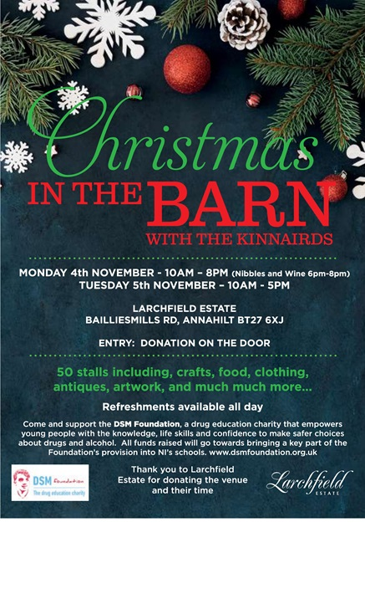

**LISBURN FOODBANK**

The Lisburn Foodbank is providing an essential service to those within our community who are experiencing difficult times, often due to circumstances beyond their control.

The Foodbank provides emergency food and support to local people in crisis in the Lisburn area.

A particular request from the Foodbank for the Christmas period is for

* Bottles of Shloer
* Small selection boxes

Parishioners are asked to leave these items in the basket in Annahilt Church Porch or in the Parish Hall on or before 1st December 2024.

**YOUR HELP WOULD BE GREATLY APPRECIATED**.

**Recording of Annahilt Church Services**

Free recordings (CD format) are available weekly of the Church services or requested special services.

These CDs are delivered free of charge. If you would like to receive a CD copy, please contact Shirley Robinette on 07974093382

**Parish Website:  AnnahiltAndMagherahamlet.org**

Parishioners are reminded that the website [annahiltandmagherahamlet.org](http://annahiltandmagherahamlet.org/) has been created to provide information on church related activities and organisations for parishioners and the wider community. The website also continues to host online services most weeks. In addition, the website contains a list of upcoming church services and news from our group of parishes, as well as downloadable versions of the parish magazine.  The site will be continually developed, so if you have any submissions, suggestions or requests relating to the website, these can be sent to [admin@annahiltandmagherahamlet.org](mailto:admin@annahiltandmagherahamlet.org).



[www.annahiltandmagherahamlet.org](http://www.annahiltandmagherahamlet.org)

**Parish Magazine**

Any contributions for the next edition of the Parish Magazine should be left with the Rector or Roger Maxwell ([roger.maxwell1@btinternet.com](mailto:roger.maxwell1@btinternet.com)) by Sunday 17 November 2024.

Registered as a charity with The Charity Commission for Northern Ireland

NIC103246 (Annahilt) and NIC102122 (Magherahamlet)