**News from the Parishes**

**Church of the Ascension, Annahilt Magherahamlet Parish Church**

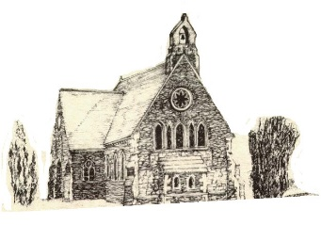 

**December 2024 & January 2025**

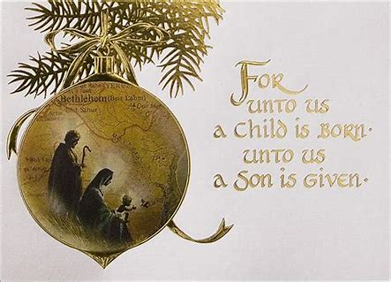

**Rector: The Revd Canon Robert Howard**

**15 Ballykeel Road, Hillsborough**

**BT26 6NW**

**Tel: 028 9263 8218**

**E-mail:** [**jrobert.howard@btinternet.com**](mailto:jrobert.howard@btinternet.com)

**Website:** [**www.annahiltandmagherahamlet.org**](http://www.annahiltandmagherahamlet.org)

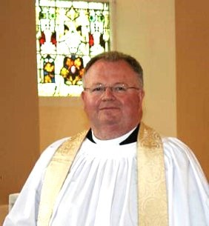

**The Rector writes…..**

My dear Parishioners,

It’s hard to believe that Christmas is just ‘around the corner’. We really shouldn’t be all that surprised, as the shops have had many of their Christmas goods on display since, perhaps even before Hallowe’en. Menus for Christmas parties in hotels and restaurants have been available since the summer and charities and churches have sent out their Christmas appeal letters looking for support in order to keep their organisations and activities running.

The Archbishops of Armagh and Dublin have designated the First in Advent, 1st December as a special day of prayer for peace in the Middle East and have launched an appeal through the Bishops’ Appeal to have special collections at all of our churches to support those whose lives have been thrown into such chaos and upheaval and unbelievable suffering as a result of the wars raging in that region.

Christmas always strikes me as a very emotional and personal time. If life is good and you are happy and healthy you look forward to gathering with family and friends, sharing a special meal together and singing carols and perhaps coming to worship together if you are a household of faith.

It’s a very different experience if you have lost someone you love and you feel that loss acutely in the midst of all the celebrations around you. Perhaps, you want to avert your eyes from all the jollity and parties and celebrations going on around you and retreat into yourself. You long for when the festival will be over and life returns to something resembling routine and normality again.

Children look forward to presents and school plays and concerts with proud parents beaming on appreciatively at their performances. The other side of course is that many children don’t have enough. They are trapped in situations of poverty and neglect and domestic violence and these are never comfortable realities to consider. Over the coming weeks we hope each household will consider this Magazine as an invitation to Christmas services and events in Annahilt and Magherahamlet. We recognise the complexity and challenge of the season for many but we also see it as an important opportunity to talk and share about a word that lies at the heart of the Christian understanding of this time of year and that word is ‘hope’.

God’s son, Jesus Christ, was born into a world that faced many challenges all those years ago. There was imperial oppression. There were malevolent forces at work that sought to kill babies and young children. There was much poverty and economic struggle. Wars raged and a little baby was born in very stripped-back and challenging circumstances. This baby was foretold centuries before by prophets and hailed as the promised or anointed one, the Messiah who would make things new, who would offer hope, shine light into people’s darkness and walk alongside them no matter what they faced. This is the one we herald and celebrate in this season. We long for people to encounter Him which is why we hold special services and events. We want to put the Christ child at the front and centre of all our celebrations. There are traditional opportunities to do that in Carol Services and The First Communion of Christmas and Family celebrations of Christmas. These are events to which we may invite neighbours and friends alongside outreach events like our ‘Wednesday Club’ on Wednesday 18 December 2024 where we want the senior citizens of our community to enjoy a Festive Lunch in the Parochial Hall, sing some carols and take away some thoughts that remind us of the true meaning of Christmas.

Wherever and however you celebrate Christmas this year, whether it’s welcoming home family from faraway places or you have a quieter more reflective time on your own, I want to take this opportunity to wish you a joyful and peaceful season. The Church’s liturgical calendar offers us the season of Advent as a way to build up towards it and make some spiritual preparations in the midst of all the other ‘busyness’ which preoccupies us.

As we look forward to these weeks, please be mindful of all those for whom it is a painful and difficult season. Checking in on those who have been through difficult times, praying for them, phone calls and cards are all greatly appreciated as we seek as a community to support one another and make the presence of Jesus real and known in our communities.

With love, prayers and blessings

Your sincere friend and Rector

Robert Howard

**Thank you……**

**To all who contributed to recent special collections:**

**Annahilt Magherahamlet**

Poppy Appeal £225.23 £137.98

Bishop’s Ministry Fund (Confirmation Service) £163.00

**…To all the various volunteers** who have assisted in the Church cleaning, as well as all who provided flowers for the Churches during the past year.

The cleanliness of the Churches for public worship does not go unnoticed and is much appreciated by all.

The floral arrangements which are given each week are also valued and admired by all who worship in both Churches.

**….To Colin Robinette and William Mathers** for their ongoing assistance in the online recording and transmission of Services.

**Confirmation in Annahilt and Magherahamlet**

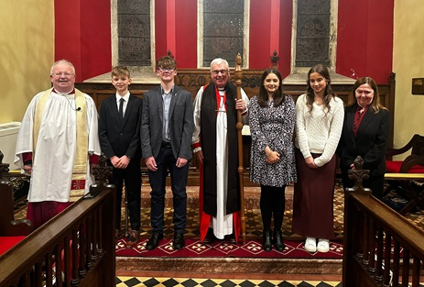

On Sunday 24 November 2024 the Bishop, the Rt Revd David McClay administered the Rite of Confirmation in our Group of Parishes. This year, the Service took place in the Church of the Ascension, Annahilt. The five candidates were well supported by the attendance of family members and friends of the candidates, as well as parishioners from both Annahilt and Magherahamlet. The music was led by a United Choir.

We are very grateful to the Bishop for officiating and to all who encouraged the candidates as they made their commitments to full membership of the Church.

The Service was very memorable and was appreciated by everyone present.

Please continue to remember the Confirmands for Confirmation in your prayers:

***From Annahilt:***

**Luke** Joseph Ewing

**Harris** Mathers

**Holly** Isabella O Neill

**Rachel** Elizabeth McMullan

***From Magherahamlet:***

**Matilda** Lucy Martha Millsopp

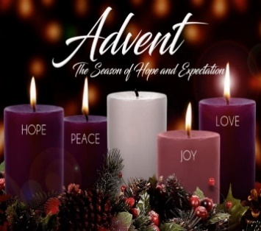

**The season of Advent**

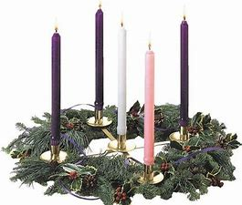‘Advent’ means ‘coming’ and marks the four weeks leading up to the celebration of the Nativity and the coming of Christ. It is traditionally a season of penance and preparation before Christmas. The official Church liturgical colour is purple, a symbol of penitence. Weddings used to be forbidden during this season, as they once were during Lent.

Tradition has given its own flavour to each of the Advent Sundays. The Sunday next before Advent was known as ‘Stir up Sunday’, so named because it was the day for ‘stirring up’ Christmas puddings. The second Sunday was known as Bible Sunday when our focus was on the reading, preaching and distribution of God’s Word as revealed in the books of the Bible. The third Sunday is the ‘Gaudete’ Sunday from the Latin word for ‘rejoice’. On that day everyone took a break from the penitential theme. A rose coloured candle is lit on this Sunday.

In our Churches an Advent wreath is often among the decorations made with evergreen branches such as holly, yew or pine. The four Advent candles are fixed into the wreath along with a white candle which represents the Light of Christ coming into the world at Christmas.

Advent calendars are still popular today, usually a card with twenty-four small doors, one to be opened each day from the first day of December until Christmas Eve. Each door conceals a picture, which originally had biblical themes. Every morning children open one door to see a pretty picture or find a chocolate inside. This popular tradition arose in Germany in the late 1800s and soon spread throughout Europe and North America.



**Holy Communion in Church**

There will be four celebrations of the Holy Communion in the Group of Parishes over the Christmas period.

There will be a SAID Communion Service on the Second Sunday **BEFORE** Christmas, 15 December, at **9.30 am.** This may be of particular interest to those who previously attended the early celebration . It may also suit those who prefer a shorter and ‘quieter’ act of worship.

On Christmas Eve, 24 December at **11.15 pm** the First Communion of Christmas will be celebrated.

On Christmas Day, 25 December at the earlier time of **11.30 am** the Parish Communion of Christmas Day will be celebrated in Magherahamlet Parish Church.

On the Eve of Epiphany, 5 January 2025 there will be Parish Communion in Annahilt at 10.00 am and in Magherahamlet at 12.00 noon.

**Private Communion at Christmas**

Any parishioners who are ill or housebound or who otherwise are not in a position to attend church and would like Holy Communion in their own home before Christmas should please contact the Rector who will only be too pleased to make the arrangements. Tel 028 9263 8218.

**Church Services in the Parishes of Annahilt and Magherahamlet**

*‘I was glad when they said to me: “Let us go to the house of the Lord”’* Psalm 122 v1

Sunday 1 December **Advent I**

10.00Parish Communion Annahilt

with the First Communion of the Newly Confirmed

*Light refreshments in the Parochial Hall*

12.00 Parish Communion Magherahamlet with the First Communion of the Newly Confirmed

Sunday 8 December **Advent II** *Bible Sunday*

10.00 Advent Carol Service Annahilt *Service Sheets*

*w*ith offering of gifts for ‘Star NI’ children in need

12.00 Advent Carol Service Magherahamlet *Service Sheets*

Sunday 15 December  **Advent III**

**9.30 am** Holy CommunionAnnahilt (SAID SERVICE) 10.00 ***No*** *Service* Annahilt

**11.30 am**  Family Christingle ServiceMagherahamlet *Service Sheets*

with offering of gifts for ‘Star NI’ children in need

**3.00 pm** Festival of Nine Lessons & Carols Annahilt *Service Sheets*

with the Choir of Anahilt Primary School

Guest of Honour: The Mayor

*followed by seasonal refreshments in the Parochial Hall*

Sunday 22 December **Advent IV**

10.00 Family Crib Service Annahilt*Service Sheets*

*with Baillies’ Mills Accordion Band*

**11.30 am**  Morning Prayer Magherahamlet *Service Sheets*

**7.00 pm** United Festival of Nibe Lessons & Carols Magherahamlet Presbyterian Church

Tuesday 24 December **Christmas Eve**

**11.15 pm** The First Communion of ChristmasAnnahilt *Service Sheets*

Wednesday 25 December **Christmas Day**

10.00 Family Service Annahilt *Service Sheets*

**11.30 am** Parish Communion Magherahamlet *Service Sheets*

Sunday 29 December **Christmas I**

10.00 Morning Prayer & Litany Annahilt **11.30** am Morning Prayer & Litany Magherahamlet

Sunday 5 January 2025 **Eve of** **Epiphany**

10.00 Parish Communion Annahilt 12.00 Parish Communion Magherahamlet

Sunday 12 January **Epiphany I**

10.00 Family Service Annahilt *Service Sheets* 12.00 Family Service Magherahamlet *Service Sheets*

Sunday 19 January **Epiphany II**

10.00 Parish Communion Annahilt

12.00 Morning Prayer Magherahamlet

Sunday 26 January **Epiphany III**

*World Leprosy Day*

10.00 Morning Prayer Annahilt 12.00 Morning Prayer Magherahamlet

Sunday 2 February **Presentation of Christ in the Temple**

10.00 Parish Communion Annahilt 12.00 Parish Communion Magherahamlet

Sunday 9 February  **IV** **Sunday before Lent**

10.00 Family Service Annahilt

12.00 Family Service Magherahamlet

**Congratulations ….**

….to George and Sally McCurry, Magherahamlet on the recent celebration of their Diamond Wedding Anniversary on Sunday 20 October. During the Church Service they were presented with a floral arrangement on behalf of the Parish. Among the various other greetings and expressions of good wishes George and Sally received was a card from Their Majesties The King and Queen.

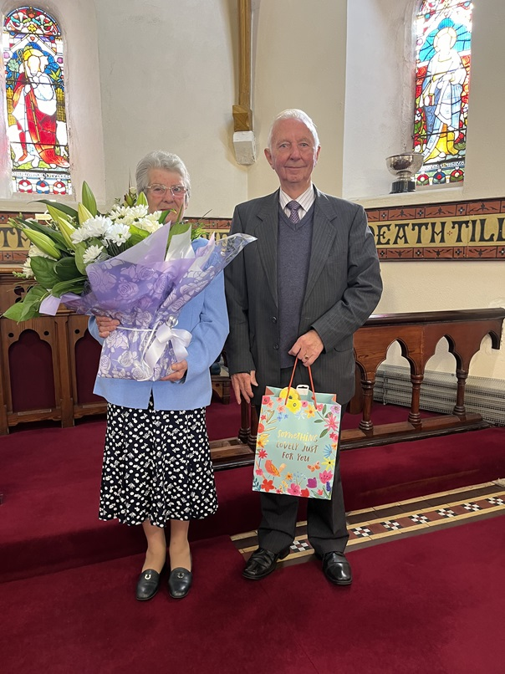

**From the Parish Registers**



**Christian Burials**

*‘In Christ shall all be made alive’*

15 October 2024

Elizabeth (Liz) Anderson, New Road, Hillsborough

*Following a Service in the Church of the Ascension, Annahilt burial took place in the adjoining Churchyard*

Liz Anderson was born on 20 October 1958, the only daughter born into a family with four brothers Norman, Hugh, David and Colin. She always knew how to ‘hold her own’ being the only girl in the family and in due course was known to have passed this onto her three daughters!

Liz always spoke fondly of her childhood growing up at The Cotton and of her time working around Newtownards in her younger years.

In due course Liz met a young Digger Driver Tommy Anderson who she married soon afterwards. They had a family of three, Shirley, Sandra and Suzy. As well as raising their family Liz and Tommy never ‘shied away’ from a busy life, following parades of the Loyal Orders, supporting The Ploughing Society and being involved in the Ulster Unionist Party. On their home farm they raised pigs, horses, dogs and cattle. The Andersons had them all!

Later in life, Liz was further blessed with the joy of becoming a grandmother. Her grandchildren gave her the nickname ‘Big Liz’ which referred to the big and warm heart she kept and the even bigger impact she had on all their lives with her virtue of patience.

We extend our deep sympathy to all Liz’s family circle in their great loss.

11 November 2024

Edmund Patterson, Fishbourne House Nursing Home, Spa (formerly of ‘The Drumlins’, Ballynahinch).

*Following Services at Douglas’s Funeral Home and in Magherahamlet Parish Church burial took place in adjoining Churchyard*

Edmund Patterson was born on 7 October 1944 at Drumgavlin to his parents Robert and Irene, the youngest child of a family of nine. His education began in Spa Primary School and continued at The High School, Ballynahinch. Edmund chose welding as a career and worked originally at Lowes in Carryduff and later at Ballykine Engineering Works. He continued his working life in Jordan’s Concrete, Stoneyford, as the Foreman for 32 years until he retired.

Edmund married Anne McComb on 23rd October 1967. They were blessed with three children, Karen, Edmund and Dana and three grandchildren Lewis, Katie and Isabella, each of whom he was very proud.

Edmund enjoyed playing a variety of sports throughout his life. He played hockey in Ballynahinch, golf at Spa and in retirement he enjoyed a game of bowls. Edmund also enjoyed throwing darts and was quite amused that when he was arranging the burial rights to a grave in this adjoining churchyard many years ago, he was assigned number one hundred and eighty which co-incidentally is the top score in darts!

Edmund, like his brothers and sisters, had a keen interest in music. He was ranked one of the best bagpipers in a world championship competition and was a member of Upper Crossgar Pipe Band for many years. He informed his children that he was also a pianist, however as the years went by questions were asked as to why he chose to play the same verse of the same hymn over and over again!

In the Funeral Address the Rector said “Many believe that silence is the opposite of sound and that there is nothing to hear. As a musician Edmund knew otherwise. Every good musician knows that silence is the necessary space between the notes. That space, what most of us might call or experience as emptiness, absence, or a void, is **the birthplace of the music**. That space of silence is as much a part of the music as is **each note**. That space sets a rhythm, holds energy, and gives music its life, power, and beauty. As we hear the music of Edmund’s life; we hear his tunes of love, his tunes of friendship, his melodies of presence in our life.”

Edmund and Anne lived in Spa for 47 years before moving to ‘The Drumlins’ in Ballynahinch where they were both keen gardeners. They both enjoyed days out especially to Newcastle. Anne enjoyed perusing the shops while Edmund held her bags!

As years went by Edmund’s health unfortunately began to deteriorate resulting in his moving to Fishbourne House Nursing Home. Although this was a very difficult decision to make, Edmund was very happy in Fishbourne and enjoyed having a laugh with his visitors, the staff and his fellow residents.

The whole family are very thankful to all the wonderful staff in Fishbourne for their devoted care and attention given to Edmund, especially over the closing weeks of his life and they will remain forever grateful.

We extend our deep sympathy to Anne and the entire family circle in their great loss.

21 November 2024

Loreen Patterson, Magherahamlet Road

*Following Services at home and in Magherahamlet Parish Church burial took place in adjoining Churchyard*

Loreen Patterson was born outside of Crossgar on the 25January 1946, the second youngest of twelve children, to the to the late Alec and Margaret Cheevers.

Her early education was gained in the local primary school, before moving on to Killyleagh High School. Upon leaving school, Loreen went to work for Plessey Communications in Ballynahinch, where in time she would meet and fall in love with Robert Patterson from Dunmore. After a period of courtship, the couple were married on 25 March 1967 in Kilmore Parish Church.

After their honeymoon in Portush, the couple moved into the Patterson family home at Magherahamlet Road where Colin, Amanda and Leslie were born and lived for a short time. Then in 1974, having built a new bungalow across the road, the family moved in – and the following year Greg was born.

In the years which followed getting married, starting a family and building a house, Robert and Loreen together established a small electrical business in 1972 on the Donegal Road in Belfast, before moving to larger premises on Sandy Row in 1984. Together, he and Loreen worked in the shop, with Robert out on the road each morning doing calls, while Loreen stayed in the shop to serve customers, and also to fix vacuum cleaners, kettles and other small electrical appliances.

Of course, life wasn’t all work and no play. Together, the family enjoyed many happy holidays touring around Scotland and England in a carvanette. Then as the children got a little bigger, Jersey became their favourite place to holiday, where Robert and Loreen made many good and lasting friendships.

Alongside work, family and life’s other commitments, Loreen had a deep love for Magherahamlet Parish Church. In her earlier years, she helped train the children to sing for Children’s Day. She, along with the whole family were members of the Parish choir. For many years, she was a faithful and committed member of the Mother’s Union, serving also alongside Robert, as a member of the Select Vestry. She was fully supportive of various issues that arose and projects that came to fruition over the years – the refurbishment and extension of the Vestry, the placing of the Cross on the Holy Table, and the building of the new Parochial Hall.

Until her health declined Loreen was a weekly attendee at worship. The last occasion was at the evening Harvest Festival Service last year which she thoroughly enjoyed and joined wholeheartedly in singing the various harvest hymns. It had been some time since she had been able to come out to Church and all present were absolutely delighted to see her both at the Service and afterwards at Supper in the Parochial Hall where she engaged with many parishioners and friends.

Loreen had a beautiful singing voice, and sang for many years alongside her niece Pauline at various events. She also sang in the Ladies Choir in Ballynahinch Technical College. Loreen played bowls for many years at Magherahamlet Presbyterian Church, serving for a time as secretary and more latterly, she played bowls in Edengrove Presbyterian Church.

Another deep passion of Loreen was the work of the Royal British Legion. She was a member of the Ladies Section of the Ballynahinch Branch of the Royal British Legion, serving for some years as Chairperson.

Loreen was a strong, independent and capable woman. She was straightforward and very clear in the views she expressed. One knew where one stood with Loreen. Life for her had many good and happy times, tinged with more than her fair share of sadness, heartache and pain. She endured much, gave much and did much good. She loved her family, and not least her grand-children and great-grandchildren and very especially, her dear sister Mary, with whom she had a deep sisterly bond.

We extend our deep sympathy to Colin & Catherine, Leslie & Laura, Amanda & Mark, Greg & Judith who are thankful for two exceptional parents who together sought to raise and instill in their children, values that would stand by them throughout life. They take solace in the faith that was passed on to them by a loving mother and father, and they draw much comfort in knowing that their mother is now at peace with the Lord, free from every pain and heartache, that she bore with such dignity, grace and strength – particularly in her later years.

The Family are deeply grateful to the Consultants, Doctors and nurses in the Ulster and Royal Victoria Hospitals.

They also thank the many carers who tended to Loreen in these past couple of years, especially Esmee and Sharon.

They would also like to thank other family members for their love and support over these past years and especially recent days.

In particular, they would like to thank most sincerely, their cousin Heather who was a tower of strength for Loreen, a shoulder to cry on when she needed that, and someone who went far and beyond what could ever have been reasonably expected from her.



***PRAYER WARRIOR***

Do you have a concern or problem and would like someone to pray for you?

If so, contact the Rector (Tel 028 9263 8218) who will be willing to help.

This is completely confidential and no details will be passed on to anyone else unless you want them to.

**Flowers for the Churches**

**Annahilt Magherahamlet**

**December**

 1 Mrs K Kingston

8 Mrs B Harrison Mrs K Kingston

15 Mr & Mrs R Carlisle The Rector

22 The Rector The Rector

29 The Rector Mrs F Magorrian

**Church Cleaning, Annahilt**

**Month**

**November**

29-30 Mrs J Guiney Mrs H Cardosi

**December**

6-7 Mrs S Chapman Mr S Chapman

13-14 Mrs E Crawford

20-21 Mrs S Chapman Mr S Chapman

23-24 Mrs H Hill Mr T Hill

27-28 Mrs S Chapman Mr S Chapman

**January 2025**

3-4 Mrs L McCambley Mrs E Harrison

10-11 Mrs J Bolas Mr A Bolas

17-18 Mrs A Maxwell Mr R Maxwell 24-25 Mrs S Chapman Mr S Chapman

31 -Feb 1 Mrs J Guiney Mrs H Cardosi

**February**

7-8 Mrs S Chapman Mr S Chapman

14-15 Mrs A Maxwell Mr R Maxwell

21-22 Mrs S Chapman Mr S Chapman

28 – Mar 1 Mrs L McCambley Mrs E Harrison

**March**

7-8 Mrs A Maxwell Mrs R Maxwell

|  |  |  |  |
| --- | --- | --- | --- |
| **Parochial Hall Cleaning, Annahilt** | |  |  |
|  | week commencing | week commencing | week comencing |
|  |  |  | 9/1/2025 |
| Susan Wilson | 25 November 2024 | 14 April 2025 | 9/15/2025 |
| Shirley Robinette | 9 December 2024 | 8 April 2025 |  |
| Gail Gibson | 23 December 2024 | 12 May 2025 | 9/29/2025 |
| Linda Hassard | 6 January 2025 | 26 May 2025 | 10/13/2025 |
| Maire Brown | 20 January 2025 | 9 June 2025 | 10/27/2025 |
| Lesley McKeown | 3 February 2025 | 23 June 2025 | 11/10/2025 |
| Louise McGregor | 17 February 2025 | 7 July 2025 | 11/24/2025 |
| Heather Bradford | 3 March 2025 | 21 July 2025 | 12/8/2025 |
| Heather Cardosi | 17 March 2025 | 4 August 2025 | 12/22/2025 |
| Jennifer Guiney | 31 March 2025 | 18 August 2025 | 1/5/2026 |



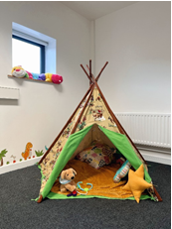With the closure of direct services in the local area, five experienced Social Workers set up a not-for-profit Community Interest Company called STARNI to continue providing support to children and families impacted by sexual abuse. STARNI is based in Millennium Court Arts Centre in Portadown. Our mission is to create a safe and nurturing environment where children feel comfortable and safe enough to explore their thoughts and feelings.

STARNI has now been running for several years. They are continually working with more children and would love to be able to give them Christmas gifts with our support.

This year, at our Advent Carol Service in **Annahilt on Bible Sunday 8 December (10.00 am)** and at the Christingle Service **Magherahamlet on Sunday 15 December** **(11.30am**) we are asking whether you might consider donating a gift which should be new, wrapped and with some indication of the age of the child for whom it is intended and whether it is for a boy or a girl. A list of presents which would be appreciated has been placed at the entrance to each Church. Alternatively, if you would like to donate the money you might have otherwise spent on a Christmas gift, this would go directly to the running costs of STAR NI and would greatly assist the company in being kept up and running.

If you would like to know more about STARNI, you can find the organisation on Facebook and Instagram.

As always, STARNI thank you so much for you your ongoing support, it is greatly appreciated and makes a big difference.

**Overseas Mission support**

During 2025-2027 Annahilt Parish will be supporting projects with both Water Drops and Church Mission Society. This month we get a brief glimpse of Water Drops Boma tank project. [www.waterdrops.uk](http://www.waterdrops.uk)

Water Drops was established in 2020 by Ronnie and Maggie Briggs, who formerly served in Kajiado Diocese over a period of forty years, with Church Mission Society and were often speaking in Annahilt when back here in Northern Ireland. Ronnie, as a small boy along with his parents and sisters belonged to the Parish prior to moving into Lisburn.

The Boma Tank is a new and exciting initiative set up by Water Drops. ‘Boma’ is a Swahili word meaning small village or homestead where maybe three or four related families of up to 30 people live together.

**Background**

The nature of the traditional Maasai social system is changing. Traditionally people used to live in large communal areas known as Group Ranches. This meant that all resources were shared – especially grazing and water – for the benefit of all. However, there is now a move towards demarcating Group Ranches into individual holdings. This means that each individual homesteads must now search for their own water and grazing to sustain their livelihoods. This has been a serious challenge for many families – especially if they are also affected by drought and famine conditions.

Water Drops ensures that our water solutions are located within designated public areas – like a church, school or health clinic to keep it accessible to everyone. However, not everyone lives close enough to these public places and can therefore be easily overlooked when it comes to valuable resources like water. So, what can we do for them? How do we help those who cannot benefit from the Water Drops’ community tanks?

If people can’t reach clean drinking water from where they live, then we should help them to have clean water available in their own Boma, so ‘The Boma Tank’ was created.

In conjunction with the Diocese of Kajiado, homesteads will be selected on a priority basis according to geographical location, homestead circumstances and availability oa water source.

The Boma Tank project will supply the following:

1. Provide a 3,000ltr plastic tank to selected Bomas.

2. Place it on a concrete base to keep it safe and make it easy to draw water.

3. Fix a lockable tap to the tank.

4. Place the tank beside a house so that gutters and a down pipe can be fixed to harvest rainwater.

**Timescale**

Approx 3 days per Boma Tank

Cost

£500 per Boma Tank



Dear Mothers’ Union Members and Friends,

We would like to begin by expressing our thanks to the Mothers’ Union members of Annahilt and all who took part in our Creative Crafts evening on 18 November and made it a very enjoyable occasion for all. We hope to sell some of the crafts at the Christmas Fair on 29 November in the Parochial Hall.

This year we will be joining the ‘Wednesday Club’ for their Festive Lunch which will be held on Wednesday 18 December from 11.00 am to 1.00 pm.in the Parochial Hall. All members will be very welcome. For catering purposes, places need to be booked by 11 December with Patricia Halliday or any other member of the Wednesday Club Committee. There will be a small charge of £5.00. (See elsewhere in this Magazine.)

Our first meeting of 2025 will take place on Monday January 20th at 8pm in Annahilt Hall. Members are asked to bring their annual subscription which will be gratefully received by our Treasurer, Elaine Finney.

On 13 November, Magherahamlet members met in the Parochial Hall when Beverley led us in a craft evening. It was very enjoyable with a great night of friendship had by all.

We look forward to attending the MU Advent Carol Service in St Mary’s Parish Church, Comber on Monday 2 December at 7.30 pm.

Magherahamlet members Parcel Night will take place in the Rectory on a date to be confirmed.

We wish you all a very Happy Christmas and a Peaceful and Prosperous New Year.

With very kind regards and every blessing

Beth Avril / Sally

Esme Frances / Avril B

**Wave of Prayer for Mothers’ Union December 2024**

1-2 December: Mpumalanga in South Africa; Central Buganda in Uganda; Zonkwa in Nigeria; Bo in Sierra Leone; Newcastle in England and Barrackpore in India

3-5 December: Akot in South Sudan; South West Tanganyika in Tanzania; Aba Irele-Ese Odo in Nigeria; Coventry in England and Cuttack in India

7-9 December: Namibia; Mount Kenya South in Kenya; Northern Izon & Ijebu North in Nigeria and Durham in England

10-12 December: Lusaka in Zambia; Shyogwe in Rwanda; Sokoto & Ikka in Nigeria; Ely in England and Karimnagar in India

14-16 December: Fianarantsoa in Madagascar; Central Tanganyika in Tanzania; Calabar & Igbomina in Nigeria; Derry & Raphoe in All-Ireland and Banks & Torres in Vanuatu

17-19 December: Lui in South Sudan; Embu in Kenya; Orlu & Awori in Nigeria; The Murray in Australia and Medak in India

21-23 December: Archbishops, Bishops and all clergy in the Anglican Communion

24-26 December: Refugees, internally displaced families & those living in a climate of fear

28-30 December: All involved with the responsibility of caring and supporting family life

31 December: Mothers’ Union worldwide



In February 2025, a team of 11 cyclists from Northern Ireland, including Ian Dunn from Annahilt Parish will embark on a challenge across Rwanda, the land of a thousand hills! Aiming to cycle more than 350km on dirt and tarmac roads, with many hills along the route, the team are hoping that this challenge will have a lasting impact for some of the most vulnerable girls and boys and families in Rwanda.

Each team member is funding their own trip and giving up their own time to travel with Fields of Life to Rwanda to take on this cycle challenge and also visit Fields of Life partner schools.

Fields of Life seeks to transform the lives of the most vulnerable and marginalised people in East Africa through the provision of quality education, clean water, health promotion and other enterprise and livelihoods projects. And to this end we are fundraising for some school development projects.

Anyone unable to attend the Coffee Morning and wishes to contribute can do so by going to the JustGiving website and clicking on the <https://www.justgiving.com/page/bennyrwandacycle2025> link which has been set up by the Team Captain, Mark McKeown.

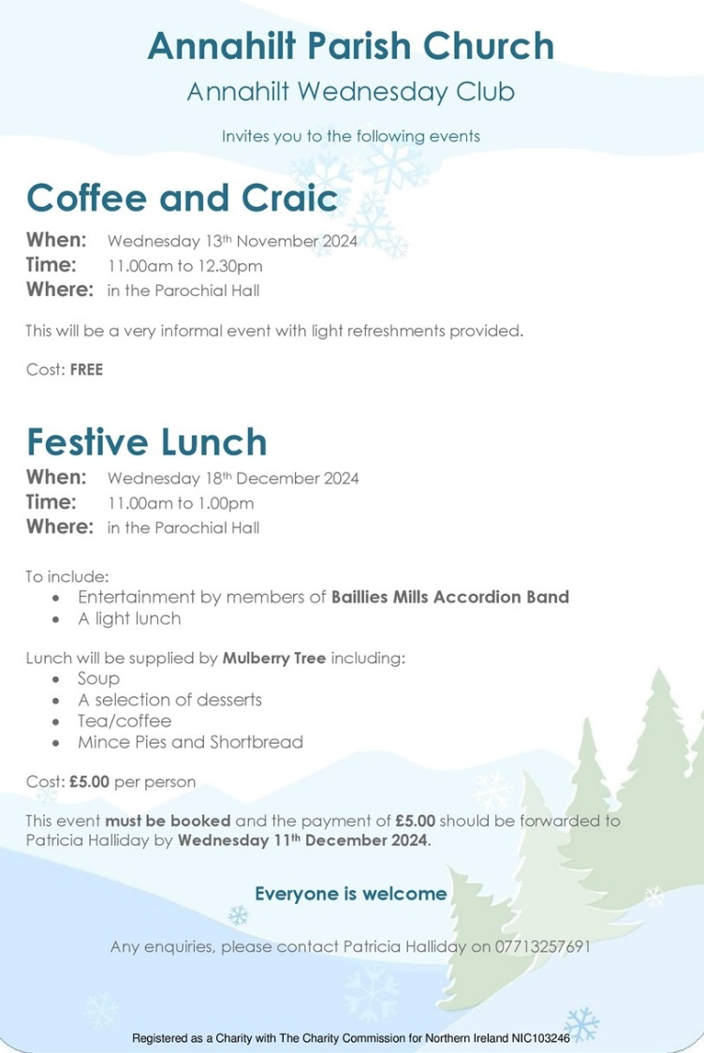

**Annahilt Wednesday Club**

Will hold a Festive Lunch on Wednesday 18th December from 11am - 1.00pm in the Parochial Hall. This follows on from the Spring Wellness events earlier in the year and the two Autumn Coffee and Craic mornings. For the Festive Lunch there is a small charge of £5. Places must be booked with Patricia or any of the committee **by 11th December** for catering purposes. These events are open to all (Senior Citizens) in the Community and are part funded by Lisburn and Castlereagh City Council.

We are delighted that some of the Baillies Mills band folks will be providing Festive music on the day of the Lunch.

Other committee members are Eileen Codd, Edwina Crawford, Linda Hassard, Trevor Hill, Canon Howard and Violet Swarbrigg.

**Financial matters**

**FWO Envelopes – Annahilt**

These are now available in Church. If you require any amendments or would like them delivered, please contact Patricia on 07713 257691 asap. If you wish to set up a Standing Order for regular monthly giving and/or require details of how much you have paid in to 30th November 2024 contact Patricia from 7th December.

**Mission Support – Annahilt**

For a number of years Annahilt Parish has supported overseas mission projects on three year cycles. During 2024-26 we will be supporting projects through Church Mission Society (CMS) and Water Drops Partnership Ltd.

**Fuller details of the projects will be included in a future magazine.**

**Gift Aid**

For those parishioners who currently Gift Aid their subscription-are you still a tax payer? If not, please contact the Parish Treasurers to update Parish records.

If you are a tax payer and do not currently Gift Aid your subscription (FWO) the Parish could benefit from an additional 25% income at no cost to you. Again, please contact the Treasurer.

**Thank you to all who contributed to recent special collections…..**

….. Annahilt Harvest collection and envelopes £833.00

**Parish Magazine**

With increasing printing and postage costs for distribution of the Parish magazine, would there be any additional households happy to receive notification via email when the magazine is available on the website?

If so, please email

[**patriciaapc@btinternet.com**](mailto:patriciaapc@btinternet.com)**or**[**info@annahiltandmagherahamlet.org**](mailto:info@annahiltandmagherahamlet.org)

**Contact details**

While we try to keep contact details up to date, sometimes parishioners move house and we don't have your new address.

Some no longer have or use landline telephone numbers and only use mobile numbers. It would be helpful if your details have changed, if you could contact Patricia (Annahilt) on 028 92665310, Mobile 07713 257 691, email [patriciaapc@btinternet.com](mailto:patriciaapc@btinternet.com) or Abbie (Magherahamlet) on 07753 746940, email [abigailstanford@btinternet.com](mailto:abigailstanford@btinternet.com) with up to date details. The vast majority of contact numbers we hold are landline numbers.

Your contact details are only used for Parish purposes.

**Finance Matters – Magherahamlet**

If you are a UK taxpayer, you can boost the amount of every donation you make by giving through “Gift Aid”. This is an Income Tax relief scheme created to help charities like our church get the most out of funds that they receive. Gift Aid enables the church to recover the base rate of tax on your donation. The scheme adds 25 pence on each £1.00 you give at no extra cost to you.

We would ask all taxpayers who give to parish funds to give through “Gift Aid”. All that is required is the completion of a “Gift Aid Declaration” form. If you have recently stopped paying tax then any existing Gift Aid declaration needs to be cancelled. Please contact the Treasurer, Abbie Stanford on 028 44811361 should you require a “Gift Aid Declaration” form or need to update an existing Gift Aid Declaration.

.

**Lunch Club**

The next time we meet will be Friday 31 January in the Pheasant at the usual time of 12.30pm.

Subsequent Lunch Club meetings will take place on the following date:

28 February

28 March

The Lunch Club is a very relaxed and enjoyable occasion, giving retired and semi-retired members an opportunity to connect with each other. If you would like the opportunity of enjoying a lunchtime meal in the company of established friends or perhaps some new ones, do come along. Please contact Violet Swarbrigg (Telephone 07866914651) for further information.

**LISBURN FOODBANK**

The Lisburn Foodbank is providing an essential service to those within our community who are experiencing difficult times, often due to circumstances beyond their control.

The Foodbank provides emergency food and support to local people in crisis in the Lisburn area.

A particular request from the Foodbank is for items listed below:

* Long life milk
* Sugar
* Custard
* Rice pudding
* Small diluting juice
* Jam
* Biscuits
* Porridge

In addition, we have been asked over the Christmas period to provide bottles of Shloer and small selection boxes

**YOUR HELP WOULD BE GREATLY APPRECIATED**.

**Recording of Annahilt Church Services**

Free recordings (CD format) are available weekly of the Church services or requested special services.

These CDs are delivered free of charge. If you would like to receive a CD copy, please contact Shirley Robinette on 07974093382

**Parish Website:  AnnahiltAndMagherahamlet.org**

Parishioners are reminded that the website [annahiltandmagherahamlet.org](http://annahiltandmagherahamlet.org/) has been created to provide information on church related activities and organisations for parishioners and the wider community. The website also continues to host online services most weeks. In addition, the website contains a list of upcoming church services and news from our group of parishes, as well as downloadable versions of the parish magazine.  The site will be continually developed, so if you have any submissions, suggestions or requests relating to the website, these can be sent to [admin@annahiltandmagherahamlet.org](mailto:admin@annahiltandmagherahamlet.org).



[www.annahiltandmagherahamlet.org](http://www.annahiltandmagherahamlet.org)

**Parish Magazine**

Any contributions for the next edition of the Parish Magazine should be left with the Rector or Roger Maxwell ([roger.maxwell1@btinternet.com](mailto:roger.maxwell1@btinternet.com)) by Sunday 19 January 2025.

Registered as a charity with The Charity Commission for Northern Ireland

NIC103246 (Annahilt) and NIC102122 (Magherahamlet)