**News from the Parishes**

**Church of the Ascension, Annahilt Magherahamlet Parish Church**

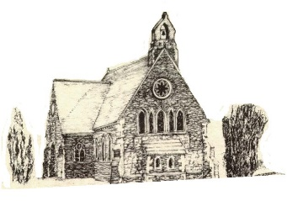 

**July and August 2024**

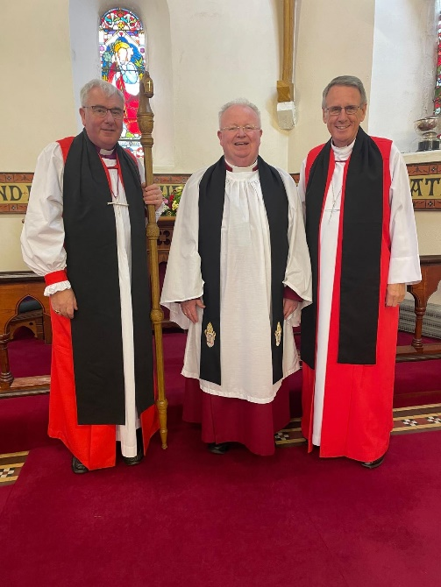

**Rector: The Revd Canon Robert Howard**

**15 Ballykeel Road, Hillsborough**

**BT26 6NW**

**Tel: 028 9263 8218**

**E-mail:** [**jrobert.howard@btinternet.com**](mailto:jrobert.howard@btinternet.com)

**Website:** [**www.annahiltandmagherahamlet.org**](http://www.annahiltandmagherahamlet.org)

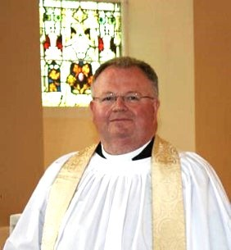**The Rector writes…..**

Forty years ago, on the evening of Friday 29 June 1984, the Feast of Saint Peter, I was ordained Deacon and one year later was raised to the Priesthood. In one sense, it was the culmination of something. A sense of call to this ministry had developed (very gradually) during secondary school days. On entering university, I entered a seven-year process of prayer, trial, anxiety, blessing, uncertainty, formation, mentorship, education, and trust in God preparing me for ordination.

Both ordinations (to the Diaconate in Down Cathedral and to the Priesthood in Holy Trinity Church, Waringstown) were beautiful and holy experiences. As I think about both, I always remember the love of family (especially my dearest parents, who had laboured so hard to help me come to those days), the support of friends, the solemnity of the sermon and the liturgy, the press of the hands laid upon me at the moment of ordination, and the utter silence and enfolding sense of God's presence when the red stole was placed on my shoulders.

Yet, that night was not really a culmination so much as a ***translation***, a movement from one place or role to another in the Church by God's grace and human response. As a follower of Christ, I was not "stopping." Rather, grace was being given, authority deputed, and a new mission being transmitted for the journey ahead.  
Ordination is not a "graduation" from the ranks of the laity (the *laos*, or People of God). It is an intentionalising, a specifying (and, in a sense, a narrowing) of one's ministry in and with God's People. It points always to the Kingdom of God, wherein it is both completed and dispensed with. If lived properly, it never points to itself. And this is what I am thinking of particularly now.

Ordination places a solemn and very real burden on the person being ordained, *and* on the rest of the Christian community, to recall the wholeness of our identity in Christ. All of us are needed for the work of the Body. Ordination is never an excuse for imperiousness in the clergy or for slackness and indifference in those not ordained; all the baptized are equal in God's sight and all are called to show forth the Kingdom in the way God calls us, with the gifts God gives each of us.

An ordination anniversary is always a good time to review one's vows as a deacon or priest. It is also a time to remember that our basic identity as disciple is never superseded, never put into the background by ordination. Our effectiveness as leaders and sacramental ministers of the Gospel is fed and given authenticity *only* by the state of our discipleship. The current era, in its fascination with a plethora of techniques and its re-definition of vocation into "profession" or "coach" (verging on "career") needs to hear this especially.

On this anniversary, I am grateful for all those along the way who have shown me both the potential of ordained ministry *and* its direct correlation with discipleship in Christ. I continue to feel my utter poverty as a deacon, priest, and disciple--and the unending flow of grace from our merciful God that fills up the lack and speaks through the limitations of the frail person I am. As the prayer says, may I be "preserved in God's gifts"...for it is the only way anything lasting, holy, and truly good will result from my (or any other disciple's) ministry.

Having now celebrated 40 years in Ordained Ministry, please remember to pray for me, Christ's imperfect ordained disciple.

The summer holiday period is now upon us. Whether ‘at home’ or away, I wish you all a refreshing, relaxing and enjoyable break from routine.

With love, prayers and blessings

Your sincere friend and Rector

Robert Howard

**The Rector celebrates 40th anniversary of Ordination**

CELEBRATION: Canon Robert Howard recently celebrated the 40th anniversary of his Ordination as a Deacon in the Church of God

Large congregations gathered together for joyful occasions at The Church of the Ascension, Annahilt and Magherahamlet Parish Church when Canon Robert Howard celebrated 40 years in Holy Orders.

He was ordained Deacon on 29 June, 1984, at Down Cathedral by the then Bishop of Down & Dromore, The Rt Revd Dr Robin Eames. One year later, Bishop Eames raised him to the Order of Priest.

Apart from local parishioners, there were people from Canon Howard’s former parishes and many past and present clergy colleagues.

Among them were Bishop Harold Miller, Bishop Ken Good and Bishop Edward Darling and also Canon John Moore who was Rector of Donaghcloney and Waringstown during Canon Howard’s Curacy and is now retired. Mr Andrew Smyth, the Principal of Anahilt Primary School where Canon Howard has served on the Board of Governors over his entire association with the School was also present.

In Annahilt Church, the present Bishop, the Rt Revd David McClay presided over a celebration of the Holy Communion. The Rector and his brother-in-law, the Revd Adrian Waller also officiated. In Magherahamlet Church, a Service of the Word was conducted by the Rector assisted by the Revd Adrian Waller with the Blessing given by the Bishop. At both Services the sermon was to have been given by Lord Eames who unfortunately was unable to be present as he was indisposed following a recent fall. In his place the preacher was the former Bishop of Limerick and Killaloe, the Rt Revd Dr Kenneth Kearon who taught the Rector ‘Christian Ethics’ while a student at Trinity College and the Church of Ireland Theological College.

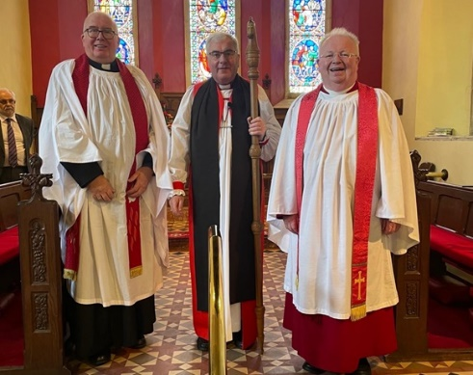

Bishop Kearon spoke of Canon Howard’s commitment to his diaconal and priestly duties, particularly his pastoral ministry in various parishes and of the challenges that faced all the clergy nowadays.

After the services, there was a Parish Picnic in the Barn at Larchfield Estate, by very kind permission of Gavin and Sarah Mackie. Expressions of congratulations and good wishes were expressed by the Bishop, Canon Moore, David Brown (Rector’s Churchwarden, Annahilt) and Abbie Stanford (Rector’s Churchwarden, Magherahamlet). Canon Howard spoke with great affection about the various parishes in which he had served, and the friendships he had made over the years. He thanked everyone who made up the capacity attendance in the Barn and the full congregations in both Churches which really ‘made’ a very real sense of occasion of the celebration of his 40th Anniversary.

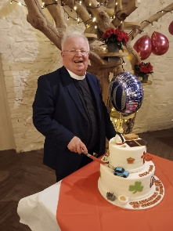

**Ordination 1984**

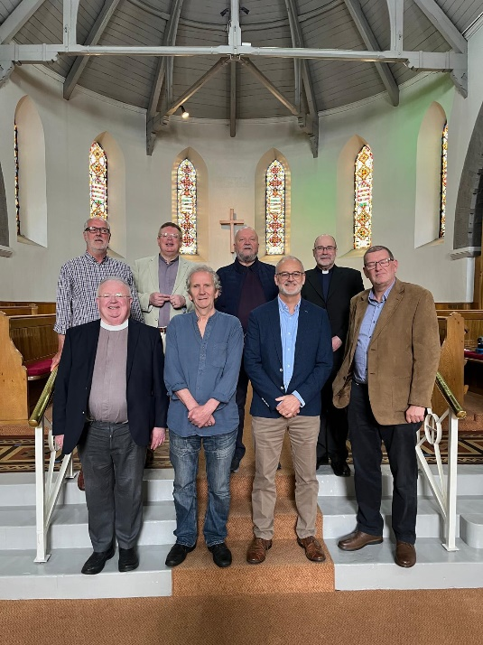

Eight of the clergy who were ordained Deacon 40 years ago met recently for a said Holy Communion Service & lunch afterwards.

Back, left to right Colin Hall Thompson (retired), Nigel Baylor (Jordanstown), Barry Payne (retired), Nigel Crossey (Dean of Kilmore)

Front, left to right: Robert Howard (Annahilt & Magherahamlet), Robin Moore (retired), Chris Easton (Armoy), Jim Carson (St Stephen’s, Belfast).

Of those not in the photograph sadly 2 are deceased Sam Barton & Jan Taylor; two are unwell, Raymond Thompson & Tommy Allen; Gordon Wynne is now living in England; three were unable to come, Bishop Paul Colton, David Frazer, Robert Keogh.

**Congratulations….**

…to Mrs Sally McCurry on the recent celebration of her 80th birthday.

**Church Services in the Parishes of Annahilt and Magherahamlet**

*‘I was glad when they said to me: “Let us go to the house of the Lord”’*

Sunday 7 July  **Trinity VI**

10.00 Parish Communion Annahilt

12.00 Parish Communion Magherahamlet

Sunday 14 July **Trinity VII**

10.00 Morning Prayer Annahilt

12.00 Morning Prayer Magherahamlet

Sunday 21 July **Trinity VIII**

10.00 Parish Communion Annahilt

12.00 Morning Prayer Magherahamlet

Sunday 28 July **Trinity IX**

10.00 Morning Prayer Annahilt

12.00 Morning Prayer & Holy Baptism Magherahamlet *Service Sheets*

Sunday 4 August **Trinity X**

10.00 Parish Communion Annahilt

12.00 Parish Communion Magherahamlet

Sunday 11 August **Trinity XI**

10.00 Morning Prayer Annahilt

12.00 Morning Prayer Magherahamlet

Sunday 18 August **Trinity XII**

10.00 Parish Communion Annahilt

12.00 Morning Prayer Magherahamlet

Sunday 25 August **Trinity XIII**

10.00 Morning Prayer Annahilt

12.00 Morning Prayer Magherahamlet

Sunday 1 September **Trinity XIV**

10.00 Parish Communion Annahilt

12.00 Parish Communion Magherahamlet

Sunday 8 September **The Birth of the Blessed Virgin Mary**

10.00 Family Service Annahilt *Service Sheets*

12.00 Family Service Magherahamlet *Service Sheets*

***PRAYER WARRIOR***

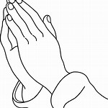

Do you have a concern or problem and would like someone to pray for you?

If so, contact the Rector who will be willing to help.

This is completely confidential and no details will be passed on to anyone else unless you want them to.

**028 9263 8218**

**From the Parish Registers**

**Christian Burials**

*‘In Christ shall all be made alive’*

27 June 2024

Thomas James (Tom) Russell, Kernaghan Park, Annahilt

*Following Services at home and in the Church of the Ascension burial took place in adjoining Churchyard*

Thomas James Russell was born in Ballymacash on 8 September 1942 the only son Thomas and Elizabeth and brother of Jean, Arlene and Audrey. He was initially educated at the Primary School in Ballymacash, then the William Foot Memorial Primary School and later at Lisburn Tech. in his mid-teens, he completed his apprenticeship as an Electrician and then began contracting on various building sites. He became Contracting Manager in Bemac Electrics and then with Satchwell Grant, a United States Firm. He ultimately completed his career with Sanmina as Facilities Manager. In business he was well known and established numerous contacts and connections.

Aged 17, Ann met Tom at ‘The Top Hat’, Lisburn and they never parted afterwards. They were married in Shankill Parish Church, Lurgan by the late Dean Samuel Crooks. They set up home on Drumbeg Drive initially at no 19 and then at no 109. They had a family of two, Brian and Diane. In 1993 they moved to Annahilt.

While they had differences of opinion, Diane would testify that she never witnessed any argument between them.

Tom was a characteristic ‘people person’. He loved company and avoided confrontation, He happily engaged in conversation and always enjoyed a joke. He loved his holidays when he also ‘gelled’ with people and made many friends especially in Spain and particularly in Majorca.

Tom gave his time freely to other people and would have always been helpful to them. He was a devoted father and grandfather who loved good honest fun and carefully planned taking his grandchildren to Wallace Park.

A keen gardener, he enjoyed chatting to neighbours when they were also working outside. He also enjoyed a spot of fishing. It was said Tom ‘fantasised’ about playing golf, he got a set of clubs which were never used! He watched some TV enjoying football and tennis and joined Ann in watching the Soaps!

We extend our deepest sympathy to Ann, Brian, Diane and the entire family circle in their great loss.

**Flowers for the Churches**

**Annahilt Magherahamlet**

**July Annahilt Magherahamlet**

7 Mrs B Harrison Mrs S McCurry

14 Mrs B Oliver The Rector

21 Mrs B Oliver The Rector

28 Dr & Mrs W Chambers

**August**

4 Dr W & Mrs Chambers Miss V Begley

11

18 The Rector

25 Mrs E Crawford



**Church Cleaning, Annahilt**

**Month**

**July**

5-6 Mrs L McCambley Mrs E Harrison

12-13 Mrs E Crawford

19-20 Mrs S Chapman Mr S Chapman

26-27 Mrs J Bolas Mr A Bolas

**August**

2-3 Mrs H Hill Mr T Hill

9-10 Mrs J Guiney Mrs H Cardosi

16-17 Mrs A Maxwell Mr R Maxwell

23-24 Mrs L McCambley Mrs E Harrison

30-31 Mrs E Crawford

**September**

6-7 Mrs S Chapman Mr S Chapman

13-14 Mrs J Bolas Mr A Bolas

20-21 Mrs H Hill Mr T Hill

27-28 Mrs A Maxwell Mr R Maxwell

**October**

4-5 Mrs J Guiney Mrs H Cardosi



**Reminder dates for your diary:**

MU Diocesan Holy Communion Service Thursday 1st August 11:15am in Down Cathedral.

**MU Diocesan Big Hymn Sing Sunday 8th September 7pm in St. Finnian’s Parish Church.** Following the service, refreshments will be served in the Huston Hall. Everyone is very welcome.** ** If you would like to nominate your favourite hymn/worship song please let any of the Committee know what it is and we will put it forward for consideration-hymns chosen will depend on how many votes each hymn receives.

**THE MARY SUMNER PRAYER**

All this day, O Lord

Let me touch

As many lives as possible for thee;

And every life I touch,

Do thou by thy spirit quicken

Whether through the word I speak,

The prayer I breathe,

Or the life I live.

**Amen**.

**THE MOTHERS’ UNION PRAYER**

Loving Lord,

We thank you for your love so freely given to us all.

We pray for families around the world. Bless the work of the Mothers' Union as we seek to share your love through the encouragement, strengthening and support of marriage and family life.

Empowered by your Spirit, may we be united in prayer and worship, and in love and service reach out as your hands across the world.

In Jesus' name**. Amen.**

**Wave of Prayer: July 2024**

1 July: Eastern Zambia in Zambia; Mombasa in Kenya; Gwagwalada & Ekiti-West in Nigeria; Leicester in England and Temotu in Solomon Islands

2-4 July: Renk in South Sudan; Cyangugu in Rwanda; Arochukwu/Ohafia & Ile- Oluji in Nigeria; St Andrews, Dunkeld & Dunblane in Scotland and Sittwe in Myanmar

6-8 July: Wad Medani in Sudan; Kondoa in Tanzania; Ikwo & Remo in Nigeria; Montreal in Canada and the Windward Islands in St. Lucia, Grenada, St Vincent & The Grenadines

9-11 July: El Obeid in Sudan; Butere in Kenya; Nnewi in Nigeria; London in England and the Province of the USA

13-15 July: Toliara in Madagascar; Mbale in Uganda; Zaria & Ndokwa in Nigeria; Rochester in England and Chhattisgarh in India

16-18 July: Lake Malawi in Malawi; Byumba in Rwanda; Jalingo in Nigeria; St Edmundsbury & Ipswich in England and Lucknow in India

20-22 July: Gitega in Burundi; Murag’a South and Mbeere in Kenya; Enugu North in Nigeria; Tonga in Diocese of Polynesia and Jaffna in Diocese of Church of South India

23-25 July: George in South Africa; Bungoma in Kenya; Western Tanganyika in Tanzania; Ideato in Nigeria; Sodor & Man in Isle of Man and Toronto in Canada

27-29 July: Northern Zambia in Zambia; Mpwapwa in Tanzania; Gusau & Osun in Nigeria; Sydney in Australia and Rayalaseema in India

30-31 July: Boga in DR Congo; Manicaland in Zimbabwe; Tanga in Tanzania; Ogoni in Nigeria; Carlisle in England and Melbourne in Australia

**Wave of Prayer: August 2024**

1 August: Boga in DR Congo; Manicaland in Zimbabwe; Tanga in Tanzania; Ogoni in Nigeria; Carlisle in England and Melbourne in Australia

3-5 August: Juba in South Sudan; Kitale in Kenya; Minna & Lagos in Nigeria; Moray, Ross & Caithness in Scotland and Madurai-Ramnad in India

6-8 August: Northern Malawi in Malawi; Eldoret in Kenya; Ngbo & Akure in Nigeria; North West Australia in Australia and Aipo Rongo in PN Guinea

10-12 August: Niassa in Mozambique; Masindi Kitara in Uganda; Langtang & Esan in Nigeria; North Queensland in Australia and Kolhapur in India

13-15 August: Natal in South Africa; Kajiado in Kenya; Okigwe & Western Izon in Nigeria; Nova Scotia & Prince Edward Island in Canada and Toungoo in Myanmar

17-19 August: Kasai in DR Congo; Shyira in Rwanda; Ijumu & Egba West in Nigeria; Liverpool in England and Sambalpur in India

20-22 August: Central Zimbabwe in Zimbabwe; Lango in Uganda; Kebbi in Nigeria; Tamale in Ghana; Sheffield in England and Guadalcanal in Solomon Islands

24-26 August: Saldanha Bay in South Africa; Karamoja in Uganda; Udi & Etsako in Nigeria; Wellington in New Zealand and Yangon in Myanmar

27-29 August: Matabeleland in Zimbabwe; Mount Kenya Central in Kenya; Niger West in Nigeria; Wangaratta in Australia; Clogher in All Ireland and Hpa-An in Myanmar

31 August: Harare in Zimbabwe; Machakos in Kenya; Ogori-Magongo & Ekiti in Nigeria; Southwark in England and Phulbani in India

**Bible Week 2024**

We hope you’ll join us at the end of the summer for this year’s Bible Week with the Rt Revd Stuart Bell. Stuart is an Assistant Bishop in the Anglican Convocation in Europe with primary responsibility for Wales.

Bishop Stuart Bell

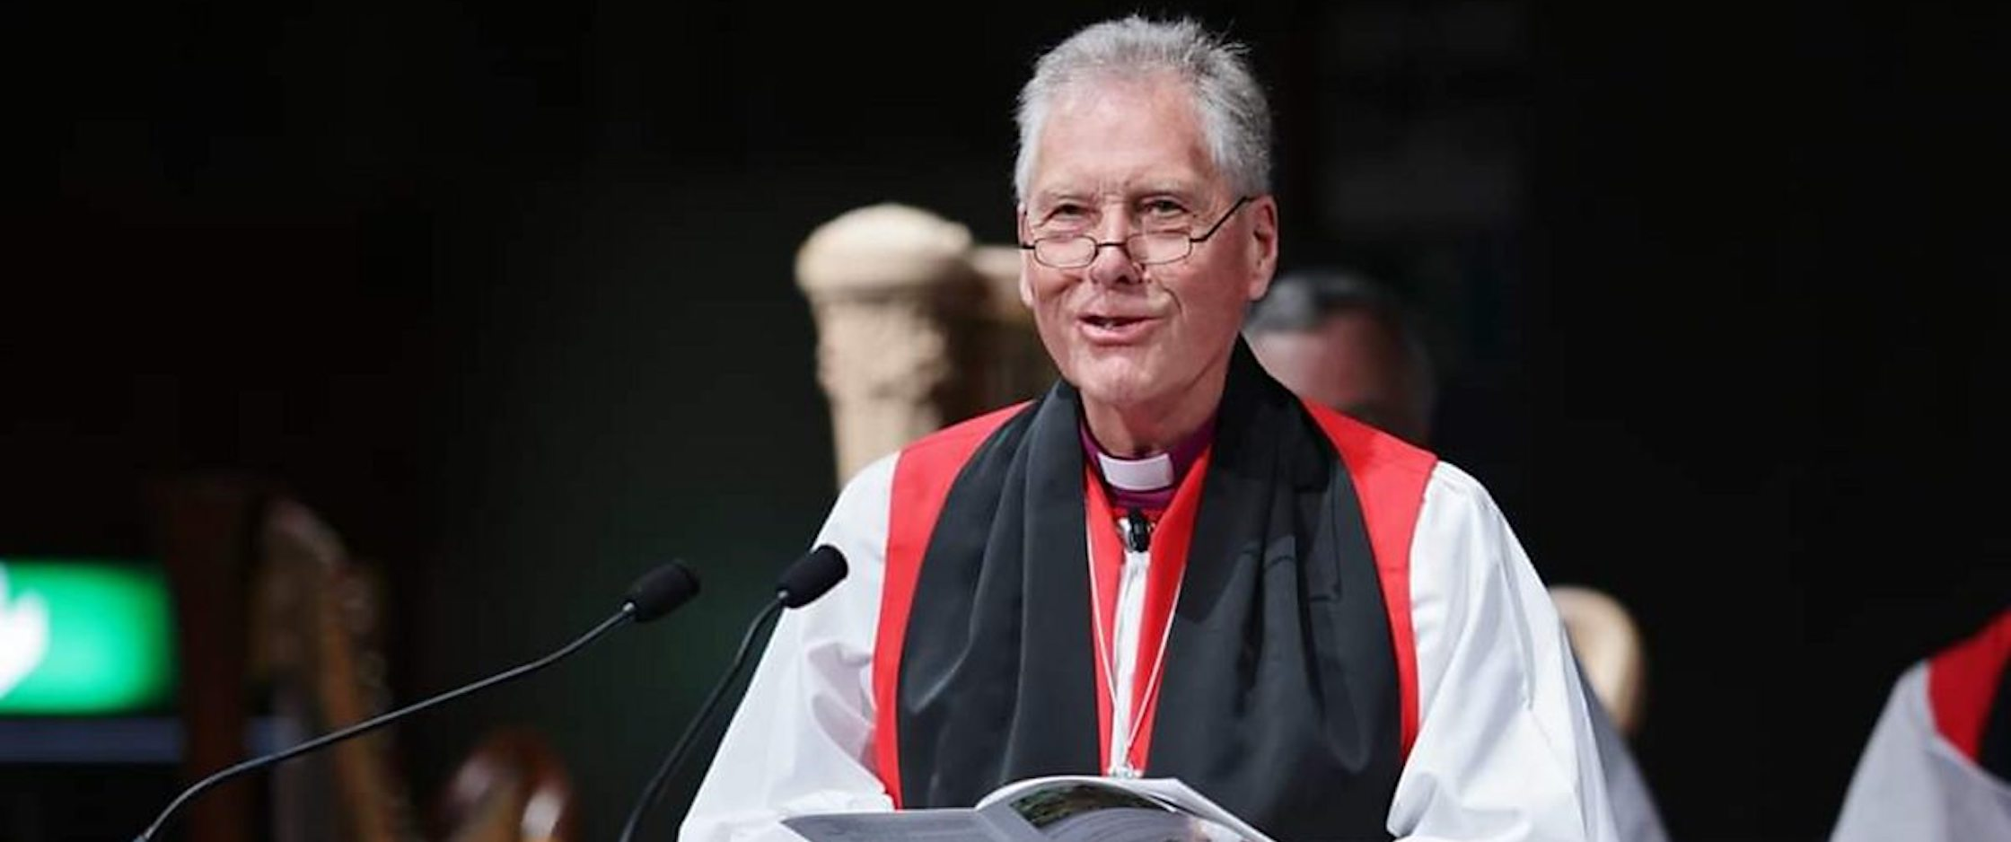

An Englishman by birth, Bishop Bell was formerly a Canon of the Church in Wales and a former rector of St Michael’s Church, Aberystwyth, the largest Anglican congregation in Wales.

As well as inspiring teaching, our annual Bible Week includes worship and prayer ministry. It is a wonderful opportunity for clergy, leaders and parishioners alike to be refreshed ahead of the busy autumn term.

**Our venue this year is St Saviour’s Dollingstown and the dates are** **Tuesday 27 – Friday 30 August. Don’t miss it!**

Top of Form

Top of Form

**Coffee and Craic**

Following the very successful Spring Wellness events held earlier in the year and a desire from those present to attend something similar in the future the organising committee is planning a "Coffee and Craic" morning in the parochial hall on Wednesday 18th September 2024 from 11am-12.30pm. The morning will be very informal and an open invitation is extended to all in the parishes and the community. At this stage the thoughts are that we would follow up with future events in possibly November 2024 and February 2025. Light refreshments will be served and there is no need to book. If anyone has any queries, please contact Patricia on 028 92665310 or 07713 257691

**Financial matters**

The Parish Treasurers would like to thank those Parishioners who responded to previous invitations to arrange a standing order, make a direct bank payment to the Parish or post a cheque to the Treasurer in lieu of or as a supplement to their weekly envelopes during the current emergency.

If you have not yet availed of one of these methods of giving and would wish to do so, please contact:

Annahilt – Miss Patricia Halliday Email [patriciaapc@btinternet.com](mailto:patriciaapc@btinternet.com) Telephone 028 9266 5310 Mobile 07713 257691

Magherahamlet – Hillary Edgar Email: [hillary.edgar01@btinternet.com](mailto:hillary.edgar01@btinternet.com) Telephone 028 4481 1361

**Recent collections - Annahilt**Children's Day-Air Ambulance            £127.50  
Christian Aid Coffee June                    £152.00  
Rector's 40th anniversary service-Bicycles for Maridi Diocese  £575.00  
Legacurry Orange Lodge-Orange Charities                                 £220.00

Christian Aid envelopes                    £125.00

**LISBURN FOODBANK**

The Lisburn Foodbank is providing an essential service to those within our community who are experiencing difficult times, often due to circumstances beyond their control.

The Foodbank provides emergency food and support to local people in crisis in the Lisburn area.

Parishioners may leave items for the Foodbank in the basket in Annahilt Church Porch, on the FIRST and SECOND Sunday of each month.

A particular request from the Foodbank is for cleaning items such as:

* small packs of toilet roll
* nappies
* baby wipes
* shower gel
* soaps
* washing powder

**YOUR HELP WOULD BE GREATLY APPRECIATED**.

**Parish Website:  AnnahiltAndMagherahamlet.org**

Parishioners are reminded that the website [annahiltandmagherahamlet.org](http://annahiltandmagherahamlet.org/) has been created to provide information on church related activities and organisations for parishioners and the wider community. The website also continues to host online services each Sunday. In addition, the website contains a list of upcoming church services and news from our group of parishes, as well as downloadable versions of the parish magazine.  The site will be continually developed, so if you have any submissions, suggestions or requests relating to the website, these can be sent to [admin@annahiltandmagherahamlet.org](mailto:admin@annahiltandmagherahamlet.org).



[www.annahiltandmagherahamlet.org](http://www.annahiltandmagherahamlet.org)

**Parish Magazine**

Any contributions for the next edition of the Parish Magazine should be left with the Rector or Roger Maxwell ([roger.maxwell1@btinternet.com](mailto:roger.maxwell1@btinternet.com)) by Sunday18 August 2024.

Registered as a charity with The Charity Commission for Northern Ireland

NIC103246 (Annahilt) and NIC102122 (Magherahamlet)