News from the Parishes
Church of the Ascension, Annahilt Magherahamlet Parish Church
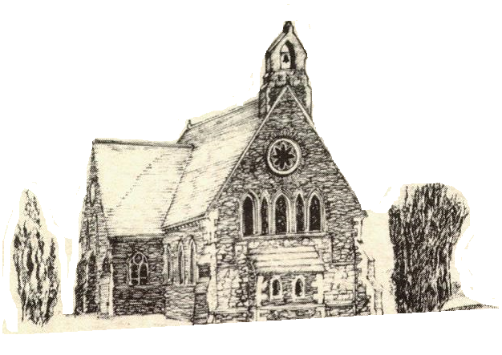

October/November 2022

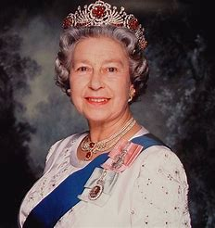
Her Majesty Queen Elizabeth II
21 April 1926 – 8 September 2022

Rector: The Revd Canon Robert Howard
15 Ballykeel Road, Hillsborough
BT26 6NW
Tel: 028 9263 8218
E-mail: jrobert.howard@btinternet.com
Website: www.annahiltandmagherahamlet.org

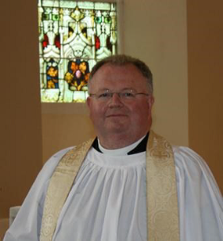The Rector writes….

My dear parishioners
When viewing the photographs taken of HM The Queen at Balmoral when she appointed the new Prime Minister one was immediately struck by how ‘old age’ was catching up with the elderly monarch. Nevertheless, despite her obvious physical frailty she looked well for her 96 years and was reported to be mentally very alert and in excellent spirits. Her declining health over recent months and her advancing years indicated that she was in the twilight days of her long reign. Yet, the Royal Family, the Nation and Commonwealth as well as the whole world were completely caught ‘on the hop’ by what transpired two days later on 8 September. The lunchtime statement of ‘concern’ for the Queen’s health followed later by the announcement of her death was in one sense expected yet also somehow shocking.
The passing of Queen Elizabeth II was momentous after a reign of over 70 years. Most people have no memory of any other British monarch. It was also historic with the end of the second Elizabethan age. Her people had felt a comfortable familiarity with the presence of Her Majesty on the balcony of Buckingham Palace during the recent Platinum Jubilee celebrations and on other national occasions over the years. Now they are experiencing an acute sense of grief and loss. Of course, she was not only our Sovereign but also a beloved wife, mother, grandmother and great-grandmother and it is her family who will experience those feelings the most.
I have always recognized and appreciated The Queen’s long life of duty and service as well as her deep Christian Faith. I had a great desire to mark the period of national mourning by paying my respects in person at the Lying-in-State at Westminster Hall. I joined the queue early on Friday afternoon and was admitted to the Hall 13 hours later early on Saturday morning. Without in any way being presumptuous or wanting to assume liberties I felt I was representing my family, friends and parishioners who could not travel.
There was a big physical effort involved in attending but I was sustained by the comradery of those nearby in the queue. There were so many different age groups, backgrounds, races and cultures which were all united in gratitude and respect. There was much friendly chat and there were recollections of seeing the Queen albeit at a distance. I met a lady from Northern Ireland who after her marriage 40 years ago to a gentleman from Belfast came to live in London and had remained there ever since. I was able to share that although I was never presented to the Queen, I was at a Garden Party hosted by her at Buckingham Palace at which I was accompanied by my late mother.
At Westminster Hall I was fortunate to see the Changing of the Guard before slowly walking down the steps and standing before the coffin. I prayed in remembrance of Her late Majesty and for the new King Charles III and all the Royal family. It was a deeply moving and religious experience which I will very gratefully remember as long as my memory lasts.

With very best wishes to everyone.

Your sincere friend and Rector

Robert Howard

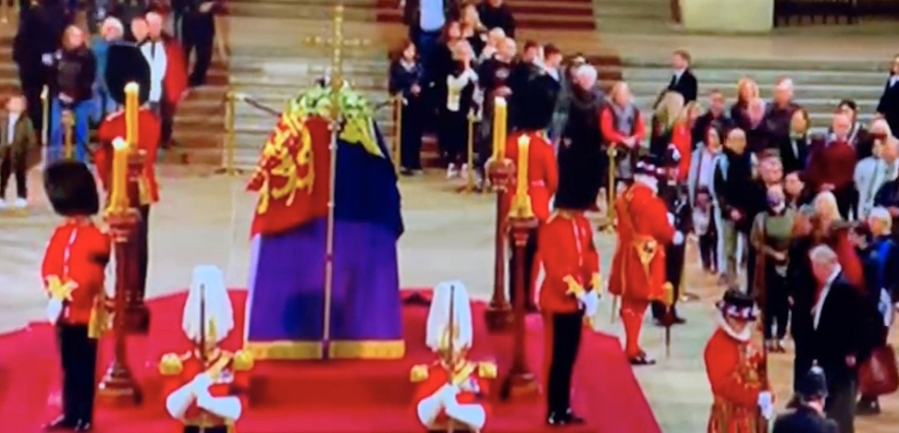

Prayers

Thanksgiving for the life of Her late Majesty Queen Elizabeth II
Merciful Father and Lord of all life,
we praise you that we are made in your image
and reflect your truth and light.
We thank you for the life of Her Majesty, Queen Elizabeth,
for the love she received from you and showed among us.
Above all, we rejoice at your gracious promise to all your servants, living and departed,
that we shall rise again at the coming of Christ.
We ask that in due time we may share with your servant Elizabeth
that clearer vision promised to us in the same Christ our Lord;
who is alive and reigns with you and the Holy Spirit, one God, world without end. Amen.

For those who mourn
Almighty God, Father of all mercies and giver of all comfort:
deal graciously, we pray, with all who mourn,
King Charles and the members of the Royal Family,
this Nation and all the Nations of the Commonwealth,
that casting all our care on you,
we may know the consolation of your love;
through Jesus Christ our Lord. Amen.
Most merciful God,
whose wisdom is beyond our understanding,
surround the people of Creeslough, Co Donegal with your love,
that they may not be overwhelmed by their enormous grief and loss following the recent explosion,
but have confidence in your goodness
and strength to meet the days to come.
We ask this through Christ our Lord.
Amen.

For King Charles III following his Accession
Lord God, the Ancient of Days,
you are sovereign over all your people;
Give to His Majesty, King Charles
enduring wisdom and faith
in the service of the people of this land
and of you, his Lord and master.
Grant that his reign may be one of faithful witness
And prove to others a source of hope,
that they may come to know more fully
your Son Jesus Christ,
who is alive and reigns with you and the Holy Spirit,
one God, now and forever.
Amen.

Reflections on Harvest Time in Annahilt

In Annahilt we gave thanks for the blessings of Harvest on Sunday 25 September. Much of the summer weather was good this year and harvest yields were bountiful. This was the first Harvest Festival without the restrictions which had to be imposed over recent years. As a result, the twin theme of celebration and thanksgiving was very evident throughout each of the services.
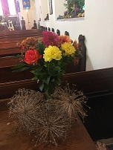
There were beautiful displays of flowers, along with fruit and vegetables. Last year and the year before there were real difficulties distributing fresh harvest produce afterwards. However, this year we were once again able to resume donating it to the Northern Ireland Hospice. Other parishioners continued the more recent practice of giving non-perishable food items which were later donated to the Foodbank.
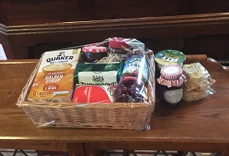
There was a lovely atmosphere of worship on Sunday. In the morning, a Celebration of the Holy Communion was presided over by the visiting Preacher, the Most Revd John McDowell, Archbishop of Armagh and Primate of All Ireland, assisted by the Rector, Canon Robert Howard. The special music featured a solo ‘Look at the World’, sung by Mrs Hailey Howe. The Choir sung a responsorial setting of Psalm 67. There was also a sung version of the Lord’s Prayer and a musical setting of the ‘Gloria in excelsis’.
In the evening, an uplifting Service of Praise, Readings and Thanksgiving was conducted by the Rector. Special Guests were the Baillies’ Mills Accordion Band who, together with the Organist, led the congregational singing in very familiar Harvest hymns as well as some not so well known ones. This marked a very different order of service to what was usual at Harvest time but was very well received by all present. It was wonderful that the Harvest Supper could take place again with most of the congregation in the Parochial Hall afterwards.
At the conclusion of each Service the Rector thanked all those who had provided gifts and those who assisted with the decoration of the church. He expressed particular appreciation of the playing of our Organists, Mr Tim Howe in the morning and Mr Timothy Wilson in the evening. In addition, he expressed gratitude to the Churchwardens who co-ordinated the seating arrangements in addition to their normal duties, also to Colin Hassard for type setting the Orders of Service and to the visiting preachers.
Mr Stephen Dickson spoke on behalf of the Band and thanked the Choir for entertaining all present to supper.
The following message message of thanks from Northern Ireland Children’s Hospice for the produce received following the harvest services in Annahilt.

‘With sincere thanks to the parishioners of Annahilt for the lovely hamper of fresh fruit and vegetables donated to us at harvest. It was much appreciated and enjoyed by the children and their nurses. Please pass on our grateful thanks to everyone involved.’

Congratulations…..

…..to Maud and William Harrison, Annahilt on the celebration of their Golden Wedding Anniversary.

SUNDAY SCHOOL IS BACK!

WHEN? Annahilt at 10.00am
Magherahamlet at 11.00 am

WHERE? Parochial Hall

After the summer break, we are delighted that Sunday Schools are back in the respective Parochial Halls at 10.00am in Annahilt and 11.00am in Magherahamlet.
It will be great to see everyone again and any children in P1-P7 who would like to come along will be very welcome. We will be having fun as always learning Bible stories, making crafts and playing games.
If you are thinking about sending your child and have any queries, please contact the Rector.

At Parish Communion in Magherahamlet on Sunday 4 September the Rector dedicated a set of stoles in the liturgical colours of green, white, violet and red for use in the Parish Church. The stoles originally belonged to Canon Eric Kingston, late Rector of the Parish and were very kindly presented by his wife Mrs Kathleen Kingston and the family circle in his memory.
(The Rector with Mrs Kingston, daughters Susan and Helen and sons-in-law Aubrey Magill and Stuart McAtee)
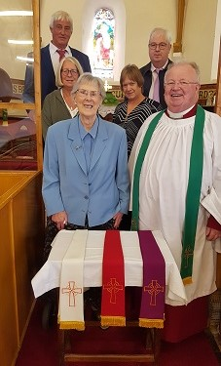
Church Services in the Parishes of Annahilt and Magherahamlet

‘I was glad when they said to me: “Let us go to the house of the Lord’ Psalm 122 v1

Sunday 2 October Trinity XVI
10.00 Parish Communion Annahilt
12.00 Parish Communion Magherahamlet

Sunday 9 October Trinity XVII
10.00 Family Service & Holy Baptism Annahilt Service sheets
12.00 Family Service & Holy Baptism Magherahamlet Service sheets

Sunday 16 October Trinity XVIII
10.00 Parish Communion Annahilt
12.00 Morning Prayer Magherahamlet

Sunday 23 October V Sunday before Advent
10.00 Service of the Word & Holy Baptism Annahilt Service Sheets

Magherahamlet Harvest Festival

Sunday 23 October 2022
12.00 noon Harvest Parish Communion Service Sheets
Preacher: The Rector

7.00pm Harvest Praise Service Sheets
Readings, Anthems & Hymns to celebrate Harvest

led by Baillies’ Mills Accordion Band

Supper afterwards in the Parochial Hall

Sunday 30 October IV Sunday before Advent
10.00 Morning Prayer & Litany Annahilt
12.00 Morning Prayer & Litany Magherahamlet

Sunday 6 November Festival of All Saints
10.00 Parish Communion Annahilt
12.00 Parish Communion Magherahamlet

Sunday 13 November Remembrance Sunday
10.00 Morning Prayer & Act of Remembrance Annahilt Service Sheets
12.00 Morning Prayer & Act of Remembrance Magherahamlet Service Sheets

Sunday 20 November Christ the King
10.00 Parish Communion Annahilt
12.00 Morning Prayer Magherahamlet

Sunday 27 November Advent Sunday
10.00 Hymns and Readings for Advent Annahilt Service Sheets
12.00 Hymns and Readings for Advent Magherahamlet Service Sheets

Sunday 4 December Advent II
10.00 Parish Communion Annahilt
12.00 Parish Communion Magherahamlet

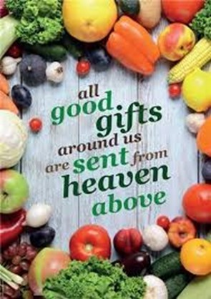

Decoration of Magherahamlet Church for Harvest
Saturday 22 October
From 2.00 pm
Gifts of flowers, greenery, corn, and other non-perishable foodstuffs will be gratefully received
Your assistance with the decoration will also be greatly valued

Magherahamlet Harvest Appeal
Harvest Thank Offering envelopes are included with this magazine. Once again we have the opportunity of thanking God for all his love and goodness, especially in the realms of nature. We can also do this by making as worthwhile and generous a thank offering as possible. The Thank Offering envelope may be returned at either of the Harvest Services.
Magherahamlet Harvest Supper
Unfortunately, due to public health restrictions we were unable to host the traditional Harvest Supper over the past 2 years. Now that circumstances have improved, with great pleasure, the Harvest Supper will resume this year in the Parochial Hall following the Evening Service on Sunday 23 October at 7.00 pm.
It is hoped that parishioners, visitors and friends will avail of this occasion for engaging in face-to-face fellowship and conversation which was not possible over the various lockdown periods.

Children’s Harvest Offerings
The younger members of the congregation are asked to bring a non-perishable item of food (eg a packet of biscuits or a tin of fruit) to the 12 noon service on Harvest Sunday. They will have the opportunity of making their own Harvest Offerings during the service.

In Memoriam
On the Sunday after All Saints Day (6 November) at the 10.00 am and 12 noon services in Annahilt and Magherahamlet respectively, we will remember by name those from each parish who have died during the past year.

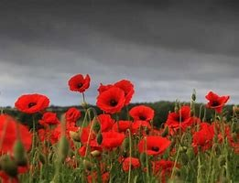Remembrance Sunday, 13 November 2022
On the 11th of November 1918 Private Arthur Wrench of the Seaforth Highlanders wrote in his diary: “I think it is quite hopeless to describe what today means to us. We who will return to tell people what war really is surely hope that 11 am this day will be of great significance to generations to come. Surely this is the last war that will ever be between civilised nations.” From our perspective what a terribly tragic irony.
We pause to remember all those who have fallen in wars present and past. Some of you will have a personal memory of losing a member of your own family or friend, but for many of us it will be an inherited memory, passed on from one generation to the next.
It is 104 years since the Armistice was signed at the end of the First World War, and 98 years since the Cenotaph was unveiled and the Unknown Warrior was buried in Westminster Abbey.
These things are part of history, but for millions of people since then war has not been history but a part of their lives.
How do we define a war? So often we hear and read about the number of deaths and injured; the length of campaigns, the number of guns and missiles and the size of the armed forces. Perhaps the numbers suggest the scale of a conflict, but I suggest that statistics have little, if any, relevance to those who have lost a son, daughter, brother, sister, father or mother.
Several years ago I accompanied a group of Yr 9 girls on their annual history trip to the Belgian battlefields. On one evening we all went to the Menin Gate at Ypres for the ceremony of the last post. This is performed every evening at 8.00pm and shows the gratitude of the Belgian people to those who fought and died in protecting their country. It was a very moving ceremony and had a profound effect on the girls. We had brought a wreath with us and two of the girls laid this beside the others.
It is eternally important that we remind ourselves of the dreadful cost of war if we are ever to live in peace. The most compelling outward sign of our remembrance is the simple red flower, the Flanders Poppy. It has become the symbol of the Royal British Legion, but more than that, across the world, it has come to represent the sacrifice made by all those men, women and children who have given their lives in conflict.
From early history flowers have become symbols, Lilies for purity, Roses for love and for England, Daffodils for the Marie Curie charity and for Wales, Thistle for Scotland and the Shamrock for Ireland and for the Holy Trinity – Father, Son and Holy Spirit. But, how was the poppy chosen as the universal symbol of remembrance?
As you might expect, it began with a death, the death of a friend of a man called John McCrae in 1915 in Belgium. John McCrae was kneeling at the grave of his friend and was moved to write a poem reflecting the scene around him. He wrote:
In Flanders fields the poppies blow
Between the crosses, row on row
That mark our place; and in the sky
The larks, still bravely singing, fly
Scarce heard among the guns below.
We are the dead. Short days ago
We lived, felt dawn, saw sunset glow,
Loved and were loved, and now we lie In Flanders fields.
McCrae himself was unhappy with the poem and he threw it aside, but one of McCrae’s fellow officers found it and was so touched that he sent the poem to England where it was published in the magazine Punch.
As a result, the scarlet poppy quickly became the symbol for soldiers who died in battle.
In 1921, the Royal British Legion was founded and began the Poppy Day Appeal to raise money for poor and disabled veterans, and now the Poppy campaign is the Royal British Legion’s most important activity.
The appeal continues to raise the funding needed to help all service-men and women and their families in the most practical way. However, critically, the appeal serves to maintain our awareness of our past, and present, in order that our prayers for peace, and the future of our families, our children and grandchildren, will be fulfilled.
Adapted from talk written by the Revd John Brown in 2011

A Prayer to be said by families visiting a war grave or memorial:

Lord Jesus, we believe that you stood beside N and his fellow-soldiers as they fought to bring peace to your world.
We believe that you have stood among us as we have tried to imagine the fear and pain and loneliness of the wounded and the dying on the battlefield.
We believe that you stand beside us now, as we remember and honour N.
In your great mercy, bless our good memories, comfort us when we grieve for the life that might have been, and strengthen us in all we do to seek the peace and freedom which are your desire for the world. Amen.

From the Parish Registers

Holy Baptism
‘Go therefore and make disciples of all nations, baptising them in the name of the Father and of the Son and of the Holy Spirit’’

9 October 2022
Church of the Ascension, Annahilt
Max Charles, son of Andrew and Amy Corry

Magherahamlet Parish Church
Autumn Laura, daughter of Ryan and Laura Sweeney

Philippians 4:13 God gives me strength

Prayers for climate change

Creator of our common home,
You fill the earth and sea and sky with life
Forgive us our neglect of your creation
The choking waste of our pollution
The damage done by careless habits
And our indifference to future generations.
Help us to amend our lives
To refuse more plastic if we can’t reuse it
To lift our voice for lasting change
And to live well and gently on the earth
To the glory of your Son, the Living Word
Through whom you made this fragile world.

Amen.

Creator God,
We acknowledge that as your handiwork, we stand alongside all that you have made.
Trees and rivers, mountains and valleys, soaring birds and scuttling creatures, all are held within your care.
May we grow in our love and appreciation for the fabulous variety around us and may our awe and wonder draw us closer to the natural world and through it to you, the God of all things.
We pray in Jesus name,

Amen.

God of life, we praise you for the beauty of creation, its richness and variety; yet, through greed and ignorance, we scar your world with plastic waste and throw so much away.
Make us more like Jesus, treading gently on our common home, and breathe your Spirit on us, that we may care more deeply for your Earth.
We ask this through Jesus Christ our Lord.

Amen.

PRAYER WARRIOR

Do you have a concern or problem and would like someone to pray for you?
If so, contact the Rector who will be willing to help.
This is completely confidential and no details will be passed on to anyone else unless you want them to.

Telephone: 028 9263 8218
Flowers for the Churches
Annahilt Magherahamlet
October
2 Miss V Begley
9 Mrs B Oliver
16 Mrs B Oliver Mrs F Magorrian
23 Mrs B Harrison Harvest
30
November
6
13 Remembrance Sunday Remembrance Sunday
20
27 Mrs M McCauley

Church Cleaning, Annahilt
Month
October

21-22 Mrs J Bolas Mr A Bolas
28-29 Mrs E Ogle

November
4-5 Mrs H Hill Mr T Hill
11-12 Mrs A Maxwell Mr R Maxwell
18-19 Mrs L McCambley Mrs E Harrison
25-26 Mrs E Crawford
December
2-3 Mrs J Guiney Mrs H Cardosi

Dear Mothers’ Union Members and Friends,
Please remember to pray for each other. Special requests for prayers can be made through the Mother’s Union Prayer Chain.

On Monday 17th October at 8pm: Annahilt Mothers’ Union have invited guest speaker Carol Fulton to give ‘An entertaining talk on the 1960’s’. Visitors welcome.

On Wednesday 19th November Magherahamlet Mothers’ Union will arrange flowers for the Harvest Festival.

On Monday 7th November at 7.30pm Mothers Union members have been invited to ‘a Worldwide Evening at St. Ignatius Parish Church where the guest speaker will be Worldwide President, Sheran Harpur.

On Monday 14th November at 8pm Annahilt Mothers’ Union will be enjoying a Fun and Festive Evening of Christmas Crafts. Visitors are welcome.

With very kind regards and every blessing

Beth Avril
Esme Ann

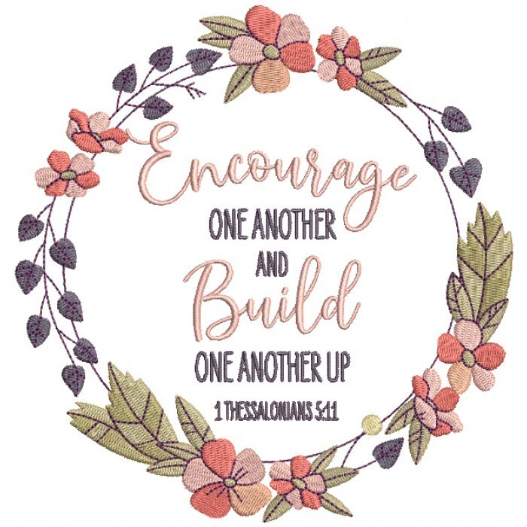
Mothers’ Union—Midday Prayers—October 2022
Transformed Lives

Monday: Zaccheus
Zacchaeus said to the Lord,
“Here and now I give half of my possessions to the poor, and if I have cheated
anybody out of anything, I will pay back four times the amount.”
Luke 19: 8
Lord, transform our hearts, transform our lives. Work deeply within to bring newness and change that we may be channels of your love and blessing for the world.
Like Zacchaeus, help us, O God, to lose our fear of stepping outside our place, of doing things differently, of seeking Christ in our lives. Christ’s invitation awaits us to start anew, to make amends, to live in Christ’s way.
God of change and renewal, we give thanks for your love that makes this possible for each one of us.
Amen.

Tuesday: Mary of Nazareth
The angel said: “Nothing will be impossible with God.” Mary said, “Here am I, the servant of the Lord; let it be with me according to your word.”
Luke 1:37-38 (NRSV)
Lord, transform our hearts, transform our lives. Work deeply within to bring newness and change that we may be channels of your love and blessing for the world. Lord, like Mary, you call us to lives of obedience and faith.
Forgive us when we ignore your voice and surrender to doubt and fear. Lord, like Mary, you call us to lives of acceptance and praise.
Forgive us when we reject your ways and surrender to selfishness. God of mercy and grace forgive our faults and weaknesses. Transform us into people of obedience and faith that all things are possible with God.
Amen.

Wednesday: Bartimaeus
Bartimaeus said, “Rabbi, I want to see.”
Jesus said, “Go, your faith has healed you.” Immediately he received his sight and followed Jesus along the road.
Mark 10:51-52
Lord, transform our hearts, transform our lives. Work deeply within to bring newness and change that we may be channels of your love and blessing for the world. God, who gives sight to the blind, flood the eyes of our hearts with light and transform our clouded vision. We pray for those whose vision is clouded by the storms of life; where knowledge is partial and understanding blurred. Help us to shine with your light through mists of confusion and hurts. Help us to share the power of your love to bring clearer insight and healing.
Amen.

Thursday: Woman at the well
Jesus said to her, ‘Everyone who drinks this water will be thirsty again, but whoever drinks the water I give them will never thirst. Indeed, the water I give them will become in them a spring of water welling up to eternal life.’ John 4:13-14
Lord, transform our hearts, transform our lives. Work deeply within to bring newness and change that we may be channels of your love and blessing for the world.
Still us, God, so we might listen to you speaking to us, knowing us, seeing us, loving us. Fill us with your Living Water that will transform our spirits and souls into springs that burst forth with life and love for your people, for ourselves, and for our world.
Amen.

Friday: Lazarus
Jesus called in a loud voice, ‘Lazarus, come out!’ The dead man came out, his hands and feet wrapped with strips of linen, and a cloth round his face. Jesus said to them, ‘Take off the grave clothes and let him go.’ John 11:43-44 Lord, transform our hearts, transform our lives. Work deeply within to bring newness and change that we may be channels of your love and blessing for the world. Holy God, Creator of Life, you call us out of our dark places, offering us the grace of new life.
When we see nothing but hopelessness, you surprise us with the breath of your Spirit.
Call us out of our complacency and routines, set us free from our self-imposed bonds, and fill us with your Spirit of life, compassion, and peace.
Amen.

Saturday: Mary Magdalene
Jesus said to her, “Mary.”
Mary Magdalene went to the disciples with the news: “I have seen the Lord!” And she told them that he had said these things to her.
John 20: 16, 18
Lord, transform our hearts, transform our lives. Work deeply within to bring newness and change that we may be channels of your love and blessing for the world. May the risen Christ who called Mary by her name come to us to reassure us that he knows us and loves us as if there was no one else.
May he fill us with his life and his love, for our own sake, in the service of others, and above all to his everlasting glory.
Amen.

Thank you……

To all who contributed to recent special collections:

Annahilt Magherahamlet

Special collection for Pakistan Floods £202.70 £125.00
Mothers Union service for Pakistan Floods £91.00 £141.00
Harvest collection and envelopes £915.00
Christian Aid Coffee October £121.00
Mission to Seafarers (August) £141.00 £83.00

Financial matters
Gift Aid
For those parishioners who currently Gift Aid their subscription-are you still a tax payer? If not, please contact the Parish Treasurers to update Parish records.
If you are a tax payer and do not currently Gift Aid your subscription (FWO) the Parish could benefit from an additional 25% income at no cost to you. Again please contact the Treasurers.
2023 FWO/Weekly Giving
Parishioners can contribute via weekly envelopes, monthly/annual Standing Order or a combination of both or by cheque/annual direct payment.
If you wish to change/amend or add to your method of giving please contact the Treasurers by 20th November prior to preparation of the 2023 envelopes.

Contact details
While we try to keep contact details up to date, sometimes parishioners move house and we don't have your new address.
Some no longer have or use landline telephone numbers and only use mobile numbers. It would be helpful if your details have changed, if you could contact Patricia (Annahilt) on 028 92665310, Mobile 07713 257 691, email patriciaapc@btinternet.com or Hillary (Magherahamlet) on 028 44811361, email hillary.edgar01@btinternet.com with up to date details. The vast majority of contact numbers we hold are landline numbers. Your contact details are only used for Parish purposes.
Annahilt Harvest Envelopes
If you were unable to attend Annahilt Harvest Services but would still like to contribute to the collections towards the various Mission organisations, please send your envelope to Patricia at 35 Cabra Road, Hillsborough, BT26 6NB.

Friday 4th November 2022
In The Pheasant
7.45pm.

Admission £5, payable at the door

Proceeds in aid of Annahilt Parish Church Development Fund

Parish of Annahilt
is holding a
Christmas Fair
Friday 2 December 2022
7.00 pm – 9.00 pm
Parochial Hall
All welcome

Parish of Magherahamlet
is holding a
Christmas Fair
Saturday 3 December 2022
10.00 am – 12 noon
Parochial Hall
All welcome

LISBURN FOODBANK

The Lisburn Foodbank is providing an essential service to those within our community who are experiencing difficult times, often due to circumstances beyond their control.

The Foodbank provides emergency food and support to local people in crisis in the Lisburn area.
Parishioners may leave items for the Foodbank in the basket in Annahilt Church Porch, on the FIRST and SECOND Sunday of each month.
A particular request from the Foodbank is for items listed below:

Toiletries
Cleaning supplies
Small packs of toilet roll
Nappies
Baby wipes
Shower gel
Soaps
Small boxes of washing powder

YOUR HELP WOULD BE GREATLY APPRECIATED.

Parish Website: AnnahiltAndMagherahamlet.org
Parishioners are reminded that the website annahiltandmagherahamlet.org has been created to provide information on church related activities and organisations for parishioners and the wider community. Although circumstances have changed considerably since the various lockdown periods the website continues to host online services each Sunday. It also contains a list of upcoming church services and news from our group of parishes, as well as downloadable versions of the parish magazine. The site will be continually developed, so if you have any submissions, suggestions or requests relating to the website, these can be sent to admin@annahiltandmagherahamlet.org.

www.annahiltandmagherahamlet.org

Parish Magazine
Any contribution for the combined December 2022/January 2023 edition of the Parish Magazine should be left with the Rector or Roger Maxwell (roger.maxwell1@btinternet.com or magazine@annahiltandmagherahamlet.org) by Sunday 20 November 2022.

Registered as a charity with The Charity Commission for Northern Ireland
NIC103246 (Annahilt) and NIC102122 (Magherahamlet)
Top of Form

