News from the Parishes
Church of the Ascension, Annahilt Magherahamlet Parish Church
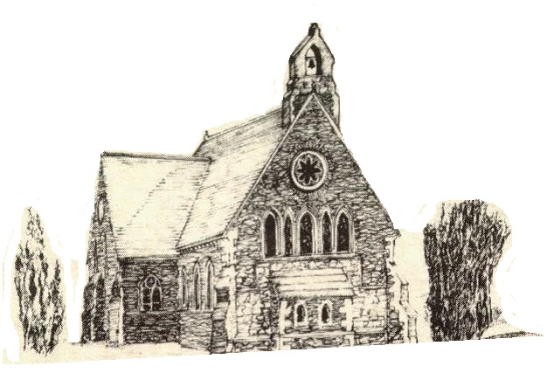

June 2021

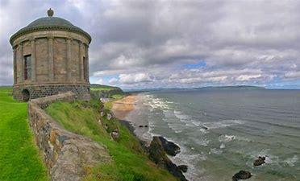

Rector: The Revd Canon Robert Howard
15 Ballykeel Road, Hillsborough
BT26 6NW
Tel: 028 9263 8218
E-mail: jrobert.howard@btinternet.com
Website: www.annahiltandmagherahamlet.org

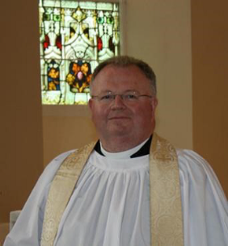The Rector writes….

My dear Parishioners

A couple of weeks ago at the time of the first anniversary of my dear mother’s death, I returned to my native city of Cork along with other members of my family. On Trinity Sunday, we attended a moving Service in the Church where once we worshipped regularly. The following day we gathered at my parents’ grave at the precise time my mother departed this life one year previously. Naturally we felt sorrow at the poignancy of the occasion. Yet on what was a beautiful sunny day we experienced a genuine feeling of peace that both our mother and father were reunited and at rest. We also felt profound thanksgiving for their lives and the example they set us over the years.
Returning ‘home’ in these circumstances perhaps inevitably evoked memories of times past. Much of my home city and its surrounding suburbs look the same, but landmarks have gone: the buildings of both the Primary and Secondary Schools I attended have been demolished and replaced with the finest up-to-date facilities. The once familiar distinctive ‘big name’ shops in the City Centre have long closed - Roches’ Stores, The Munster Arcade, Todko, Lipton’s, Smith Stores, Cashs, Bolgers, The House of Cassidy, Thompson’s Bakery, Scotts and Hadji Bey et Cie – in much the same way as Robinson & Cleaver, Robbs, the Co-Op and Anderson & McAuley have long ceased trading in Belfast. The once small village of Douglas where we grew up has continued to develop. It was once served by a small supermarket, a chemist, a Garda station, a post office, a newsagent, a bank, a fish and chip shop and some public houses. Nowadays there are two thriving shopping centres and numerous additional housing developments. An ever-expanding city suburb with an excellent network of roads will likely become a town in its own right.
Some friends and members of the extended family have moved on to pastures new, but many have died who were alive when I grew up in the city: my grandparents and now both parents. I expect many of you are able to tell similar stories.
I have, of course, been returning ‘home’ several times a year since I left for Theological College in 1981, but over my most recent visit I noticed the changes more.
It would have been easy to simply lament that life as I knew it had gone. Yet, I also realised that it was somewhat selfish to try to hold onto things as I wanted to remember them. I will no longer visit my native city in the same way that I have done previously. My parents’ home was the centre to which we were all drawn as family who now live in disparate places. Someone else now draws their family into that homely space in Douglas. Another person is now about to move into the sheltered housing apartment my Mum & Dad occupied in their twilight years.
Cork has formed me. Family life has shaped me, ‘Communities’ of school, university, church and leisure, moulded me. Who I am today is rooted in who I then was. It is the same for each of you. All of us bring our past into our present.
As a church community we are a canvas of individual stories, a rich tapestry of histories and experiences. Our stories matter, however ordinary they might feel.
Much of my life has been ‘ordinary’, perhaps you feel that of yours?
This month in the liturgical calendar, we enter ‘Ordinary Time’ when the stoles burses and veils, bookmarkers and frontals in church stay green for a long period. Green is a sign of life in nature, it represents the growth, life and hope inherent in each new day. So, however ordinary we may feel our stories have been, they will represent growth, life and hope for us as we live each day. Maybe each evening as we prepare to sleep, we can ask ourselves ‘where might the green shoots have been today!’ Then thank God for his goodness.

With very best wishes,

Your sincere friend and Rector

Robert Howard

Children’s Day, 13 June 2021
Children’s Day this year will take place on Sunday 13 June.
There will be Services in Annahilt & Magherahamlet at 10.00 am and 12.00 noon respectively at which the Rector will preach. Both services will include the annual Distribution of Church Loyalty and Sunday School Prizes which was postponed last year.
The Rector would appreciate a full attendance of parents, grandparents, relatives, parishioners and friends in support of our young people on their special day. On account of the Lockdown a year ago it was not possible to hold a Children’s Day service in Church. It would be great to support them by our presence at this event as we make another tentative step to a normal parochial schedule.

A Prayer for Children

Loving God,
your Son told his disciples
to become like little children.
Lead us to work for the welfare
and protection of all young people.
May we respect their dignity
that they may flourish in life,
following the example of the same
Jesus Christ our Lord. Amen.

Confirmation in Annahilt and Magherahamlet
On Sunday 20 June 2021 the Bishop, the Rt Revd David McClay will administer the Rite of Confirmation in our Group of Parishes.
Over many years Confirmation Services have alternated between our two Churches. However, in the exceptional circumstances of the present pandemic and to facilitate the attendance of family and friends of candidates as well as parishioners while maintaining safe distancing, the Bishop has very kindly and generously offered to hold a Confirmation Service in each Church. This is a ‘one off’ gesture made in the midst of current restrictions. It should not be taken as the ‘new normal’ future practice.
The Confirmation Service in the Church of the Ascension, Annahilt will be held at 3.00 pm and in Magherahamlet Parish Church at 6.30 pm.
Please let the respective Churchwardens know the service at which you intend being present. Their contact details are included elsewhere in this Magazine.
Please remember the candidates for Confirmation in your prayers:
From Annahilt:
Rhys Ewing
Alana Jiandani
Joshua McKeown
Emily O’Neill
Zara Saulters

From Magherahamlet:
Charlotte Moore
Mark Stanford
Sarah Wightman
Jenny Wightman

We thank you, our God and Father, for those who in confirmation, will make confession of their faith and be welcomed into the communicant life of the Church family in this place.
Help us each one, by our prayers, our friendship and our example, to encourage them in the way of Christ, that they may fully grow up into him and continue steadfastly in the worship and fellowship of the Church, to the glory of your name; through Jesus Christ our Lord. Amen.

Something to celebrate
We offer our heartiest congratulations to Mr & Mrs Robert T Carlisle on the recent celebration of their Diamond Wedding Anniversary. Bert & Ruth were married 60 years ago in Annaghmore Parish Church on 6 June 1961. They have lived in Annahilt almost their entire married life where they have made the Church of the Ascension their spiritual home.
Among the many cards and messages Bert & Ruth received was a special greeting from HM The Queen. During the Church Service on 6 June, on behalf of all in Annahilt Parish the Rector presented them with a bouquet of flowers.
We renew our congratulations to Bet & Ruth on attaining this wonderful milestone and wish them every blessing and happiness in the years ahead.

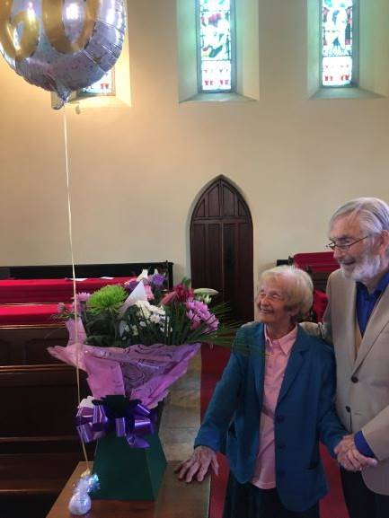

Hello, my name is Beth Wilson for those of you who don’t know me. I’ve been a member of Annahilt Parish for a long time but the past four years I have been studying English and Journalism at the University of Stirling in Scotland. I am excited to share with you all that this September I will be starting the Connect internship with The Navigators in Stirling.

The Navigators are a Christian charity founded by Dawson Trotman in America in 1933 and they exist to “advance the gospel of Jesus and His kingdom into the nations”. The Navigators’ (or Navs) work in Stirling involves running small group Bible studies which encourage maturity in faith and personal development. They also offer pastoral support and one to one meet ups with students.

In my four years studying at university I was part of a Navs small group which was a source of immense support and encouragement. This community helped to strengthen my faith and allowed me to build a lot of close friendships.

As a Connect worker I will be following a 12 month programme receiving teaching on theology and evangelism as well as working in Stirling leading small group Bible studies and checking in with students individually as a form of pastoral ministry. I will also be working alongside the university Christian Union to support the committee and assist with evangelical events. Each component of the Connect internship is geared towards the Navigators’ aim of ‘investing deeply in the lives of the few in order to reach the many.’ I look forward to telling you more about my work in the future!

Church Services in the Parishes of Annahilt and Magherahamlet

‘I was glad when they said to me: “Let us go to the house of the Lord”’

Sunday 6 June Trinity I
10.00 Parish Communion Annahilt
12.00 Parish Communion Magherahamlet

Sunday 13 June Trinity II
Children’s Day
10.00 Children’s Service & Prize Distribution Annahilt
SERVICE WILL TAKE PLACE IN THE PAROCHIAL HALL
12.00 Children’s Service & Prize Distribution Magherahamlet
SERVICE WILL TAKE PLACE IN THE PAROCHIAL HALL

Sunday 20 June Trinity III
9.30 am Holy Communion Annahilt SAID Service
10.00 No Service Annahilt
12.00 No Service Magherahamlet

3.00pm Rite of Confirmation Annahilt
Preacher: The Bishop
6.30 pm Rite of Confirmation Magherahamlet
Preacher: The Bishop

Sunday 27 June Trinity IV
Centenary of the State Opening of the first Parliament of Northern Ireland
10.00 Service of the Word Annahilt
12.00 Service of the Word Magherahamlet

Sunday 4 July Trinity V
10.00 Parish Communion Annahilt
12.00 Parish Communion Magherahamlet

Sunday 11 July Trinity VI
10.00 Morning Prayer Annahilt
12.00 Morning Prayer Magherahamlet

In-Church Worship in the Church of the Ascension, Annahilt and Magherahamlet Parish Church

Numbers are reduced at Services in both Churches because of the legal requirement to facilitate safe distancing. Because of this, it would be very helpful if those intending to come to church would give notice of their intentions.
Annahilt
Trevor Hill trevorhill111@btinternet.com
Magherahamlet
Hillary Edgar hillary.edgar01@btinternet.com

Alternatively, you may contact by telephone:
Annahilt
Trevor Hill 07890552930
Magherahamlet
George & Sally McCurry 028 9756 3955
Hillary Edgar 028 4481 1361

For Annahilt, notification of attendance can also be given via the Parish website up to the Friday before.

PRAYER WARRIOR
Do you have a concern or problem and would like someone to pray for you?
If so, contact the Rector who will be willing to help.
This is completely confidential and no details will be passed on to anyone else unless you want them to.
Telephone: 028 9263 8218

From the Parish Registers

Christian Marriage
‘What God has joined together let no one put asunder’

29 May 2021
Magherahamlet Parish Church

Ryan Sweeney and Laura Jennings
We congratulate Ryan and Laura and wish them every happiness.

Flowers for the Churches

Annahilt Magherahamlet
June
6 Mr & Mrs R Carlisle The Rector
13 Mrs L Crompton
20 The Rector The Rector
27 Mrs S McCurry

Church Cleaning, Annahilt
June
4-5 Mrs E Ogle
11-12
18-19 Mrs L McCambley Mrs E Harrison
25-26 Mrs H Hill Mr T Hill
July
2-3 Mrs E Crawford Mrs M Finlay
9-10 Mrs A Patterson
16-17 Mrs A Maxwell Mr R Maxwell
23-24 Mrs J Bolas Mr A Bolas
31- Aug1 Mrs J Guiney Mrs H Cardosi

General Prayers for different situations

Merciful God, come to the help of your people.
Be our shelter in this time of peril and strengthen the bonds of our community. Bring healing to all who suffer the ravages of disease and assist those whose skill and art can put an end to this affliction.
Through Christ our Lord.
Amen.

Wondrous God, author of life, you fashioned us in your likeness and breathed into us the life which is your own.
Be with those whose special care is the health of mind and body. Fill their hearts with awe for the life that is your gift and sustain them daily in your service, that their hands may bring to others the comfort of your healing touch.
Through Christ our Lord.
Amen.

Loving God, in Christ Jesus, the servant of all, you call us to the service of others. Grant to those who govern the community, the skill to recognise its urgent needs and the strength to pursue the common good. Endow us all with patience and courage, that we may care for the suffering, feed the hungry, shelter the homeless and sustain the needy.
Through Christ our Lord.
Amen.

Christ be with me, Christ within me,
Christ behind me, Christ before me,
Christ beside me, Christ to win me,
Christ to comfort me and restore me,
Christ beneath me, Christ above me,
Christ in quiet, Christ in danger, Christ in hearts of all that love me,
Christ in mouth of friend and stranger.
Amen.

Spirit of wisdom, Creator God, we give you thanks for all the ways you inspire your people, the ways you provide for them, and set great paths before them. We are grateful for the many small business owners who felt your creative call and pursued their dreams.
Gracious God, we know that you are the sustainer of our dreams, in prosperity and in hardship.
We pray for all those businesses who are suffering hardship because of the economic crisis caused by COVID-19.
May the communities these businesses serve rally to support them. Provide for all the people being impacted by this economic crisis, O God, the people employed by these small businesses and the families that are supported by their income. Protect them in this time of economic uncertainty, and fill their spirits with hope. Amen.

Dear Lord, You have commanded us to love our neighbours as ourselves. Help us to do that in our community and throughout our country. Help us understand the problems our fellow citizens are going through and find ways to help them in ways they need it most. Help us to love others no matter what their race or other differences. Help us to receive their love as well. Help us to not allow grievances to block giving or receiving love. Amen.

God, our rock, we pray for stability in this country that has been affected with disunity and discontent. Give us all wisdom to enable us to move forward successfully. Help us to strive to understand the others’ perspectives and to find common ground. Give us insight into what will best solve the complex problems we are facing. Help us to negotiate a new path that will be better and brighter than before. Amen.

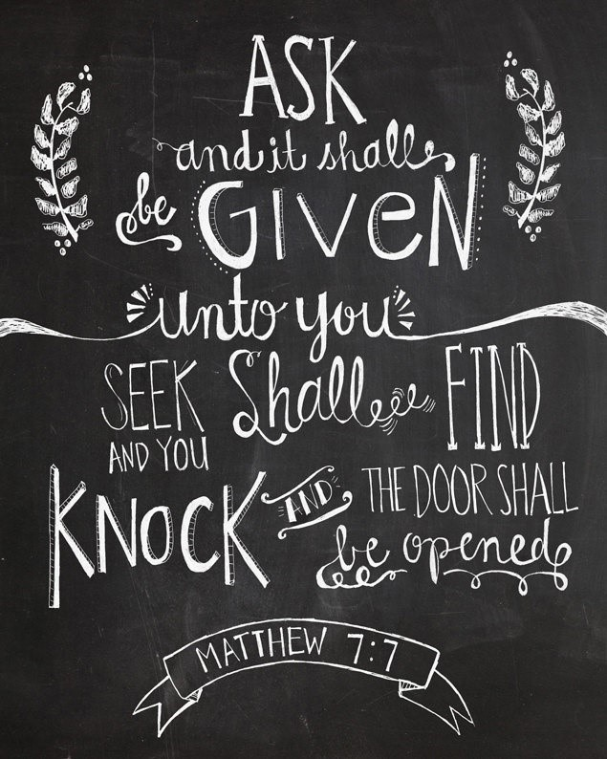
20th June—Fathers’ Day, a time to acknowledge male role models

In the UK, USA and Canada, the third Sunday in June (20th) is observed as Father's Day. It’s usually a good time for sons and daughters to take their father to his favourite restaurant, or whatever else he enjoys doing.
How will you celebrate it this year? If your own father cannot be with you, how about a Zoom meeting?
How were these special days ever started, anyway? Well, Father’s Day began in 1909 a woman in Spokane, Washington, named Sonora Louise Smart Dodd heard a church sermon about the merits of setting aside a day to honour one's mother. Mothering Sunday on the fourth Sunday in Lent was firmly established on the British Isles. However, Mother's Day was just beginning to gather widespread attention in the United States at that time. But Sonora Louise Smart Dodd knew that it was her father who had selflessly raised herself and her five siblings by himself after their mother had died in childbirth. So, the sermon on mothers gave Sonora Louise the idea to petition for a day to honour fathers, and in particular, her own father, William Jackson Smart.
Sonora Louise soon set about planning the first Father's Day celebration in Spokane in 1910. With support from the Spokane Ministerial Association and the YMCA, her efforts paid off, and a ‘Father’s Day’ was appointed. Sonora Louise had wanted Father’s Day to be on the first Sunday in June (since that was her father's birthday), but the city council didn't have time to approve it until later in the month. Therefore, on June 19, 1910, the first Father's Day was celebrated in Spokane.
Gradually, other people in other cities noticed and started celebrating their fathers, too. The rose was selected as the official Father's Day flower. Some people began to wear a white rose to honour a father who was deceased, and a red one to honour a father who was living. Finally, in 1972, President Richard Nixon signed a presidential proclamation declaring the third Sunday of June as Father's Day. It is now widely observed in other countries around the world including the United Kingdom.

Summer Solstice, 21st June 2021
Longest day of the year

June, of course, is the month of the summer solstice, the month of the Sun. Sol + stice come from two Latin words meaning ‘sun’ and ‘to stand still’. As the days lengthen, the sun rises higher and higher until it seems to stand still in the sky. The Summer Solstice results in the longest day and the shortest night of the year. The Northern Hemisphere celebrates in June, and the Southern Hemisphere celebrates in December.

While the Druids worship at Stonehenge and elsewhere, here is a Christian alternative that honour the Creator rather than the created.

St Francis of Assisi

God in All
He inspires all,
He gives life to all,
He dominates all,
He supports all.
He lights the light of the sun.
He furnishes the light of the night.
He has made springs in dry land. He is the God of heaven and earth, of sea and rivers, of sun, moon and stars, of the lofty mountain and the lowly valley, the God above heaven, and in heaven, and under heaven.

Dear Mothers’ Union Members and Friends,

We sincerely hope that you are all keeping well and are feeling uplifted and re-energised by the lovely spell of bright, sunny weather that we have been blessed with over the May Bank Holiday weekend.
The most recent communication that we have received from the All Ireland Mothers’ Union Council Meeting, held in April 2021, indicates that they will meet again towards the end of June and will hopefully, at that stage, be able to give us some guidance on the way forward for Mothers’ Union Branches. In the meantime, like all good grassroots organisations, Mothers’ Union volunteers have continued to work safely and selflessly in the background, just getting on as usual with what needs to be done.
Our thanks and support go to June Butler, All Ireland President as she proceeds with her plan of walking 21km in each of the 12 Diocese in Ireland in an effort to raise funds for the “Mums in May Project”. The Mums in May All-Ireland Fund was established in 2012 in celebration of 125 years of Mothers’ Union in Ireland. It supports new and on-going Mothers’ Union projects throughout Ireland as well as specific important Overseas projects. June has now completed a walk in Clogher Diocese, this being her tenth in total. Details of all the walks can be found on the MU All-Ireland website under ‘Mums in May’. Similarly our own individual Branch members have been devising their own enjoyable and unique “21 in 21” fund raising mini projects or have been engaged in “Counting their Blessings” throughout the month of May in order to support the cause. It should be lots of fun to hear about what everyone has been doing. The Mums in May fund will remain open until the end of 2021. “Thank you” to all those people who have already donated. This has been very much appreciated.
The highlight of our month for all the members of Annahilt and Magherahamlet Mothers’ Union this June is to join in sending our love and sincere “CONGRATULATIONS” to our dear friend Ruth Carlisle and her husband, Bert, on the occasion of their Diamond 60th Wedding Anniversary. May God Bless you both.

With all good wishes

Beth Avril
Esme Anne

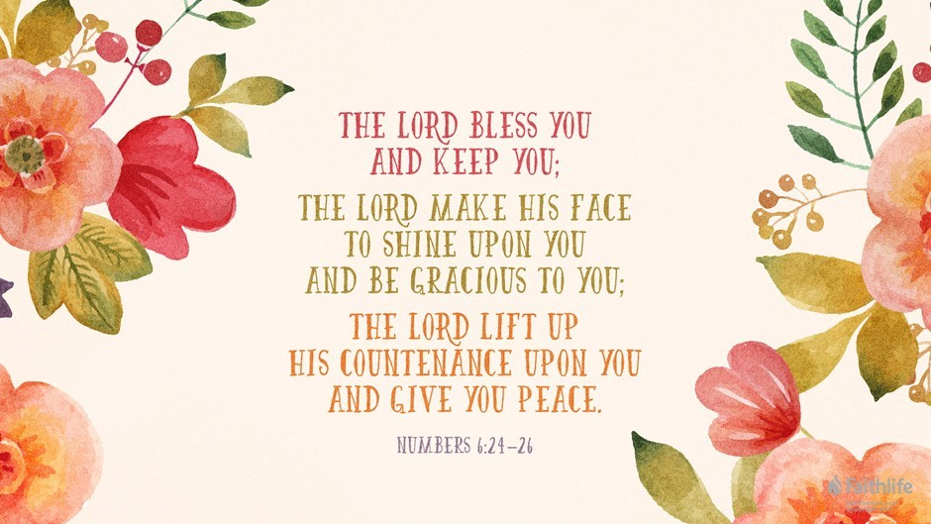
Mothers’ Union—Midday Prayers—June 2021
Rebuilding hope and confidence
Blessings

Monday: Blessings
The same Lord is Lord of all and richly blesses all who call on him.
Romans 10:12
The Lord bless us and keep us.
We pray God’s blessing for ourselves; may we be sustained in all we do.
We pray God’s blessing on those whom we love; may they be upheld by the presence of Christ. The Lord make his face to shine upon us and be gracious to us.
We pray God’s light to shine clarity on our plans for loving kindness. We pray God’s grace to encircle all who serve and those they support. The Lord turn his face towards us and give us peace.
We pray God’s divine favour and peace that surpasses all understanding to fill our lives today.
Amen.

Tuesday: Blessings and challenges
Great gifts mean great responsibilities; greater gifts, greater responsibilities!
Luke 12:48 (The Message)
God of all goodness, we give you praise and thanks for all the blessings of this life.
We are grateful for the gift of food, and the opportunity we have to feed others in your name; the blessing of shelter, and the challenge before us to care for the homeless; the love of friends and family, and your call to love those who are lost and alone; the fellowship of the church, and the presence of Christ in the lives of our needy sisters and brothers.
You have given us much, Lord, and you expect much of us. Help us to accept both your blessings and your challenges with gratitude and grace.
Amen.

Wednesday: Blessings for the day
God is able to make every blessing of yours overflow for you, so that in every situation you will always have all you need for any good work.
2 Corinthians 9:8 (ISB)
God bless each step that we take today, whether that road is rough or smooth. And in God’s strength step out in faith, step out in love, step out in peace, and bless this world with God’s presence in and through our lives.
May we be a blessing to every life we touch, and the Spirit within, that life-giving water, be a gift of refreshment in love shown and shared with all who are thirsty along the road we travel.
Amen.
A person of blessing will be enriched, and he who gives water also will be refreshed.
Proverbs 11:25 (LEB)

Thursday: Blessing of hands
The Lord will open the heavens, the storehouse of his bounty… to bless all the work of your hands.
Deuteronomy 28:12
Blessed are you, Lord. You hold us in your hands. Bless our hands, that we might hold others as dearly as you hold them.
Blessed be the hands that touch young lives and guide the young.
Blessed be the hands that embrace others with compassion.
Blessed be the hands that administer healing.
Blessed be the hands that carry out chores.
Blessed be the hands that grow stiff with age.
Blessed be the hands that capture memories in creative ways.
Blessed be the hands that greet strangers.
Blessed be the hands that learn the way of justice.
Bless our hands, Lord, for they are the work of your hands.
Amen.
From the Lutheran Deaconess Association

Friday: Blessings of peace
The Lord gives strength to his people; the Lord blesses his people with peace.
Psalm 29:11
Deep peace of the running wave to you
Deep peace of the flowing air to you
Deep peace of the quiet earth to you
Deep peace of the shining stars to you
Deep peace of the gentle night to you
Deep peace of Christ the light of the world to you Deep peace of the Son of peace to you.
Amen.
Gaelic blessing
Now may the Lord of peace himself grant us his peace at all times And in every way, that peace and spiritual well-being that comes to those who walk with him, regardless of life’s circumstances.
And may the Lord be with us all.
Amen.
From 2 Thessalonians 3:16

Saturday: Spiritual blessings
Praise be to the God and Father of our Lord Jesus Christ, who has blessed us in the heavenly realms with every spiritual blessing in Christ.
Ephesians 1:3
Eternal God, the refuge and help of all your children, we praise you for all you have given us, for all you have done for us, for all that you are to us.
In our weakness, you are strength, in our darkness, you are light, in our sorrow, you are comfort and peace. We cannot number your blessings, we cannot declare your love: For all your blessings we bless you.
May we live as in your presence, and love the things that you love, and serve you in our daily lives; through Jesus Christ our Lord.
Amen.
St. Boniface, 675-754

Remembering Prince Philip

This month (10th June) the Duke of Edinburgh would have turned 100. This article is from the Archbishop of Canterbury’s recent tribute to him in the House of Lords,

“We have thanked God for Prince Philip’s life of extraordinary service. There are some rare people who bring energy into a room - the Duke of Edinburgh was very much one of those people. His presence lifted a gathering. He might have challenged and interrogated, but whatever he said, he never bored anyone.

The Duke of Edinburgh had a profound moral imagination, extra-ordinary foresight and even vision. He saw the world not just as it is but as it could and should be, as worked out in his commitment to young people, especially through the Duke of Edinburgh’s Award, to the Commonwealth, to our Armed Forces, and to engineering, technology and design. In Edmund Burke’s words, he had an instinctive sense that the social contract was found in the traditions we inherit from the past, in our obligations to the present and in our responsibility to those yet to be born.

"His genuine and deep sense of humility and his service came from the same place, which was his faith. He had a sincere Christian faith absolutely untainted by false piety. He understood deeply how important faith is for the vast majority of the world’s population. He engaged the rich diversity of faiths within the UK and the Commonwealth. He was a pioneer in recognising the crucial role that faith leaders play in advocating for creation care. He was literally half a century ahead of his time in this area.”

We also give thanks and pray for the Queen, who celebrates her ‘official’ 95th birthday on 12th June.

LISBURN FOODBANK
The Foodbank provides emergency food and support to local people in crisis in the Lisburn area.
Parishioners may leave items for the Foodbank in the basket in Annahilt Church Porch, on the FIRST and SECOND Sunday of each month.
A particular request from the Foodbank is for items listed below:

Toiletries
Small boxes of washing powder
Cleaning Supplies
Toilet Rolls (2 or 4)
Baby wipes
Nappies

The Lisburn Foodbank is providing an essential service to those within our community who are experiencing difficult times, often due to circumstances beyond their control.

YOUR HELP WOULD BE GREATLY APPRECIATED.

.
Parish Website: AnnahiltAndMagherahamlet.org
Parishioners are reminded that the website annahiltandmagherahamlet.org has been created to provide information on church related activities and organisations for parishioners and the wider community. Since the first lockdown began in March, a year ago, the website has hosted online services each Sunday. It also contains a list of upcoming church services and news from our group of parishes, as well as downloadable versions of the parish magazine. The site will be continually developed, so if you have any submissions, suggestions or requests relating to the website, these can be sent to admin@annahiltandmagherahamlet.org.

www.annahiltandmagherahamlet.org

Parish Magazine
Any contribution for the next edition of the Parish Magazine should be left with the Rector or Roger Maxwell (roger.maxwell1@btinternet.com) by Sunday 27 June 2021.

Registered as a charity with The Charity Commission for Northern Ireland
NIC103246 (Annahilt) and NIC102122 (Magherahamlet)
Top of Form

