**News from the Parishes**

**Church of the Ascension, Annahilt Magherahamlet Parish Church**

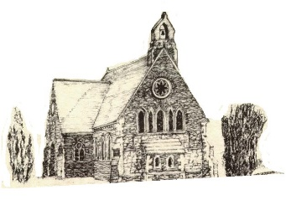 

**October/November 2025**



**Rector: The Revd Canon Robert Howard**

**15 Ballykeel Road, Hillsborough**

**BT26 6NW**

**Tel: 028 9263 8218**

**E-mail:** [**jrobert.howard@btinternet.com**](mailto:jrobert.howard@btinternet.com)

**Website:** [**www.annahiltandmagherahamlet.org**](http://www.annahiltandmagherahamlet.org)

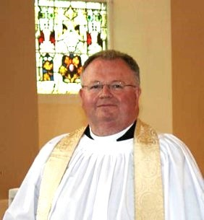**The Rector writes…..**

As I write this letter, I am conscious that we are in the midst of the season of Harvest Thanksgiving. These are always very special services in all our various churches as we give thanks to God for His faithfulness to us. Our annual Harvest Festival in Annahilt took place as always on the last Sunday in September which fell this year on 28th of last month. We are now looking forward to the Harvest Celebrations in Magherahamlet on Sunday 26 October. We remember those who have many struggles and overwhelming challenges to contend with, from food shortages to crop failures, as a result of climate change. We think too of those whose very existence is constantly threatened because of war and conflict, especially in Ukraine and Gaza. We are also deeply conscious of all those affected by recent devastating earthquakes in Afghanistan where so much infrastructure has been destroyed and so many have lost loved ones, houses and livelihoods.

If we are to be truthful, the world is torn apart through many divisions. Issues like immigration and internal political wrangling within mainstream political parties are causing a rise in anxiety levels everywhere. People are fearful, especially those who work here from overseas. They feel vulnerable after a sharp rise in racially motivated attacks. They are unsure if they are welcome anymore, despite the huge amount they have contributed to our society in the Health Service as well as in hospitality and other industries. It’s for this reason that we are blessed to have a very thoughtful Harvest preacher coming to share with us on Sunday 26 October.At 12.00 noon, our former Bishop, the Rt Revd Harold Miller will preach. At this time we look in our helplessness to God for his strength in our broken world which is so desperately in need of hope and healing, Bishop Miller will no doubt have some helpful and encouraging things to say. At our evening service we look forward to Baillies’ Mills Accordion Band joining us for A Service of Harvest Thanksgiving and Praise.

Next month it will be November, and we will be observing in a season of Remembrance. This year, our act of Remembrance again takes place against the backdrop not only of the ongoing conflict in Ukraine, but also a catastrophic war in the Holy Land, which has now become a severe humanitarian crisis. Amid this crisis, how, as Christians, might we remember the past in a way that fosters peace in the present?

The history of Israel and Palestine is the history of two traumatised peoples. The story of the modern state of Israel is entwined with the collective trauma of the Jewish people in Europe—the dark and shameful history of antisemitism, culminating in the horrors of the Holocaust—which motivated a desire for a safe homeland. Meanwhile, the Palestinian people remember the trauma of mass displacement—called in Arabic the ‘Nakba’, the Catastrophe—when in 1948 Palestinians were forcibly expelled from their homes and land. Their families remain refugees to this day, with many living under Israeli occupation.

When we listen to the ways people are talking about recent atrocities – the slaughter of Israeli civilians by Hamas, and the siege and indiscriminate bombing of the people of Gaza – we can hear how memories of historical trauma shape our perspective on the present. We are witnessing a re-traumatisation of Israelis and Palestinians, present in the comparisons of Hamas attacks to antisemitic pogroms, and in Palestinian fears of a ‘second Nakba’. Old wounds are being re-opened, as new wounds are inflicted.

So, in Israel and Palestine, the act of remembrance is far from a politically neutral act. The way we choose to talk about the past – the things we remember, and the things we forget – shapes our understanding of right and wrong, of justice and injustice. Alongside the conflict over land and borders lies a conflict between two radically different accounts of history. In the Holy Land, remembrance has become a matter of life and death.

I bring all this to our own act of remembrance this November, as we remember the wars in which our own nation has been involved. But we come to Remembrance Sunday not only as British and Irish people, but as Christians. What does Christianity have to teach us about remembering? As it turns out, rather a lot. Every time we gather for Holy Communion, we are involved in act of remembrance: ‘do this in remembrance of me…’. In the Eucharist, we gather to remember the foundational trauma of our people: the crucifixion of Jesus—a persecuted Jewish rabbi, unjustly executed by the Roman occupying force in first-century Palestine, with the participation of the religious and political elite in his society. Yet, in his cry of forgiveness on the cross, Jesus refuses to let his death be an occasion for further violence, another tragic death to be added to a long list of historical grievances. Then, in the resurrection, we are shown a version of justice built not upon revenge and destruction, but upon the triumph of love over oppression, light over darkness, the side of the victimised and oppressed, wherever we find them. Jesus dies in solidarity with all the traumatised peoples of the world, and opens up the way towards healing and hope.

So, whenever we remember the death and resurrection of Christ, we stand alongside all those who suffer with him, and cry out for peace. In this season, may our act of remembrance lead us into a deeper commitment to God’s peaceable Kingdom, as we cry out for justice and mercy in the Holy Land and across the world.

Now that all our parochial organisations are up and running again, we hope that you will find something that might be of encouragement to you during the autumn. Maybe you would enjoy the fellowship and company at activities like Bowls or Badminton. Maybe you have children or grandchildren who might enjoy the Jesus and Me Group or Sunday School. Ladies might enjoy the Mothers’ Union. Senior parishioners and other such friends in the wider community might consider coming to the Wednesday Club. There are many opportunities of becoming connected. Hopefully you will find something to get involved in.

I’m always grateful to those who lead our activities with such enthusiasm and passion and hold up the very best of what our church can offer to the wider community through giving of themselves with love and grace.

With love, prayers and blessings

Your sincere friend and Rector

Robert Howard

**Congratulations….**

**……** to Mr & Mrs Cecil McMullen on the recent celebration of their Diamond Wedding Anniversary. The Rector was pleased to call with Mr & Mrs Cecil McMullen and present them with a floral arrangement on behalf of all in Annahilt on the occasion of their Diamond Wedding Anniversary.

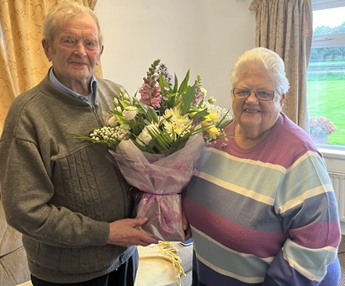

**…..**  Mrs Kathleen Kingston on the recent celebration of her 95th Birthday. The Rector was delighted to visit Mrs Kathleen Kingston, wife of our late Rector, Canon Eric Kingston, on her 95th Birthday and to present a floral arrangement on behalf of the Group of Parishes to Mrs Kingston on her special day.

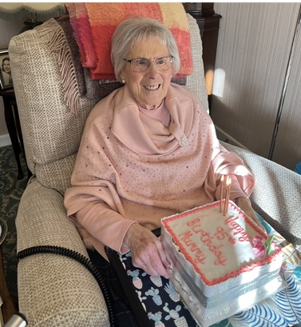

**Thank you….**

….. to all who contributed to the Annahilt Harvest Appeal in support of Missionary Societies. To date the loose collections at services and the Appeal Envelopes have raised £1061.20

**HM The King’s Accession Day**

The third anniversary of the death of Queen Elizabeth II and the Accession of King Charles III was observed at Services in both Annahilt and Magherahamlet on Sunday 7 September.

We also remembered all who suffered life changing injuries and bereavement following the terrorist atrocities in the United States on 11 September 2001.

*A prayer for King Charles III following the Anniversary of his Accession:*

Lord God, the Ancient of Days,  
you are sovereign over all your people;  
Give to His Majesty, King Charles  
enduring wisdom and faith  
in the service of the people of this land  
and of you, his Lord and master.  
Grant that his reign may be one of faithful witness  
And prove to others a source of hope,  
that they may come to know more fully  
your Son Jesus Christ,  
who is alive and reigns with you and the Holy Spirit,  
one God, now and forever. Amen.

**Reflections on Harvest Time in Annahilt**

In Annahilt we gave thanks for the blessings of Harvest on Sunday 28 September. Following a summer of glorious weather. this year’s harvest yields were really bountiful. As a result, the twin themes of celebration and thanksgiving were very evident throughout each of the services.

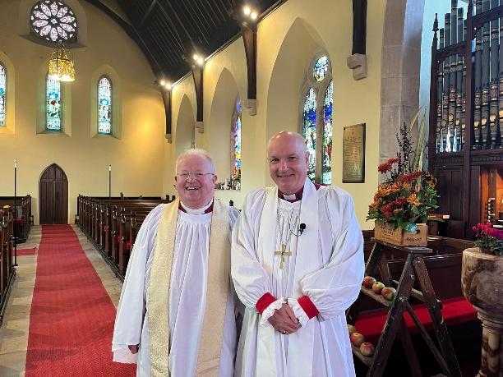

There were beautiful displays of flowers, along with fruit and vegetables. During the years of the Pandemic restrictions there were real difficulties distributing fresh harvest produce afterwards. However, we are now able to resume donating such items to the Northern Ireland Hospice. Other parishioners continued the more recent practice of giving non-perishable foods which were later donated to the Food bank.

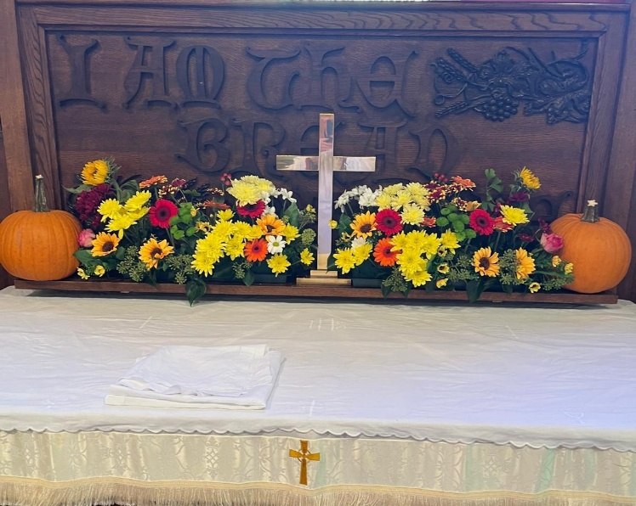

There was a lovely atmosphere of worship on Harvest Sunday. In the morning, a Celebration of the Holy Communion was presided over by the Bishop of Cashel, Ferns and Ossory, the Rt Revd Adrian Wilkinson who was also the visiting preacher. The Rector also officiated. The special music featured an anthem ‘Give thanks Canon’, sung by a united Choir of both Annahilt and Magherahamlet, accompanied by our Choir Leader, Mr Tim Howe, who presided at both the Organ and Piano. There was also a musical setting of the ‘Gloria in excelsis’ and a sung version of The Lord’s Prayer.

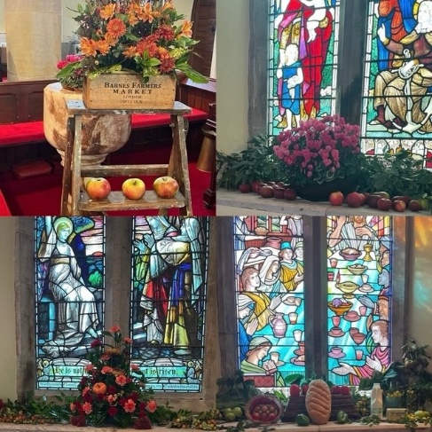

In the evening, an uplifting Service of Evening Prayer was conducted by the Rector. Bishop Adrian Wilkinson continued the Ministry of the Word which he began in the morning. Again, Tim accompanied the united Choir from Annahilt and Magherahamlet who sang ‘We love this place O God’, based on Psalms 41 and 42, in addition to the morning anthem. On their first visit to the Parish, The Lurgan Salvation Army Band also participated by playing before, during and following the Service. They also led the congregational singing in very familiar Harvest hymns. It was wonderful that the Harvest Supper afterwards was so well supported with most of the congregation, which included parishioners from Magherahamlet and visitors from other neighbouring churches, going across to the Parochial Hall afterwards.

At the conclusion of each Service the Rector thanked all those who had provided gifts and those who assisted with the decoration of the church. He expressed particular appreciation of the playing of the Organist Mr Tim Howe and of the role of The Salvation Army Band in creating such a magnificent sound. Bishop Adrian suitably replied and thanked the Choir and Select Vestry for providing and distributing the Supper. He then brought the proceedings to a formal close in prayer.



**Decoration of Magherahamlet Church for Harvest**

Saturday 25 October

From **2.00 pm**

Your assistance with the decoration will be greatly valued

Gifts of flowers, greenery, corn, fruit, vegetables and other foodstuffs will be very gratefully received

**Magherahamlet Harvest Appeal**

Harvest Thank Offering envelopes are currently being distributed. Once again we have the opportunity of thanking God for all his love and goodness, especially in the realms of nature. We can also do this by making as worthwhile and generous a thank offering as possible. The Thank Offering envelope may be returned at either of the Harvest Services.

**Magherahamlet Harvest Supper**

With great pleasure, the Harvest Supper will take place in the Parochial Hall following the Evening Service on Sunday 26 October at 7.00 pm.

It is hoped that parishioners, visitors and friends will avail of this occasion for engaging in face-to-face fellowship and conversation which was not possible over the various past lockdown periods.

**Children’s Harvest Offerings**

The younger members of the congregation are asked to bring a non-perishable item of food (e.g. a packet of biscuits or a tin of fruit) to the 12 noon service on Harvest Sunday. They will have the opportunity of making their own Harvest Offerings during the service.

**Philippians 4:13 God gives me strength**

*Prayers for climate change*

Creator of our common home,

You fill the earth and sea and sky with life

Forgive us our neglect of your creation

The choking waste of our pollution

The damage done by careless habits

And our indifference to future generations.

Help us to amend our lives

To refuse more plastic if we can’t reuse it

To lift our voice for lasting change

And to live well and gently on the earth

To the glory of your Son, the Living Word

Through whom you made this fragile world.

**Amen.**

Creator God,

We acknowledge that as your handiwork, we stand alongside all that you have made.

Trees and rivers, mountains and valleys, soaring birds and scuttling creatures, all are held within your care.

May we grow in our love and appreciation for the fabulous variety around us and may our awe and wonder draw us closer to the natural world and through it to you, the God of all things.

We pray in Jesus name,

**Amen.**

God of life, we praise you for the beauty of creation, its richness and variety; yet, through greed and ignorance, we scar your world with plastic waste and throw so much away.

Make us more like Jesus, treading gently on our common home, and breathe your Spirit on us, that we may care more deeply for your Earth.

We ask this through Jesus Christ our Lord.

**Amen.**

**Church Services in the Parishes of Annahilt and Magherahamlet**

*‘I was glad when they said to me: “Let us go to the house of the Lord”’* Psalm 122 v1

Sunday 5 October **Trinity XVI**

10.00 Parish Communion Annahilt

12.00 Parish Communion Magherahamlet

Sunday 12 October **Trinity XVII**

10.00 Family Service Annahilt *Service Sheets*

*Followed by light refreshments in the Parochial Hall in support of Christian Aid*

12.00 Family Service Magherahamlet *Service Sheets*

Sunday 19 October **Trinity XVIII**

10.00 Parish Communion Annahilt

12.00 Morning Prayer Magherahamlet

Sunday 26 October **Festival of All Saints**

10.00 Morning Prayer Annahilt

**Magherahamlet Harvest Festival**

**Sunday 26 October 2025**

12.00 noon Harvest Parish Communion *Service Sheets*

Preacher: The Revd Harold Miller

Former Bishop of Down & Dromore

7.00 pm Evening Service *Service Sheets*

*with The Baillies Mills Accordion Band*

*Supper afterwards in the Parochial Hall*

Sunday 2 November **IV Sunday before Advent**

10.00 Parish Communion Annahilt

12.00 Morning Prayer Magherahamlet

Sunday 9 November **Remembrance Sunday**

10.00 Morning Prayer & Act of Remembrance Annahilt*Service Sheets followed by Light Refreshments in the Parochial Hall in support of Christian Aid*

12.00 Morning Prayer & Act of Remembrance Magherahamlet *Service Sheets*

Sunday 16 November **II Sunday before Advent**

10.00 Parish Communion Annahilt

12.00 Parish Communion Magherahamlet

Sunday 23 November **Sunday before Advent**

*Feast of Christ the King*

10.00 Morning Prayer Annahilt

12.00 Morning Prayer Magherahamlet

**Sunday 30 November Advent I**

10.00 Advent Carol Service Annahilt *Service Sheets*

12.00 Advent Carol Service Magherahamlet *Service Sheets*

Sunday 7 December **Advent II**

*Bible Sunday*

10.00 Parish Communion Annahilt

12.00 Parish Communion Magherahamlet

**In Memoriam**

On the Sunday before All Saints Day (26 October) at the 10.00 am and 12 noon services in Annahilt and Magherahamlet respectively, we will remember by name those from each parish who have died during the past year.

**A Prayer for the Peace of the World (Book of Common Prayer)**

Almighty God, from whom all thoughts of truth and peace proceed; Kindle, we pray thee, in every heart the true love of peace; and guide with thy pure and peaceable wisdom those who take counsel for the nations of the earth; that in tranquillity thy kingdom may go forward, till the earth is filled with the knowledge of thy love; through Jesus Christ our Lord. Amen

***PRAYER WARRIOR***



Do you have a concern or problem and would like someone to pray for you?

If so, contact the Rector (Tel 028 9263 8218) who will be willing to help.

This is completely confidential and no details will be passed on to anyone else unless you want them to.



**SUNDAY SCHOOL IS BACK!**

**WHEN?**

**Annahilt from10.00 am until 11.15 am on 1St Sunday of each month in Parochial Hall, JAM (Jesus and Me) our revamped Sunday School.**

**Family Service in Church on 2nd Sunday of month in Church.**

**Magherahamlet at 11.00 am Every Sunday in Parochial Hall (except 2nd Sunday of month when Family Service is held in Church.**

**WHERE? Parochial Hall \\**

If you are thinking about sending your child and have any queries, please contact the Rector or the Sunday School teachers.

**Festival of Remembrance 2025**



**Remembrance**

The Royal British Legion believes that the poppy and Remembrance are, and always have been, unifiers of all people and communities across the United Kingdom and the Commonwealth since the First World War, supporting and recognising the contributions of the Armed Forces from these nations in times of conflict and rebuilding society. Members have remembered this contribution to the freedoms we enjoy today for over a century and will continue to do so through their work.

They are a non-partisan and non-sectarian organisation focused on the experiences of those who serve or have served in the military, and those affected by their service, without considering the politics of conflict.

The Legion recognises the service and sacrifices of all those who have served or are serving in His Majesty's British Armed Forces, including members of the Commonwealth in the Royal Navy, British Army and Royal Air Force, from 1914 to the present day. This includes both living and deceased personnel, regardless of the length of their service.

They recognise the service and sacrifice of civilian individuals, communities, services, and organisations from Great Britain and the Commonwealth during times of conflict or acts of terror. They are committed to acknowledging their contributions in Remembrance, such as the support of emergency services and the Merchant Navy.

Also recognised are the families of British and Commonwealth Armed Forces personnel; this includes those who have been bereaved.

**Acts of Remembrance**

Although it may be bookended by formal and/or religious ceremonies, the Act of Remembrance at its core is simple, brief, and non-religious. The organiser may assemble whatever readings, music or other elements to accompany the Act of Remembrance so that it is relevant for the particular community attending.

The RBL has no objection to wreaths of non-red poppies or other flowers being laid at war memorials or in Remembrance services alongside red poppy wreaths and the RBL respects the rights and freedoms of groups and individuals to make their own decisions on how to observe Remembrance.

However, red poppy wreaths are inclusive of all people and communities.

The Two Minute Silence, observed on Remembrance Sunday (second Sunday in November) and Armistice Day (11 November), is a time for the nation to honour the sacrifices of those who have served in the British and Commonwealth Armed Forces. It's an opportunity for personal reflection and remembrance, whether observed publicly or privately. While participation is voluntary, it's important to respect those who choose to pause and reflect.

**The Poppy**

The poppy is a universally recognised symbol of Remembrance and hope for a peaceful future. since it was first worn as an act of Remembrance and to raise funds for the British Legion more than 100 years ago.

It unites us in remembering all those from the British and Commonwealth Armed Forces who have served and sacrificed; and do so today, to defend democracy and freedom

The poppy also acknowledges the wider impact of conflict.

It represents the contribution of civilian services and uniformed emergency services that contribute to national security in times of war, conflict or terrorism and acknowledges innocent civilians who have lost their lives at such times.

**Wearing a poppy**

There is no right or wrong way to wear a poppy.

The poppy can be worn throughout the year whenever you wish to show your support for the British and Commonwealth Armed Forces, past and/or present.

The decision to wear a poppy is voluntary.

The red poppy also raises funds to support veterans from the British and Commonwealth Armed Forces and their families at times of need. There is no contradiction in wearing other emblems alongside the red poppy and the RBL respect the rights of any individual to express their views within the law.

In 2025, The Royal British Legion continue their commemoration of the theme of ‘Service’ and ‘Service Not Self’ in the Festival of Remembrance at the Royal Albert Hall in London, broadcast each year on national television.

Through personal testimony and storytelling, through music and ceremony, the Festival will express the core values of Service which maintain the admiration and esteem the public holds for the Armed Forces and civil society. Values such as placing others before themselves, devotion to duty and unfailing reliability.

The Festival will commemorate the above values through both the lived experience of our Armed Forces community by honouring veterans who lost their lives or were injured in service and actively serving personnel. It will further honour their families, descendants and representatives.

Perhaps in this year’s season of Remembrance, as well as remembering and giving thanks for the sacrifice of those who fought and died in service of our nation and of peace, we can also remember to pray for those still serving now, for those who love them and support them, and for healing of the seen and unseen scars of war.

God of healing and of peace, in whose service is perfect freedom, we hold before you those who serve our nation in His Majesty’s Armed Forces, and those who love them.

We pray that during times of separation you would protect their relationships.

We pray that during times of reunion you would ease the transitions and be present in homecomings.

We pray for healing of bodies, minds, and spirits broken by experiences of combat, and for healing of grief for those who will never return.

Hold and guard all who serve on behalf of others, and their loved ones, we pray.

**Amen.**

**A Prayer to be said by families visiting a war grave or memorial:**

Lord Jesus, we believe that you stood beside *N and his fellow soldiers* as they fought to bring peace to your world.

We believe that you have stood among us as we have tried to imagine the fear and pain and loneliness of the wounded and the dying on the battlefield.

We believe that you stand beside us now, as we remember and honour *N*.

In your great mercy, bless our good memories, comfort us when we grieve for the life that might have been, and strengthen us in all we do to seek the peace and freedom which are your desire for the world. **Amen**.

**Flowers for the Churches**

**Annahilt Magherahamlet**

**October**

5

12 Ms S Anderson

19 Mrs S McCurry

26 Harvest

**November**

2

9 Remembrance Sunday Remembrance Sunday

16

23



**Church Cleaning, Annahilt**

**Month**

**October**

3-4 Mrs S Chapman Mr S Chapman

10-11 Mrs J Guiney Mrs H Cardosi

17-18 Mrs S Chapman Mr S Chapman

24-25 Mrs E Crawford

**November**

1 Mrs S Chapman Mr S Chapman

7-8 Mrs H Hill Mr T Hill

14-15 Mrs S Chapman Mr S Chapman

21- 22 Mrs L McCambley Mrs E Harrison

28 –29 Mrs S Chapman Mr S Chapman

**December**

5-6 Mrs E Finney Mr P Finney

12-13 Mrs L McCambley Mrs E Harrison

19-20 Mrs S Chapman Mr S Chapman

23-24 Mrs A Maxwell Mr R Maxwell

26-27 Mrs S Chapman Mr S Chapman

The number on the rota of volunteers who clean the Church of the Ascension has significantly declined. It would now be unviable except that one couple has offered to clean the Church every 2nd week.

**It really would be very helpful if there were additional volunteers who would ease the burden on those who already faithfully fulfil this important role. If you would be willing to help, please contact the Rector (Tel 028 9263 8218) or the Secretary to the Vestry, Colin Hassard (Tel 028 9263 8263)**



Hello everyone

On Saturday 9th August, some members of the various MU Branches in our diocese had the opportunity of celebrating Mary Sumner Day* (our MU founder) by going for a morning prayer walk at the Tobar Mhuire monastery and retreat centre at Crossgar. It was a glorious sunny summer’s day. At the entrance to the monks’ walled prayer garden, there was a wooden door with a cross cut into it so you could see the sunlight shining through. It was like stepping into another world, more peaceful, less hurried. As members walked around the various prayer stations, they each had a booklet with readings and prayers read by someone from each Branch represented. Coffee and scones were enjoyed afterwards.

Autumn is here along with the shorter days and darker nights. Recently someone, perhaps surprisingly, said he liked nothing better than the onset of winter evenings as he liked to draw the curtains and lock the front door shutting the world out. Maybe there are times when we all would like to get the PJs on and live in our own interior world. As we come into another season of Branch meetings, let us hope we can work to build and maintain our MU community gathering with each other, enjoying the company, sharing our joys and sorrows together. Members, visitors, those just looking or curious are all equally welcome. So, come along and join on Monday 20 October at 8.00pm in Annahilt and Wednesday 22 October in Magherahamlet followed by a light supper.

Our sincere congratulations to Madeline and Cecil McMullen on the celebration of their 60th Wedding Anniversary and to Mrd Kathleen Kingston on attaining the milestone of her 95th birthday.

*Mary Sumner Day is marked to remember the anniversary of her death which is actually the 11th August but somehow the 9th was chosen incorrectly.

Please see the MU Wave of Prayer below for October 2025.

With very kind regards

Beth Avril & Sally Eme Frances & Avril B

**Mothers’ Union Midday Wave of Prayer October 2025**

October 1-3 October: Nzara in South Sudan; North Kigezi in Uganda; Kivu in Rwanda; Damataru in Nigeria; Auckland in New Zealand and Vanuatu and New Caledonia in Vanuatu

5-7 October: Mbhashe in South Africa; Kitgum in Uganda; Ukwa & Ilesa South-West in Nigeria; Tasmania in Australia and Central Melanesia in Solomon Islands

8-10 October: Ethiopia; Zanzibar in Tanzania; Awgu/Aninri in Nigeria; Freetown in Sierre Leone; Monmouth in Wales and Malaita in Solomon Islands

12-14 October: Ezo in South Sudan; Thika in Kenya; Jos & Akoko in Nigeria; Europe and União de Mulheres Episcopais Anglicanas do Brasil (UMEAB) in Brazil

15-17 October: Terekeka in South Sudan; Nairobi in Kenya; Maiduguri & Osun North in Nigeria; Edinburgh in Scotland and Calcutta in India

19-21 October: High Veld in South Africa; Nambale in Kenya; Niger-Delta in Nigeria; Guinea; Blackburn in England and Bhopal in India

22-24 October: Kimberley and Kuruman in South Africa; Kitui in Kenya; Kano & Kwara in Nigeria; Armidale in Australia and Myitkyina in Myanmar

26-28 October: Malakal in South Sudan; All Saints Cathedral in Kenya; Kontagora & Osun North East in Nigeria; Glasgow & Galloway in Scotland and Pune in India

29-31 October: Luapula in Zambia; Nakuru in Kenya; South Rwenzori in Uganda; Ibadan North in Nigeria; Connor in All Ireland and Pusan in South Korea

**Financial matters**

**Annahilt Harvest Envelopes**

If you were unable to attend Annahilt Harvest Services but would still like to contribute to the collections, additional envelopes are available on the table inside the Church door. Please send your envelope to Patricia at 35 Cabra Road, Hillsborough, BT26 6NB.

**Gift Aid**

For those parishioners who currently Gift Aid their subscription-are you still a tax payer? If not, please contact the Parish Treasurers to update Parish records.

If you are a tax payer and do not currently Gift Aid your subscription (FWO) the Parish could benefit from an additional 25% income at no cost to you.

Again, please contact the Treasurers.

**2026 FWO/Weekly Giving**

Parishioners can contribute via weekly envelopes, monthly/annual Standing Order or a combination of both or by cheque/annual direct payment.

If you wish to change/amend or add to your method of giving please contact the Treasurers by **20th November** prior to preparation of the 2026 envelopes.

**Contact details**

While we try to keep contact details up to date, sometimes parishioners move house and we don't have your new address.

Some no longer have or use landline telephone numbers and only use mobile numbers. It would be helpful if your details have changed, if you could contact Patricia (Annahilt) on 028 92665310, Mobile 07713 257 691, email [patriciaapc@btinternet.com](mailto:patriciaapc@btinternet.com) or Abbie (Magherahamlet) on 07753 746940, email [abigailstanford@btinternet.com](mailto:abigailstanford@btinternet.com) with up to date details. The vast majority of contact numbers we hold are landline numbers.

Your contact details are only used for Parish purposes.

**Vintage Afternoon Tea Fundraising event**

On Saturday 18th October 2025, Annahilt Parish is holding a Vintage Afternoon Tea fundraising event for Parish Funds.

We hope you are able to attend and have already purchased tickets for yourselves and your friends. Several men have already purchased their tickets so hopefully that will encourage a few more men to attend. Admission to the event is ideally by ticket. If you are unable to attend but would like to donate towards expenses that would be appreciated.

Contact Patricia for tickets on 07713 257691 or other members of the committee.



**Annahilt Wednesday Club**

The Wednesday Club recommenced on 18th September with a very interesting talk from Padre Stanley Gamble on his time with the United Nations in Cyprus.

On 22nd October we will hear the story of local pioneer, Harry Ferguson. We meet from 11am-12.30pm in the Parish Hall and all Seniors and Retirees in the community

Are welcome.

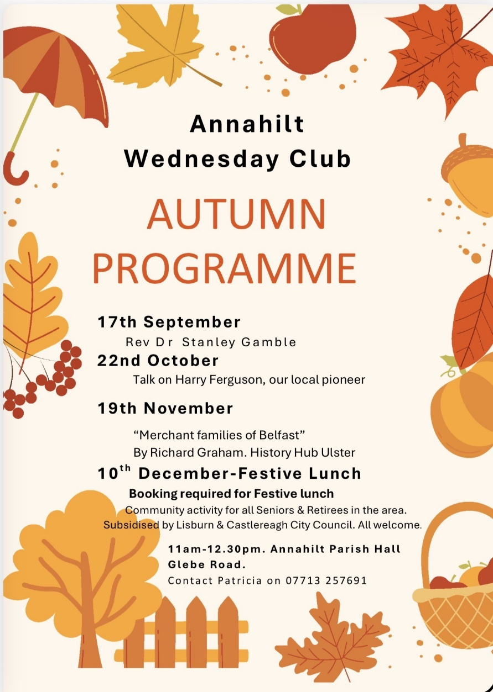

**Larchfield Community Development Association**

Unfortunately had to postpone their Family Fun Day and Vintage Rally event in September due to the weather.

They will now hold a Road Run and Threshing Day event at 14, Loughaghery Road, on Saturday 11th October from 11am.

All welcome especially if you are interested in tractors and Vintage Threshing. Charity Donation on entry for Angel Wishes.

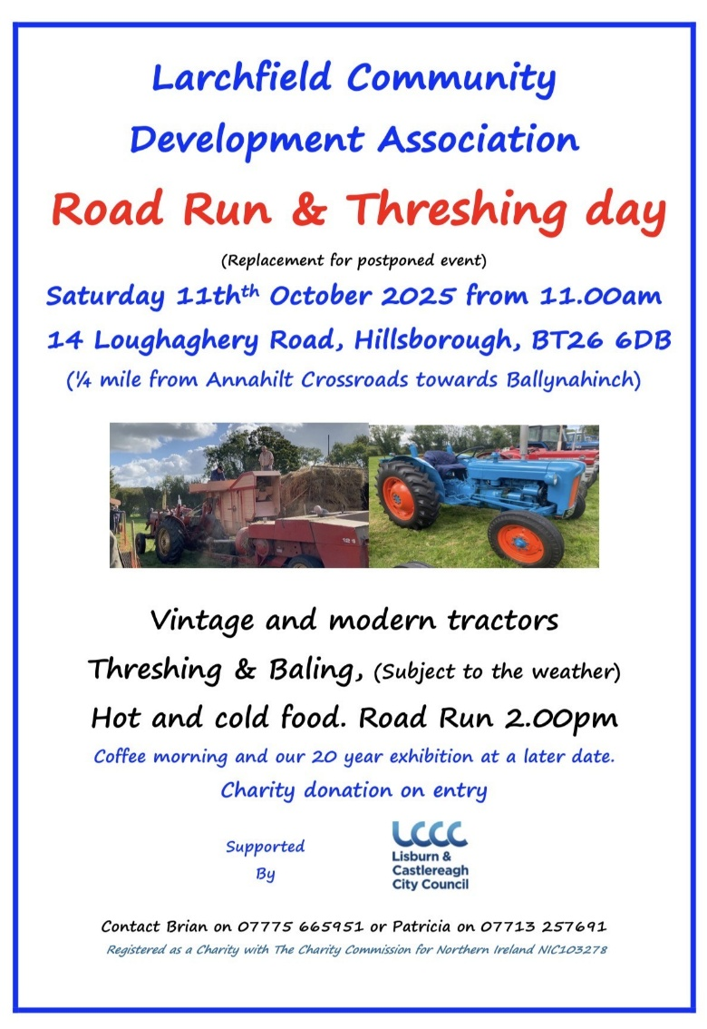

**Walks in grounds of HRP Hillsborough Castle**

Anyone can join with us in these walks kindly accommodated by an invitation from Larchfield Community Development Association. Next date is Wednesday 29th October, meeting at 11am at the reception area off the A1 car park. Contact Patricia on 07713 257691.

If anyone is interested in a tour of Hillsborough Castle, Patricia will be organising one later in the Autumn. Contact her if you are interested.

**Ongoing works around Annahilt Parish Hall**

As we go to press these are unfortunately are running behind schedule.

We will update you in a future edition of the magazine however if you are at the Afternoon Tea you will be able to see much of the work which has been completed.

**Lunch Club**

Annahilt Lunch Club continues to meet in The Pheasant Restaurant on the last Friday of every month (except December) at 12.30pm.  
The autumn dates are:  
  
31 October 2025  
28 November 2025  
  
The Lunch Club is very informal and gives retired and semi-retired members of the local community the opportunity to enjoy fun and friendship over a light meal.  
  
Please contact Violet Swarbrigg (07866914651) for further information or just come along as everyone will be made very welcome.

**Christmas in the Barn at Larchfield**

A Christmas Fair will be held at Larchfield on Monday 3 November between 10am and 8pm (drinks and nibbles from 6pm) and also on Tuesday 4 November from 10am to 5pm.

Money raised will go to Riding for the Disabled NI.

**Parish of Annahilt**

is holding a

**Christmas Fair**

**Friday 28 November 2024**

**7.**00 pm – 9.00 pm

Parochial Hall

**All welcome**

**LISBURN FOODBANK**

The Lisburn Foodbank is providing an essential service to those within our community who are experiencing difficult times, often due to circumstances beyond their control.

The Foodbank provides emergency food and support to local people in crisis in the Lisburn area.

Parishioners may leave items for the Foodbank in the basket in Annahilt Church Porch, on the FIRST and SECOND Sunday of each month.

A particular request from the Foodbank is for cleaning items such as:

* Fairy Liquid
* small packs of toilet roll
* large nappies (sizes 6 and 7)
* baby wipes
* shower gel
* soaps
* washing powder

**YOUR HELP WOULD BE GREATLY APPRECIATED**

**Recording of Annahilt Church Services**

Free recordings (CD format) are available weekly of the Church services or requested special services.

These CDs are delivered free of charge. If you would like to receive a CD copy, please contact Shirley Robinette on 07974093382

**Parish Website:  AnnahiltAndMagherahamlet.org**

Parishioners are reminded that the website [annahiltandmagherahamlet.org](http://annahiltandmagherahamlet.org/) has been created to provide information on church related activities and organisations for parishioners and the wider community. The website also continues to host online services each Sunday. In addition, the website contains a list of upcoming church services and news from our group of parishes, as well as downloadable versions of the parish magazine.  The site will be continually developed, so if you have any submissions, suggestions or requests relating to the website, these can be sent to [admin@annahiltandmagherahamlet.org](mailto:admin@annahiltandmagherahamlet.org).



[www.annahiltandmagherahamlet.org](http://www.annahiltandmagherahamlet.org)

**Parish Magazine**

Any contributions for the next edition of the Parish Magazine should be left with the Rector or Roger Maxwell ([roger.maxwell1@btinternet.com](mailto:roger.maxwell1@btinternet.com)) by Sunday 16 November 2025.

Registered as a charity with The Charity Commission for Northern Ireland

NIC103246 (Annahilt) and NIC102122 (Magherahamlet)