**News from the Parishes**

**Church of the Ascension, Annahilt Magherahamlet Parish Church**

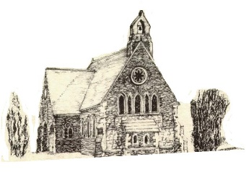 

**April & May 2024**



**Rector: The Revd Canon Robert Howard**

**15 Ballykeel Road, Hillsborough**

**BT26 6NW**

**Tel: 028 9263 8218**

**E-mail:** [**jrobert.howard@btinternet.com**](mailto:jrobert.howard@btinternet.com)

**Website:** [**www.annahiltandmagherahamlet.org**](http://www.annahiltandmagherahamlet.org)

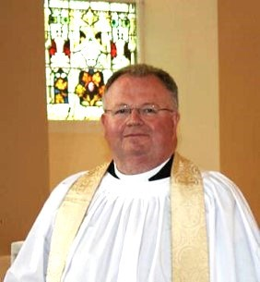**The Rector writes…..**

This month marks the first Anniversary of the Coronation of HM King Charles III. This will be observed on the Eve of the Anniversary (Sunday 5 May) in both Annahilt (10.00 am) and Magherahamlet (12.00 noon). It seems very appropriate to mark this event as we delight with the King on his return to public face duties as DV he responds to his ongoing treatment for serious illness.

The previous month, April 2024, marked the 100th anniversary of the first broadcast by a monarch of the United Kingdom, when King George V opened the British Empire Exhibition at Wembley in north London in April 1924. The speech lasts about six and a half minutes, and you can hear it on You Tube, although the recording is a bit scratchy.

I wonder if anyone then had any idea how much broadcasting would change in the coming century? We now take for granted the fact that we can see and hear almost anyone in public life at any time, thanks to a 24-hour media. TikTok and Instagram have brought broadcasting within reach of any of us with a smartphone.

Communication seems to be hard-wired into us as human beings. That shouldn’t surprise us, because our God is a God who communicates. Back in the earliest chapters of Genesis, it’s the voice of God that brings creation into being. When Jesus is awoken by his terrified disciples in the middle of a storm, it is his words shouted into the tumult that calm the winds and the waves. When the Holy Spirit comes upon the apostles at Pentecost, they speak the message of Christ crucified and risen in words their hearers can understand.

The story is told of a rabbi who could never get further in his reading of the Scriptures than Genesis 1:2, “And God said.” The wonder of a God who speaks was too much for him to take in.

I wonder if that’s why we love podcasts, audiobooks, and the radio so much – because it’s as if someone were sitting next to us and chatting? As if we’re listening in on a conversation that we’re invited to be part of?

I wonder, too, if that’s why words can wound us as well as heal us – because they go deep into the heart of our being?

The apostle James talked about the power of speech, how hard it is to tame the tongue, and how inconsistent we are when we say, “Praise God,” in one breath and in the next run down another human being. Those are challenging words in an era where talk is easy, but we do well to take them to heart.

There are other times when we are slow to speak, perhaps out of anxiety or fear. One such time can be when we try to talk about our faith. We are all encouraged to have confidence that the story we have to share in our Christian faith is one people want to hear, and to become more comfortable talking about our faith.

We may never become those who broadcast to the world, as King George V did 100 years ago, but I wonder how we could learn to “broadcast” our faith in simple ways, and speak words of life to those who are longing to hear them?

Your sincere friend and Rector

Robert Howard

**Congratulations…**

….to Richard McGregor, Annahilt on his engagement to Rachel Lynch.

**Parish of Annahilt – Easter General Vestry Meeting – Monday 11 March 2024**

In his remarks from the Chair, the Rector reported that in 2023 the Parish’s official membership (those households who are subscribers) stood at 109 family units. However, there are additional households who have called on the Rector’s ministrations although they have no formal link with the Parish. There were two baptisms, two marriages and there were four funerals.

With deep regret, the Rector recorded the passing of our former Bishop, the Right Revd Dr Gordon McMullan. Notwithstanding his somewhat early retirement in 1997 and his quite low public profile since, we remember appreciatively his episcopal ministry in the diocese spanning some 17 years. During that time his visits to our Group of Parishes were many and included his Dedication of the Parochial Hall Refurbishment and Extension. In retirement he was twice able to make return visits to the parishes for the 150th Anniversary of the Church of the Ascension on Advent Sunday 2006.

Each of the following parochial activities implemented the advancement of religion in our community.

Worship and prayer were paramount during 2023 which contributed to the spiritual well-being of participants and the reinforcement of Christian values.

The Rector expressed congratulations and good wishes to Mr Timothy Howe who took up duty as full time Organist & Choir Director at the Parish Church on the first Sunday in September.

Special services in Church included a Celebration on the afternoon of Sunday 7 May to mark the Coronation of HM King Charles III, with Lord Eames as special preacher and music led by Baillie’s Mills Accordion Band. This was followed by a Picnic at Larchfield Estate, by kind permission. The traditional Harvest Festival Services were held on the last Sunday in September. The Bishop of Clogher, the Right Revd Dr Ian Ellis, presided and preached at the Morning Service. Following the evening service, a Harvest Supper was held in the Parochial Hall and was very well supported. The annual Christmas Carol Service also took place. The long-standing Christmas / New Year reciprocal arrangement between our Parish and Legacurry Presbyterian Church was not possible this year on account of the ministerial vacancy at Legacurry. However, the First Communion of Christmas went ahead in the Parish Church on Christmas Eve. As Christmas Eve fell on a Sunday this year, a rare opportunity presented itself for a Nativity Service that morning. The Baillie’s’ Mills Band again joined us and facilitated us with both congregational carols and other seasonal music. It was a unique and very special event.

The Parochial Hall is a very useful facility which has again more than proved its worth in advancing Christian activity in our parish. Its use will no doubt continue to develop in a post-covid situation. Sunday School continued to meet on Sunday during the Church Service. The Parish Indoor Bowling Club also ran its normal schedule of activity. Meetings of The Mothers’ Union Branch also took place. One Sunday each month (from September to June) following the Church Service, light refreshments were served in the Parochial Hall in support of ‘Christian Aid’.

The traditional Christmas Fair at the end of November took place which was both a great social and financial success. The monthly collection of items for the local food-bank continued and proved to be of immense benefit for those in our community who are less fortunate than others.

The Report following the 2019 Quinquennial Inspection of the Church and Rectory was on the agenda of the Select Vestry and its recommendations continue to be acted upon. The construction of toilet facilities at the rear of the Church building and a new entrance to the Parochial Hall site were completed. The Dedication by the Bishop of this and other construction and maintenance work took place when he and Mrs McClay visited the Parish on the First Sunday in Advent. The routine maintenance of the Parochial Hall and the Rectory continued throughout the year. The Select Vestry remain committed to the upkeep and development of all parochial property and assets for the future benefit of the Parish and the public.

Various steps were taken throughout the year to ensure that the Parish is compliant with new GDPR regulations.

Drawing his remarks to a close the Rector thanked all those who contributed to Parish Life throughout the year, During the meeting the Trustees Annual Report was presented by the Honorary Treasurer, Miss Patricia Halliday, the annual elections were held and light refreshments were served.

**Parish of Annahilt Easter General Vestry Elections 2024**

Rector’s Churchwarden David Brown People’s Churchwarden Stephen Chapman Rector’s Glebewarden William Mathers People’s Glebewarden Gareth Simpson

*In addition to the above Officers, the following were elected to the Select Vestry:*

I Bradford Mrs L Hassard

Mrs E Crawford C Robinette Miss P Halliday G Spence

C Hassard

**Independent Evaluator** Kenneth Watterson

Honorary Secretary Colin Hassard

Honorary Treasurer Miss Patricia Halliday

Honorary FWO Treasurer Trevor Hill

Health& Safety Officer Roger Maxwell

Parochial Insurance Aubrey Campbell

**Parish of Magherahamlet - Easter General Vestry Meeting, 13 March 2024**

In his opening remarks, the Rector reported that in 2023 the Parish’s official membership (those households who are subscribers) stood at 65 family units. However, there are additional households who have called on the Rector’s ministrations, especially during illness, on occasions of bereavement or at various times of crisis although they have no formal link with the Parish. There were three baptisms, one marriage and there were three funerals.

The Rector expressed deep regret at the passing of our former Bishop, the Right Revd Dr Gordon McMullan. During his episcopal ministry in the diocese spanning some 17 years, his visits to the Parish were many and included his Dedication of the Church Vestry Refurbishment and Extension in 1995. In retirement he was able to make a number of return visits including Remembrance Sunday during the 200th Anniversary year of the Parish Church in 2015. Throughout his episcopate he was very supportive to his clergy as pastor pastorem (pastor of the pastors). He, in turn, was tremendously supported by his wife Kathleen who predeceased him some years ago. We renew our deep sympathy to his sons Stephen and Philip and his extended family circle.

Each of the following parochial activities implemented the advancement of religion in our community.

On the eve of the Coronation of King Charles III we celebrated this special event by holding a Vintage Tea Party & Fun Evening at the Parochial Hall with Baillies Mills Accordion Band entertaining us. On Sunday 7 May a special Service of Celebration took place in Church with Lord Eames as guest preacher, fresh from attending the Coronation the previous day where he represented those who hold the Order of Merit Honour. The traditional Harvest Festival Services were held on the fourth Sunday in October. The Bishop of Derry & Raphoe, the Right Revd Andrew Forster, presided and preached at the Morning Service. Following the evening service, a Harvest Supper was held in the Parochial Hall and was very well supported. In December it was wonderful to resume the traditional United Carol Service in the community, this year held in Spa Presbyterian Church. This was the first time the event was held since the pandemic restrictions were lifted and was very well supported. As Christmas Eve fell on a Sunday this year, a rare opportunity presented itself for the Children’s Nativity Service to be held that morning.

The Parochial Hall is a very useful facility which has again more than proved its worth in advancing Christian activity in our parish. Its use will no doubt continue to develop in a post-Covid situation. Sunday School continued to meet on Sunday prior the Church Service. The Parish Badminton Club also ran its normal schedule of activity. Meetings of The Mothers’ Union Branch also took place.

The Report following the 2019 Quinquennial Inspection of the Church and Rectory was on the agenda of the Select Vestry and its recommendations continue to be acted upon. The routine maintenance of the Parochial Hall and the Rectory continued throughout the year. The Select Vestry remain committed to the upkeep and development of all parochial property and assets for the future benefit of the Parish and the public.

Various steps were taken throughout the year to ensure that the Parish is compliant with new GDPR regulations.

**Parish of Magherahamlet Easter General Vestry Elections 2024**

Rector’s Churchwarden Ms Abbie Stanford People’s Churchwarden Mrs Avril Burrows Rector’s Glebewarden George McCurry

People’s Glebewarden Norman Hughes

*In addition to the above Officers the following were elected to the Select Vestry*

Miss V Begley L Fryers W Chambre Mrs F Magorrian H Edgar Mrs S McCurry W Kelly Mrs L Vladeanu

**Independent Examiner** Mrs Carol Shields

Honorary Secretary Ms Abbie Stanford Honorary Treasurer Hillary Edgar Honorary FWO Treasurer Mrs Sally McCurry Health & Safety Officers Mrs Linda Vladeanu & William Chambre

**Lent, Holy Week & Easter Festival**



The Rector wishes to thank everyone who made our Lent, Holy Week and Easter services so special. Our Holy Week speaker, the Very Revd Shane Forster was informative and interesting in his nightly Addresses. The music, the Readings the Flowers and the overall level of engagement made us very aware of God’s presence during that most holy season. Many people made behind-the- scenes preparations including our Organists and Choirs, our Churchwardens and all who decorated the churches so beautifully. Sometimes we are perhaps inclined to take such things for granted without being aware of all that has gone into making them happen. Our deepest thanks to everyone involved.



***PRAYER WARRIOR***

Do you have a concern or problem and would like someone to pray for you?

If so, contact the Rector who will be willing to help.

This is completely confidential and no details will be passed on to anyone else unless you want them to.

**028 9263 8218**

**First Anniversary of the Coronation of King Charles III**

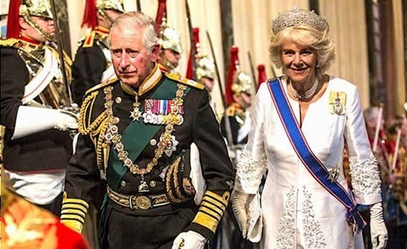

The First Anniversary of the Coronation of HM The King will be observed in both our Churches on the Eve of the Anniversary, Sunday 5 May 2024.

Annahilt, 10.00 am

Magherahamlet 12.00 noon

**PRAYERS  
  
For the King**

*(Based on a prayer in the 1953 Coronation Service)*

Lord God, in your power you provide for your people and rule over them in love:

Grant to your servant Charles, our King, the spirit of wisdom and government,

that being devoted to you with his whole heart, he may so wisely govern,

that during his reign your church may be protected, and Christian devotion may continue in peace;

that so persevering in good works to the end, he may by your mercy enter your everlasting kingdom;

through Jesus Christ, your Son, our Lord, who lives and reigns with you in the unity of the Holy Spirit,

one God now and for ever. **Amen.**

*(Based on a prayer from the Jubilee Resources)*

Lord God, the Ancient of Days, you are sovereign over all your people;  
Give to His Majesty, King Charles enduring wisdom and faith  
in the service of the people of this land and of you, his Lord and Master.

Grant that his faithful witness may be to others a source of hope,  
that they may come to know more fully your Son Jesus Christ,  
who is alive and reigns with you and the Holy Spirit,

one God, now and for ever. **Amen.**



**From the Parish Registers**

**Holy Baptism**

*‘Go therefore and make disciples of all nations, baptising in the name of the father, and of the Son and of the Holy Spirit’*

31 March 2024

Magherahamlet Parish Church

Poppy Robyn, daughter of Connor and Laura Sweeney

**Church Services in the Parishes of Annahilt and Magherahamlet**

*‘I was glad when they said to me: “Let us go to the house of the Lord”’* Psalm 122 v1

Sunday 28 April **Easter V**

10.00 Morning Prayer Annahilt

12.00 Morning Prayer Magherahamlet

Sunday 5 May **Easter VI (Rogation Sunday)**

*Eve of First Anniversary of Coronation of HM The King*

10.00Parish Communion Annahilt

12.00 Parish Communion Magherahamlet

Thursday 9 May **Ascension Day**

**7.30 pm** Holy Communion Annahilt

Sunday 12 May **Sunday after Ascension Day**

*Launch of Christian Aid Week*

10.00 Family Service Annahilt

*followed by Light Refreshments in the Parochial Hall*

12.00 Family Service Magherahamlet

Sunday 19 May **Pentecost**

10.00 Parish Communion Annahilt

12.00 Parish Communion Magherahamlet

Sunday 26 May **Trinity Sunday**

*Vocation Sunday*

10.00 Morning Prayer Annahilt

12.00 Morning Prayer Magherahamlet

Sunday 2 June **Trinity I**

10.00 Parish Communion Annahilt

12.00 Parish Communion Magherahamlet

Sunday 9 June **St Columba’s Day**

10.00 Morning Prayer Annahilt

12.00 Morning Prayer Magherahamlet

Sunday 16 June **Trinity III**

*Celebration of 40th Anniversary of the Rector’s Ordination*

10.00 Parish Communion Annahilt *Service Sheets*

Presiding Bishop: The Rt Revd David McClay

Preacher: The Rt Revd the Lord Eames of Armagh, OM

12.00 Service of the Word Magherahamlet *Service Sheets*

Presiding Bishop: The Rt Revd David McClay

Preacher: The Rt Revd the Lord Eames of Armagh, OM

***followed by Picnic at Larchfield Estate (by kind permission)***



**Christian Aid Week 12th – 18th May**

Christian Aid Week this year will focus on the cost-of-living crisis faced by many people around the world, particularly in areas of Africa, Asia, the Middle East and Latin America and the Caribbean.

Christian Aid is on a journey to build a world free from poverty and based on dignity, equality, justice and love. 783 million people around the world will not have a meal today and according to the U. N. Hunger is currently the leading cause of death in the world. While the world’s farmers should be able to grow enough food to feed everyone on the planet, the overlapping crises of conflict, climate change and economic inequality have created a cycle that has undermined food security worldwide.

Even here in Northern Ireland we have experienced some of the effects of conflict as the war in Ukraine has triggered a global increase in food and fuel prices.

Donations from Christian Aid can help transform lives, like those of Aline, whose life in Burundi was once a constant struggle, but who was able to take her first step towards her new life by participating in a transformative three-day community workshop funded by Christian Aid. Along with a small start up loan, she was able to use the knowledge and skills gained in the workshop to start trading avocados and peanuts locally and this has developed to the extent that she can now afford food, clothes and essential healthcare for her family.

Every donation to Christian Aid can help make a difference and transform lives just like Aline’s, who says:

“When we see Christian Aid, we feel comforted; we feel we are not alone. You helped us to change our poor living conditions. I really thank you from the very bottom of my heart”.

If you would like to make a donation towards Christian Aid’s work, you may use the envelope enclosed. Envelopes may be returned at any of the church services in May. Alternatively, there will be a coffee morning in favour of Christian Aid Week, after our church service in Annahilt on Sunday 12th May and we would love to see you there.

**Christian Aid Envelopes are included with this Parish Magazine and may be returned to Church at Services on any of the following Sundays 12, 19 & 26 May.**

**Alternatively, donations may be made directly to either of the Parochial Treasurers, Patricia Halliday (Annahilt) or Hillary Edgar (Magherahamlet).**



Bishop David has planned a series of eight practical teaching evenings in May to help resource our churches for growth. GROW, will take place from Sunday 12–Sunday 19 May and the teaching evenings are open to everyone in the diocese.

The topics are biblical values that, when in place in our local churches, create an environment for growth as Christ builds his Church with new converts and Christian disciples grow into maturity.

The bishop has invited speakers from Ireland who have years of experience fostering these focus areas in local church settings. What they share will be both practical and inspirational.

*Please come along and be encouraged and equipped for your context.*

**VENUE: WILLOWFIELD CHURCH BELFAST**

Sunday 12 May at 7.00pm: *Keeping evangelism at the top of the agenda*

Bishop David McClay

Monday 13 May at 7.30pm: *Worship services full of the presence of God*

Revd Eoghan Heaslip

Tuesday 14 May at 7.30pm: *Creating healthy Christian communities*

Revd Alastair Graham

Wednesday 15 May at 7.30pm: *Developing a culture of generosity*

Pastor Paul Reid

**VENUE: ST SAVIOUR’S DOLLINGSTOWN**

Thursday 16 May at 7.30pm: *Intercession and prayer in the local church*

Mrs Susan Heaney

Friday 17 May at 7.30pm: *Ministry that impacts a local community*

Mrs Hilary McClay

Saturday 18 May at 7.30pm: *Keeping the Bible front and centre*

Revd John Dickinson

Sunday 19 May at 7.00pm: *Ministry in the power of the Holy Spirit*

Pastor David Legge

**From the Bishop**

My dear friends,

As your bishop I am convinced that God is present with His people in a special way when we come together week by week to offer Him our worship, our praise our thanksgiving and our prayer. Our gathering in His name equips us for life as His word is proclaimed enabling us to go out into the world, our communities, back to our families and our places of work to live out our lives to His praise and His glory.

God’s church changes lives and changes communities. God wants his church to grow and I am certain that every local congregation has the potential to grow. Churches grow when particular biblical values are in place. For eight evenings leading up to Pentecost Sunday I have invited speakers to help us take hold of these values and see them firmly rooted in all our parishes and congregations. I will speak at the first of these evenings myself and then evening by evening visiting guest speakers will encourage us to embrace all that will enable our churches to grow and to thrive. Every parishioner in all our parishes is invited and the purpose of this letter is that I would have the opportunity to personally invite you to any and as many of the evenings as is possible for you.

May you and your local parish be encouraged and my prayer is that your parish will grow in both depth and commitment to Christ as well as grow numerically in the months and years ahead.

I look forward to welcoming you to our special GROW services from 12 to 19 May, 12 to 15 May in Willowfield Parish church and 16 to 19 May in St Saviour’s Church Dollingstown.

Blessings in Christ,

+David

 The Right Reverend David A McClay,

Bishop of Down and Dromore

**Flowers for the Churches**

**Annahilt Magherahamlet**

**April**

7 Mrs Alison Harrison-Mitchel Mr G Jennings

14 Mrs J Bradford

21 Mrs J Bradford

28

**May**

5 Mrs E Anderson Mrs M Keown

12 Mrs B Oliver Mrs F Magorrisn

19 Mrs B Oliver

26



**Church Cleaning, Annahilt**

**Month**

**May**

3-4 Mrs H Hill Mr T Hill

10-11 Mrs A Maxwell Mr R Maxwell

17-18 Mrs S Chapman Mr S Chapman

24-25 Mrs E Crawford

**June**

1 Mrs L McCambley Mrs E Harrison

7-8 Mrs J Bolas Mr A Bolas

14-15 Mrs H Hill Mr T Hill

21-22 Mrs J Guiney Mrs H Cardosi

28-29 Mrs A Maxwell Mr R Maxwell

**July**

5-6 Mrs L McCambley Mrs E Harrison

|  |  |  |  |
| --- | --- | --- | --- |
|  | **ANNAHILT CHURCH HALL CLEANING ROTA** |  |  |
|  | **2023 - 2024** |  |  |
|  |  | week commencing |  |
|  | Susan Wilson | 19/02/24 |  |
|  | Shirley Robinette | 04/03/24 |  |
|  | Gail Gibson | 18/03/24 |  |
|  | Linda Hassard | 01/04/24 |  |
|  | Maire Brown | 15/04/24 |  |
|  | Lesley McKeown | 29/04/24 |  |
|  | Louise McGregor | 13/05/24 |  |
|  | Heather Bradford | 27/05/24 |  |
|  | Heather Cardosi | 10/06/24 |  |
|  | Jennifer Guiney | 24/06/24 |  |



Dear Mothers’ Union Members and Friends,

At our April meeting of Annahilt Mothers’ Union we were delighted to assemble Toiletry bags for donation to Hospitals and Refuges. A total of 40 filled bags have been delivered to Clare Stewart of MU Action and Outreach. She will make sure that they go to where they are needed most. The planning the MU programme for the next three months was postponed until there was a fuller attendance at a subsequent meeting.

On 28 March Mothers’ Union members attended the Maundy Thursday Holy Week service in Annahilt Parish Church at 8.00 pm and all members of the congregation were invited to light refreshments in the Parochial Hall afterwards.

Please contact Esme at [esmeogle@gmail.com](mailto:esmeogle@gmail.com) or 07748736622 if you have any further queries.

On the Wednesday in Holy Week, 27 March members of the Magherahamlet Branch attended the mid-week Service in the Parish Church.

Both Branches were represented at the annual Diocesan Festival Service in Dromore Cathedral on Thursday 21 March.

The Beauty of the Bride Wedding Dress Festival takes place in Dromore Cathedral beginning with the Opening Service on Thursday 9 May at 7.30 pm with Lady Eames.

The Diocesan MU Indoor Indoor Members’ Holy Communion Service and Tea Party will be held this year in St Mark’s Parish, Newtownards on Thursday 16 May at 2.00 pm. An invitation is extended to all Indoor and Senior Members of our Branches. This is always an enjoyable event and we would encourage those eligible to go. If you would like to attend and require transport please contact Esme or Sally.

We very deeply regret the recent death of Mrs Louise McDowell, a member of Annahilt Branch over many years. We extend our deep sympathy to her family circle in their great loss and also to Ann Hall and other family members on the death of her sister.

With Kind Regards to Everyone

Beth, Esme, Elaine Avril, Frances, Virginia



**May**

1-2 May: Aru in DR Congo; Kigezi in Uganda; Ikeduru in Nigeria; Ho in Ghana; York in England and Guyana & Suriname in Guyana

4-6 May: Uppershire in Malawi; Maralal Missionary Area in Kenya; Makurdi & Ifo in Nigeria; Tuam, Killala & Achonry in All Ireland and Mumbai in India

7-9 May: Torit in South Sudan; Meru in Kenya; Ikwuano in Nigeria; Sekondi in Ghana and The Arctic in Canada

11-13 May: Twic East in South Sudan; Rorya in Tanzania; Owerri & Ughelli in Nigeria; Gippsland in Australia and Cashel & Ossory in All Ireland

14-16 May: Maridi in South Sudan; Kirinyaga in Kenya; Zaki-Biam & Ijesa North-East in Nigeria and Waikato & Taranaki in New Zealand

18-20 May: Grahamstown in South Africa; Masasi in Tanzania; Afikpo in Nigeria; Wiawso in Ghana; Chester in England and Northern Argentina in Argentina

21-23 May: Christ the King in South Africa; East Rwenzori in Uganda; Gombe & New Busa in Nigeria and Bunbury in Australia

25-27 May: Bor in South Sudan; Mount Kilimanjaro in Tanzania; Oru & Oleh in Nigeria; Rockhampton in Australia and Agra in India

28-30 May: Angola; North Ankole in Uganda; Okene & Ibadan-South in Nigeria; Aberdeen & Orkney in Scotland and Karnataka South in India

**Lunch Club**

The next time we meet will be Friday 31 May in the Pheasant at the usual time of 12.30pm.

Subsequent Lunch Club meetings will take place on the following dates:

28 June

26 July

The Lunch Club is a very relaxed and enjoyable occasion, giving retired and semi-retired members an opportunity to connect with each other. If you would like the opportunity of enjoying a lunchtime meal in the company of established friends or perhaps some new ones, do come along. Please contact Violet Swarbrigg (Telephone 028 9263 8952) for further information.

**Annahilt Spring Wellness events**

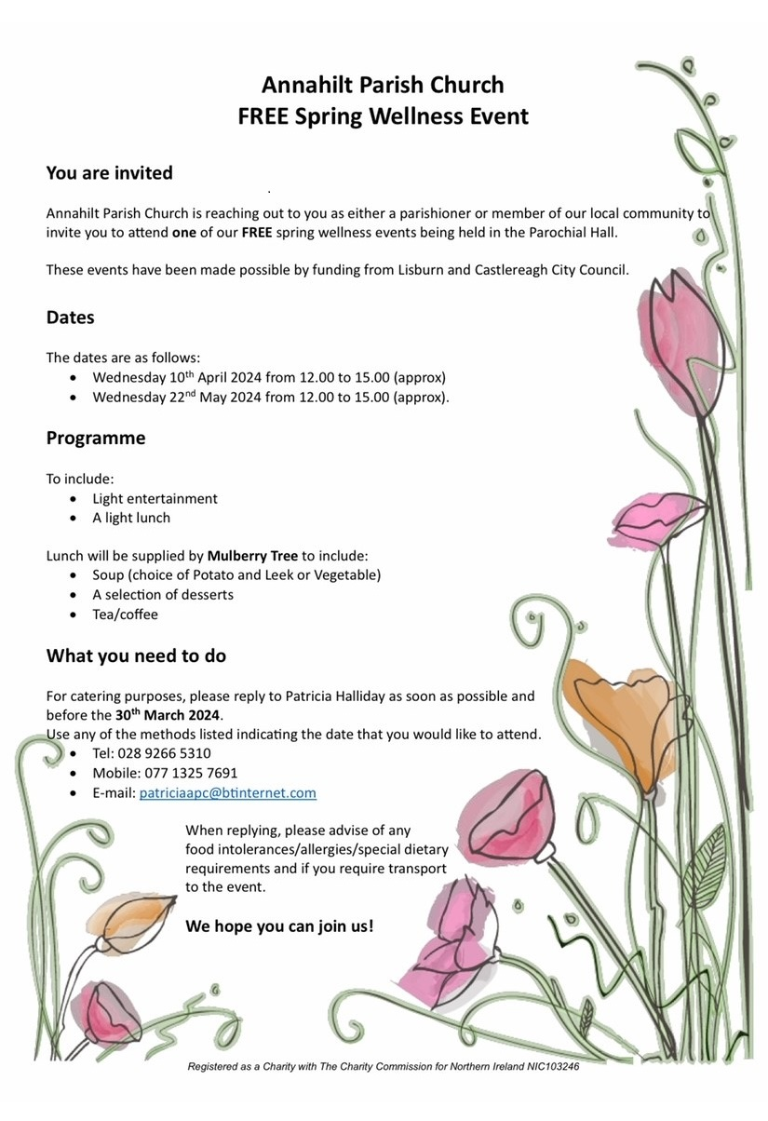

The second of these events will take place in the Parochial Hall on Wednesday 22nd May 2024 from 12.00 - 3pm (approx).

If you were unable to attend the April event, we hope that you will take the opportunity to join us in May. Please contact Patricia asap (for catering purposes). The caterer is The Mulberry Tree, Seaforde.

As we go to press the April event has already taken place and featured Baillies Mills Band providing most of the entertainment. There will be a different programme for the May afternoon.

We thank Patricia Halliday for securing funding from Lisburn and Castlereagh City Council and to the others on the organising committee - Eileen Codd, Edwina Crawford, Linda Hassard, Canon Howard and Violet Swarbrigg.

**Magherahamlet Badminton Club**

Magherahamlet Badminton Club, are having a coffee morning on Saturday 25th May 2024, with donations going towards church funds.



**Magherahamlet Badminton Club**

**invites you all to our**

Coffee Morning with Cake and Plant Sale

Saturday 25th May 2024

10am - 12.30pm



Magherahamlet Parochial Hall

2A Drumgavlin Road, Ballynahinch, BT24 8PY

Proceeds in aid of Church Funds

Magherahamlet Badminton Club is running 10 years this year. We have a great group of friendly people, playing on a Monday night at 8pm in Magherahamlet Parish Hall.

We had a friendly game between Magheradroll and Saintfield Parish recently to mark our 10th anniversary.

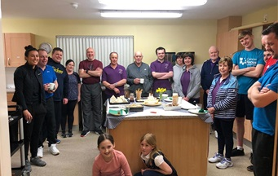

We want to thank the church for the use of the hall.  Anyone wishing to have a game will be very welcome to come and have a go.

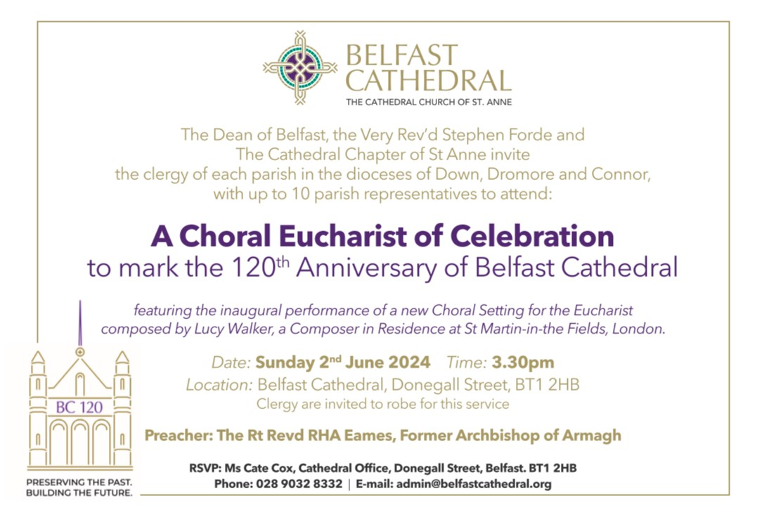

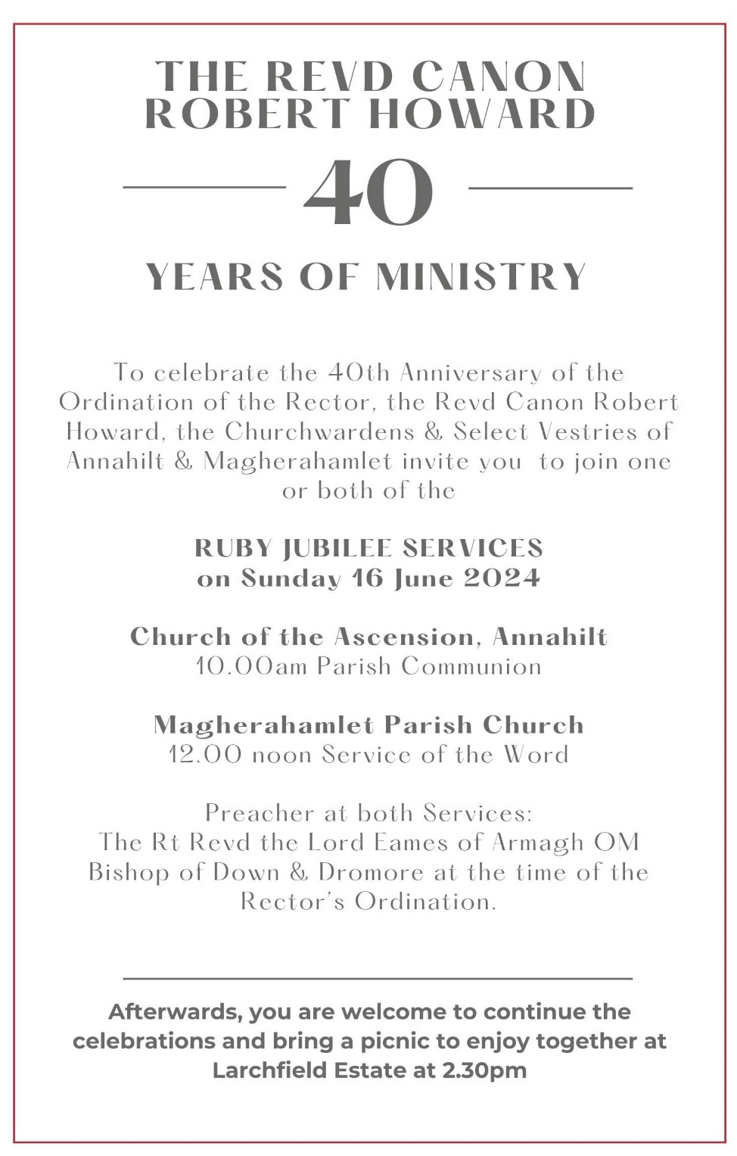

**Financial matters**

**Annahilt Annual Report** will soon be available on the website. If anyone would like a paper copy, please contact Patricia on 07713 257691.

**LISBURN FOODBANK**

The Lisburn Foodbank is providing an essential service to those within our community who are experiencing difficult times, often due to circumstances beyond their control.

The Foodbank provides emergency food and support to local people in crisis in the Lisburn area.

Parishioners may leave items for the Foodbank in the basket in Annahilt Church Porch, on the FIRST and SECOND Sunday of each month.

A particular request from the Foodbank is for cleaning items such as:

* small packs of toilet roll
* nappies
* baby wipes
* shower gel
* soaps
* washing powder

**YOUR HELP WOULD BE GREATLY APPRECIATED**.

**Parish Website:  AnnahiltAndMagherahamlet.org**

Parishioners are reminded that the website [annahiltandmagherahamlet.org](http://annahiltandmagherahamlet.org/) has been created to provide information on church related activities and organisations for parishioners and the wider community. The website also continues to host online services each Sunday. In addition, the website contains a list of upcoming church services and news from our group of parishes, as well as downloadable versions of the parish magazine.  The site will be continually developed, so if you have any submissions, suggestions or requests relating to the website, these can be sent to [admin@annahiltandmagherahamlet.org](mailto:admin@annahiltandmagherahamlet.org).



[www.annahiltandmagherahamlet.org](http://www.annahiltandmagherahamlet.org)

**Parish Magazine**

Any contributions for the next edition of the Parish Magazine should be left with the Rector or Roger Maxwell ([roger.maxwell1@btinternet.com](mailto:roger.maxwell1@btinternet.com)) by Sunday 19 May 2024.

Registered as a charity with The Charity Commission for Northern Ireland

NIC103246 (Annahilt) and NIC102122 (Magherahamlet)